

When we take an existing angular project into workspace we need to perform npm install to install all packages

E:\Angular_project\Angular Document\Section_5_Components and Directives Deep Dive\cmp-databinding-start>**ng serve -o**

**An unhandled exception occurred: Cannot find module '@angular-devkit/build-angular/package.json'**

Require stack:

C:\Users\Admin\AppData\Roaming\npm\node_modules\@angular\cli\node_modules\@angular-devkit\architect\node\node-modules-architect-host.js

C:\Users\Admin\AppData\Roaming\npm\node_modules\@angular\cli\node_modules\@angular-devkit\architect\node\index.j

added 1420 packages from 1104 contributors and audited 1426 packages in 511.702s

42 packages are looking for funding

run `npm fund` for details

found 4 vulnerabilities (3 low, 1 moderate)

run `npm audit fix` to fix them, or `npm audit` for details

E:\Angular_project\Angular Document\Section_5_Components and Directives Deep Dive\cmp-databinding-start>**npm audit fix**

npm WARN optional SKIPPING OPTIONAL DEPENDENCY: fsevents@2.1.3 (node_modules\fsevents):

npm WARN notsup SKIPPING OPTIONAL DEPENDENCY: Unsupported platform for fsevents@2.1.3: wanted {"os":"darwin","arch":"any"} (current: {"os":"win32","arch":"x64"})

+ @angular-devkit/build-angular@0.1000.4

added 134 packages from 98 contributors, removed 38 packages, updated 82 packages and moved 11 packages in 400.837s

46 packages are looking for funding

run `npm fund` for details

fixed 1 of 4 vulnerabilities in 1426 scanned packages

3 package updates for 3 vulnerabilities involved breaking changes

(use `npm audit fix --force` to install breaking changes; or refer to `npm audit` for steps to fix these manually)

E:\Angular_project\Angular Document\Section_5_Components and Directives Deep Dive\cmp-databinding-start>**ng serve -o**

Your global Angular CLI version (10.0.1) is greater than your local

version (9.1.12). The local Angular CLI version is used.

To disable this warning use "ng config -g cli.warnings.versionMismatch false".

**ERROR in TypeError: tooling_1.constructorParametersDownlevelTransform is not a function**

at downlevelFactory (E:\Angular_project\Angular Document\Section_5_Components and Directives Deep Dive\cmp-databinding-start\node_modules\@ngtools\webpack\src\angular_compiler_plugin.js:776:43)

The above error is because we have installed angular10 version and the imported project is of 9 version to fix this we need to downgrade

E:\Angular_project\Angular Document\Section_5_Components and Directives Deep Dive\cmp-databinding-start>**npm install @angular-devkit/build-angular@0.901.9**

**ON Button click display name in red and green on basis of condition**

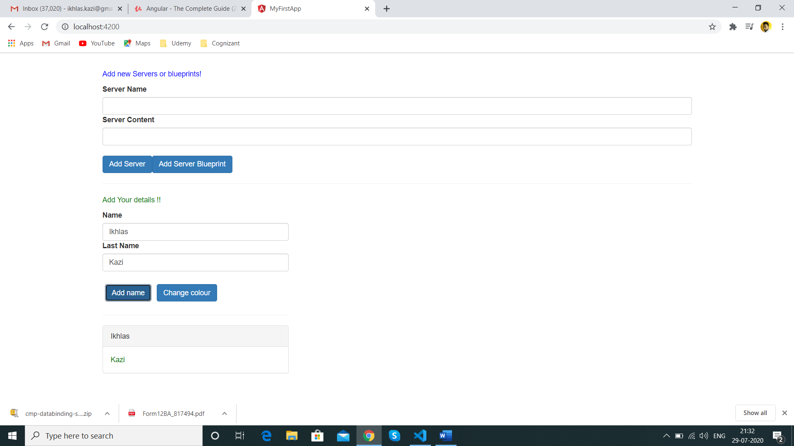

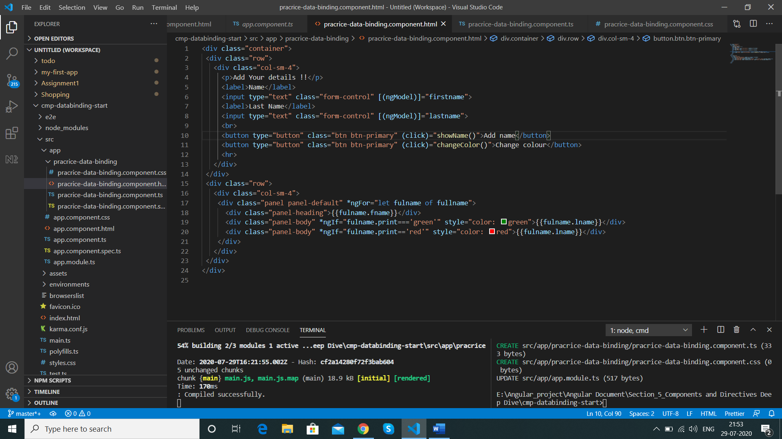

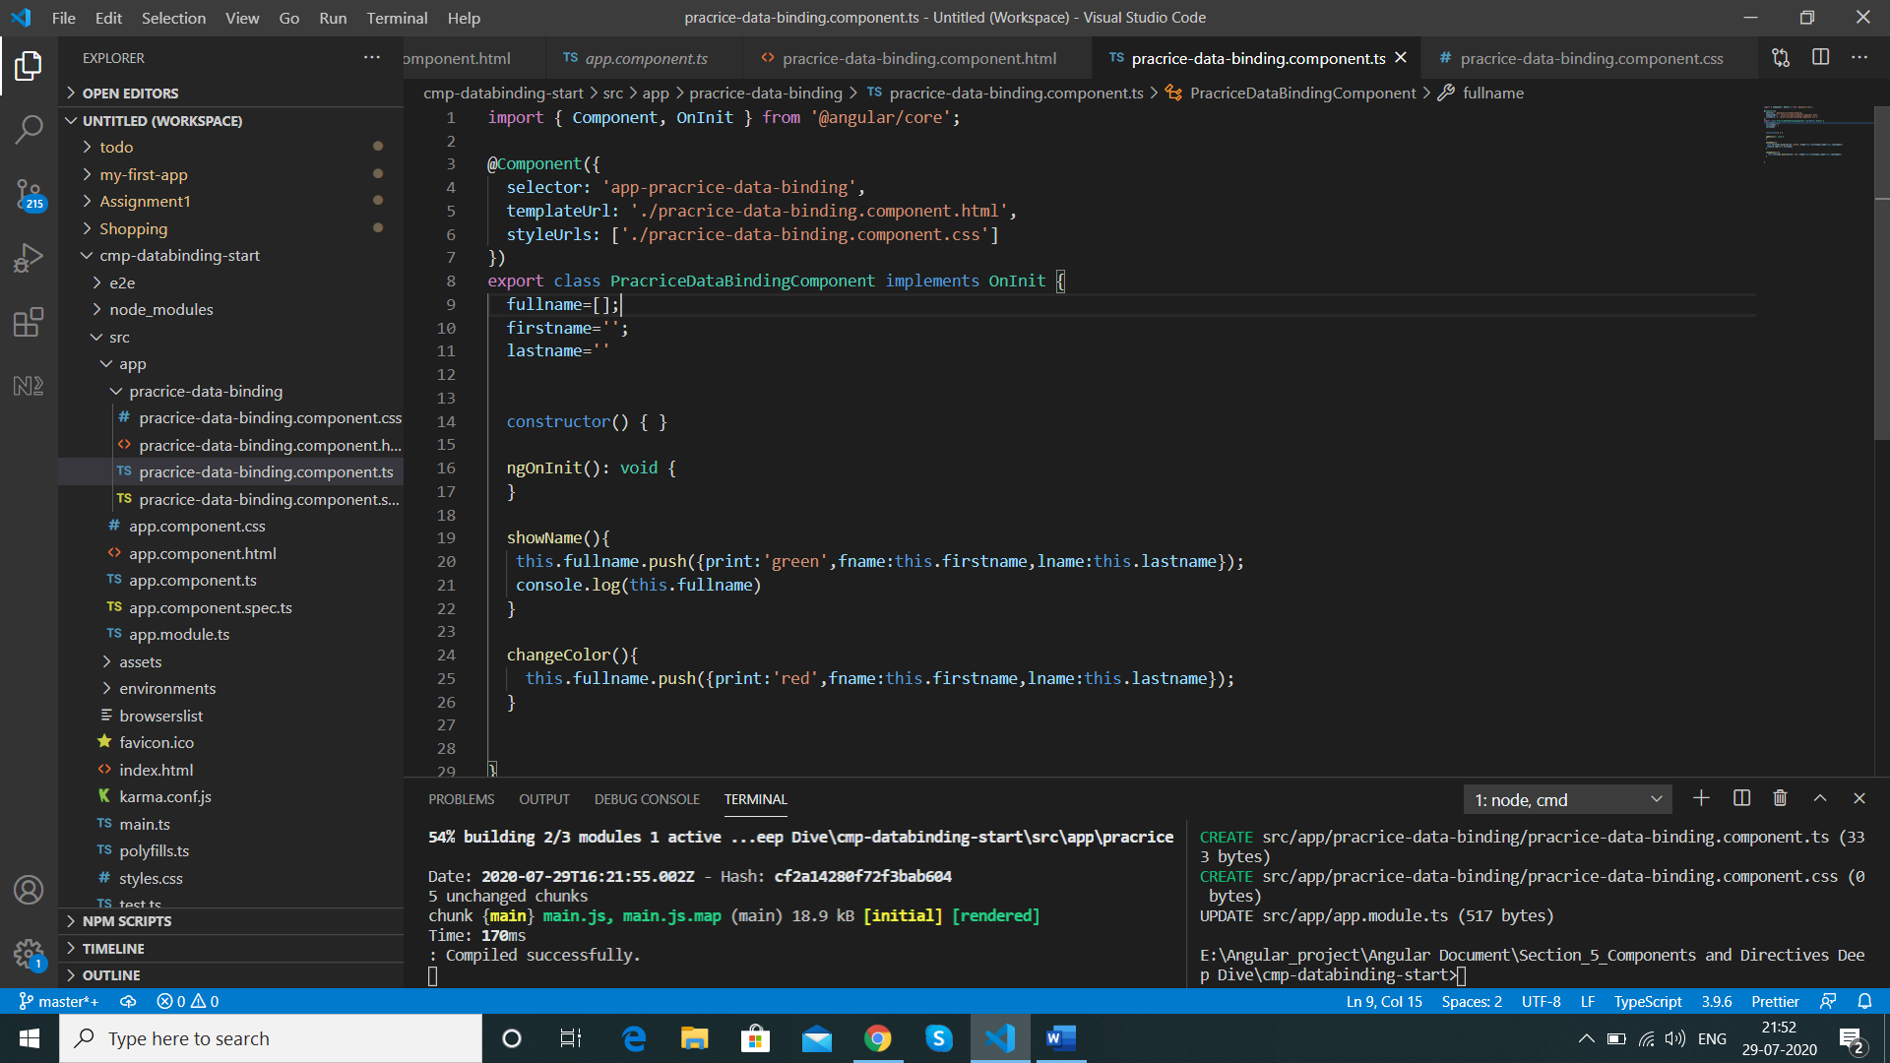

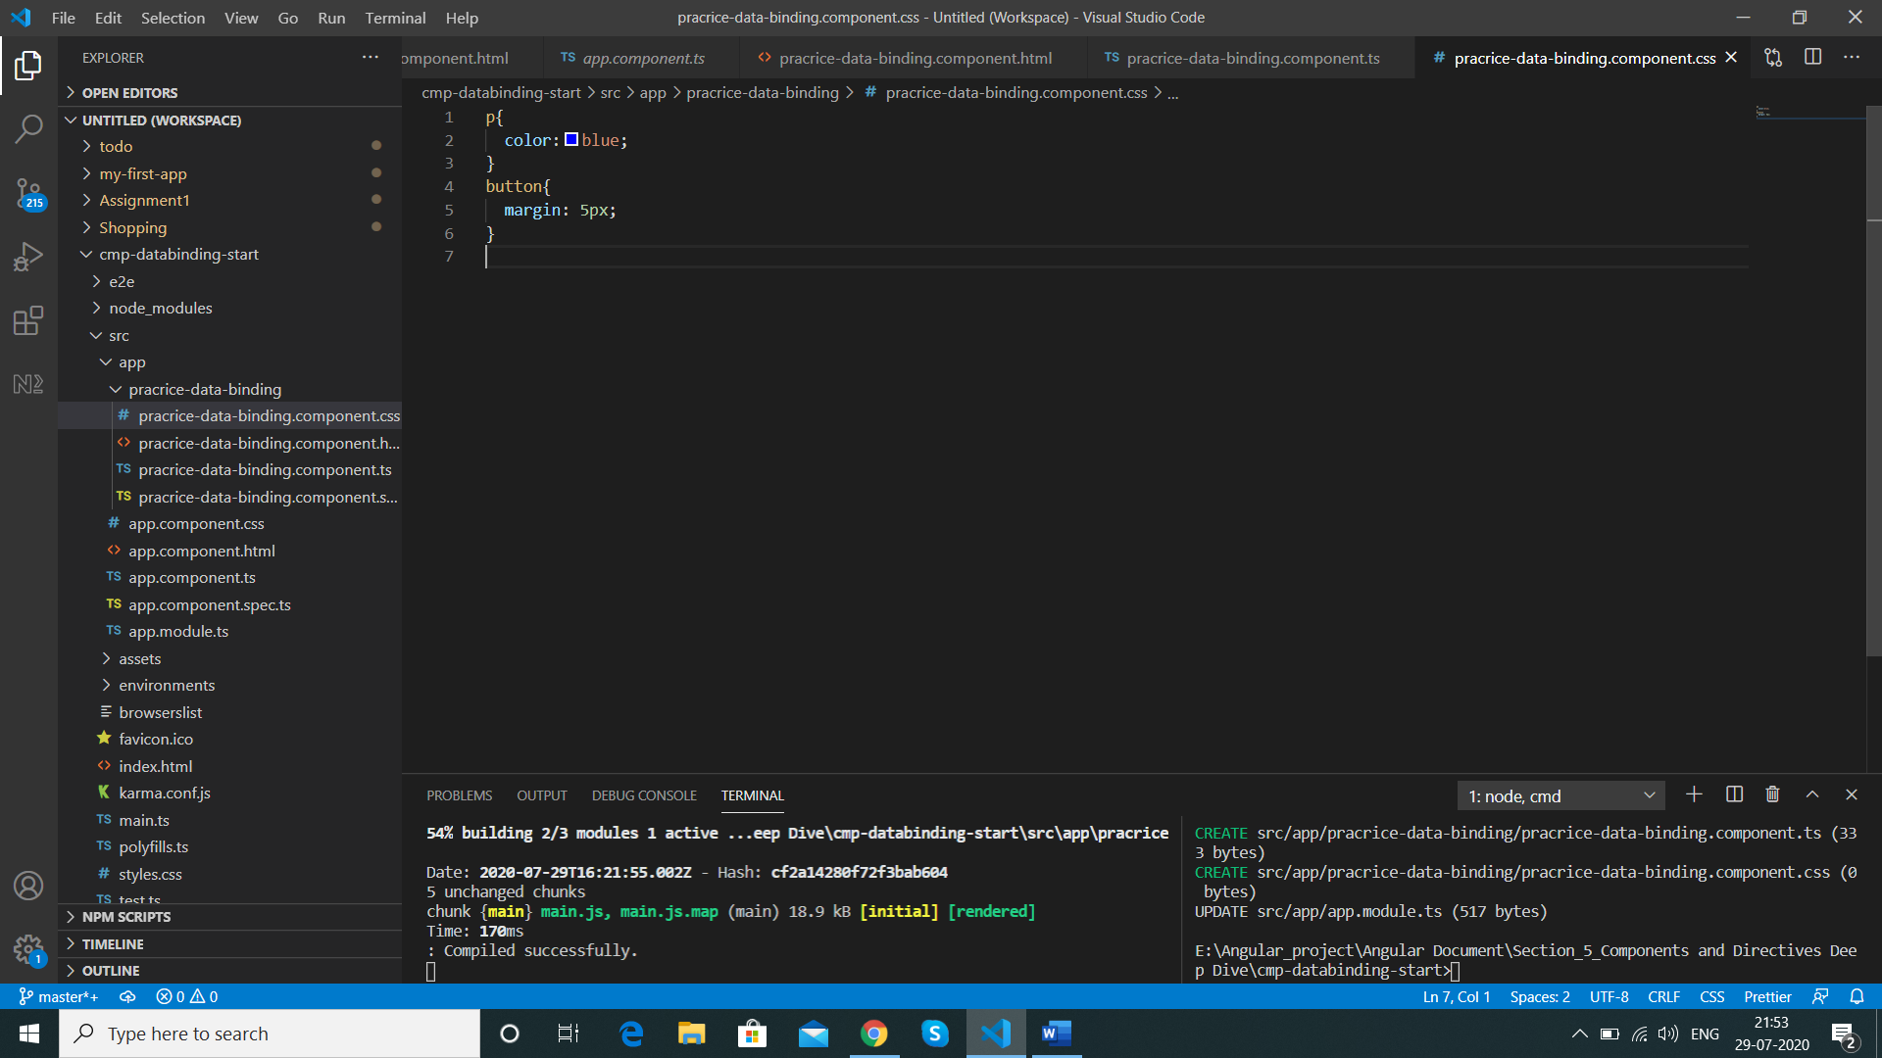

**Passing Data between components**

We have everything in one component practice -data-component we can divide the code into 2 components 1 having the logic and one only view so that we can use so that it can be reusable

We create 2 components my-Comp1 and my-Comp2

Commented is Code moved from practice-data-binding component to my-comp1

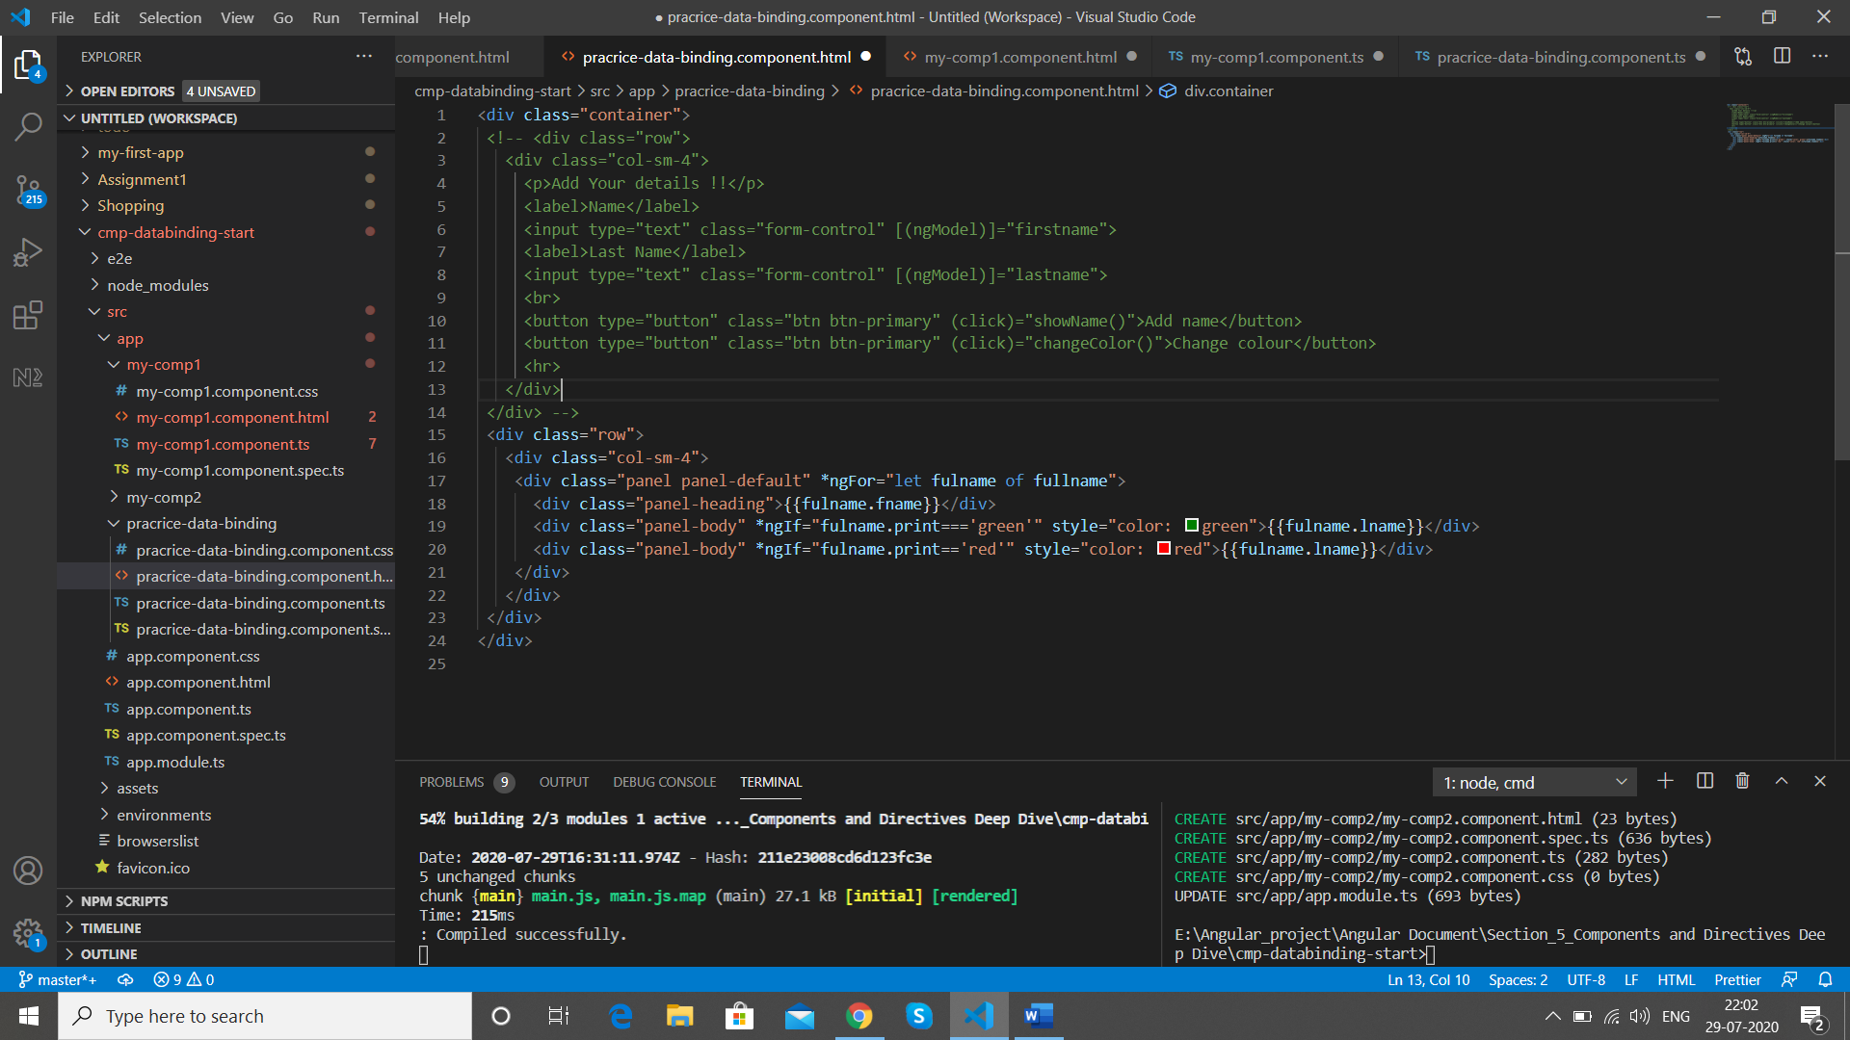

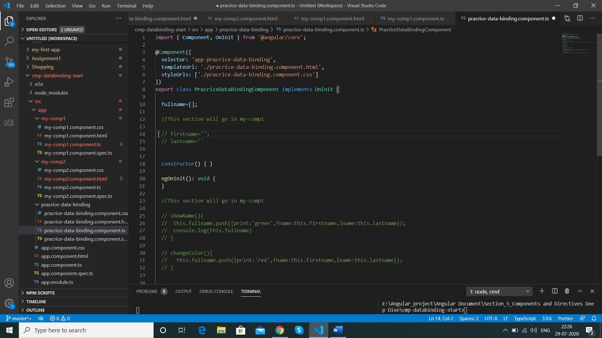

In my-Comp1 we pasted the below code

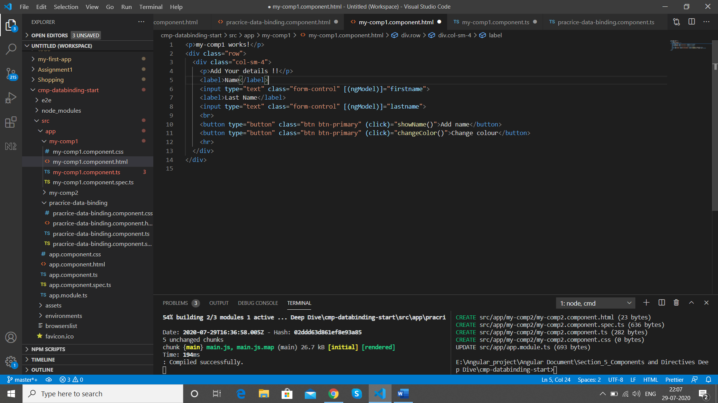

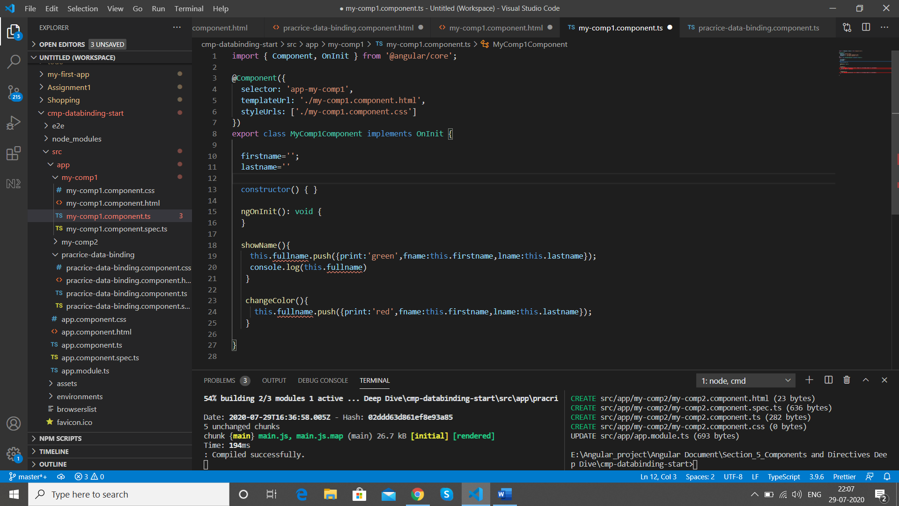

Now we need the array of **fullname []** as well as it is not on the my-comp1 component its supporting code will need it on my-comp1 as a result we are getting error **fullname[]** is still on practice-data-binding component

We futher remove the remaining code from practice-data-binding component and paste it in my-comp2 html

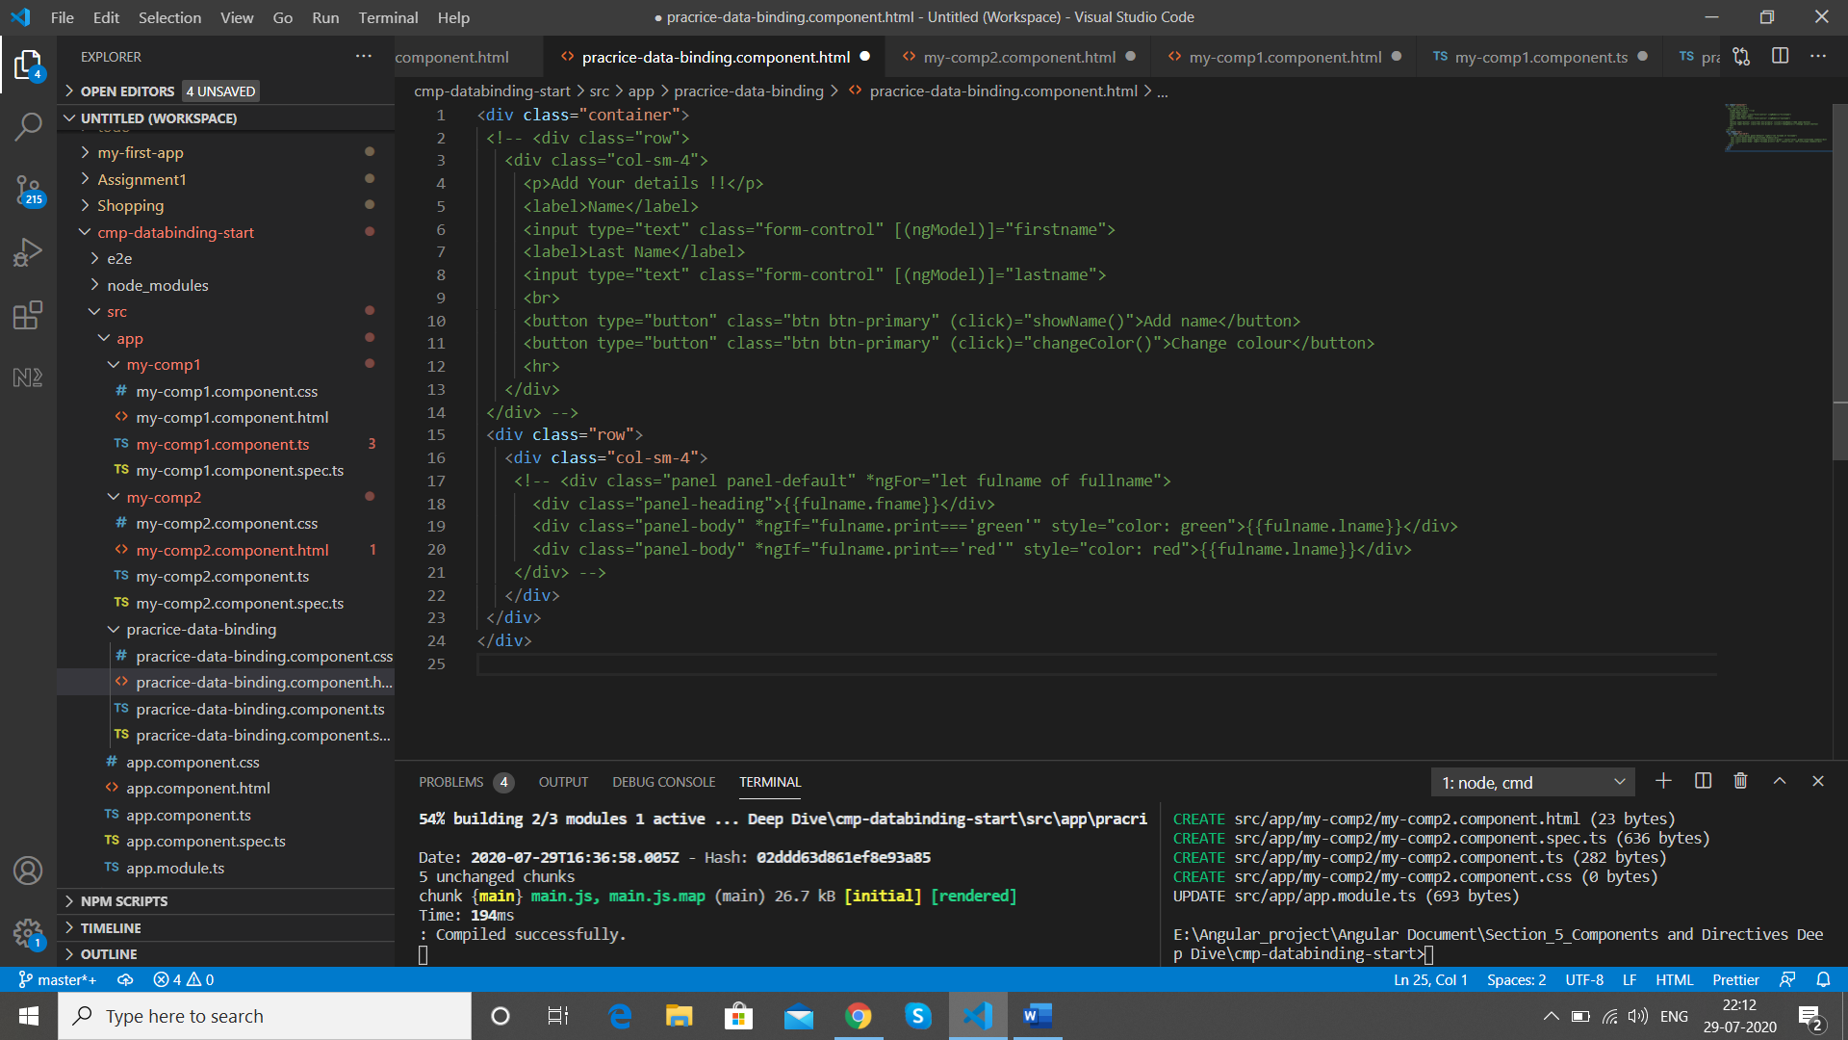

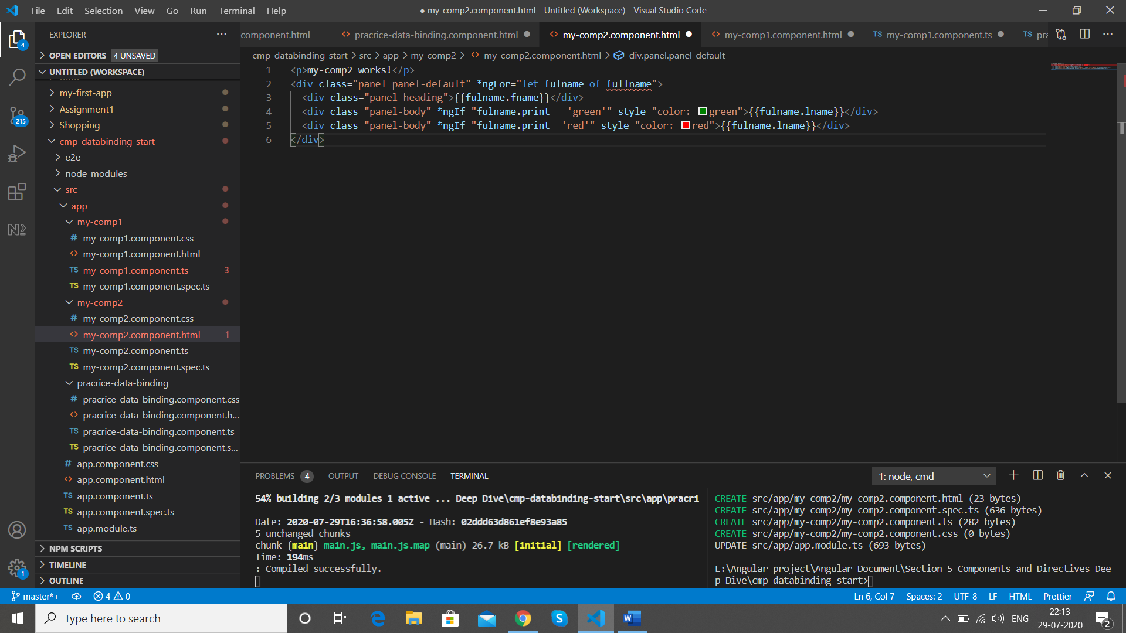

Here we remove the loop as well so that we have only the view

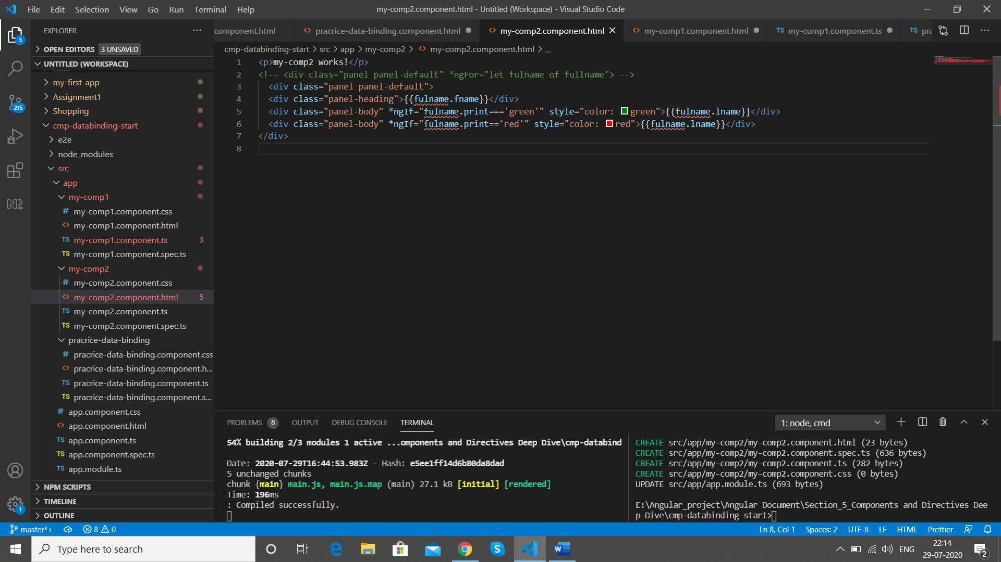

Now as we have removed the html we add the selectors of our components in its place

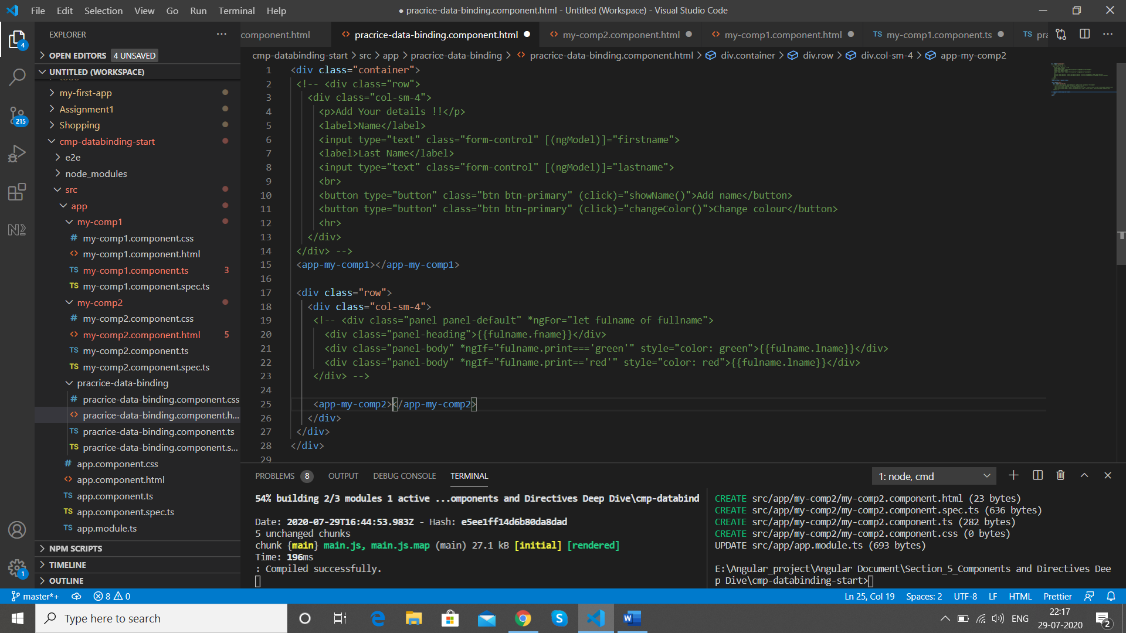

We add the loop back on the component selector

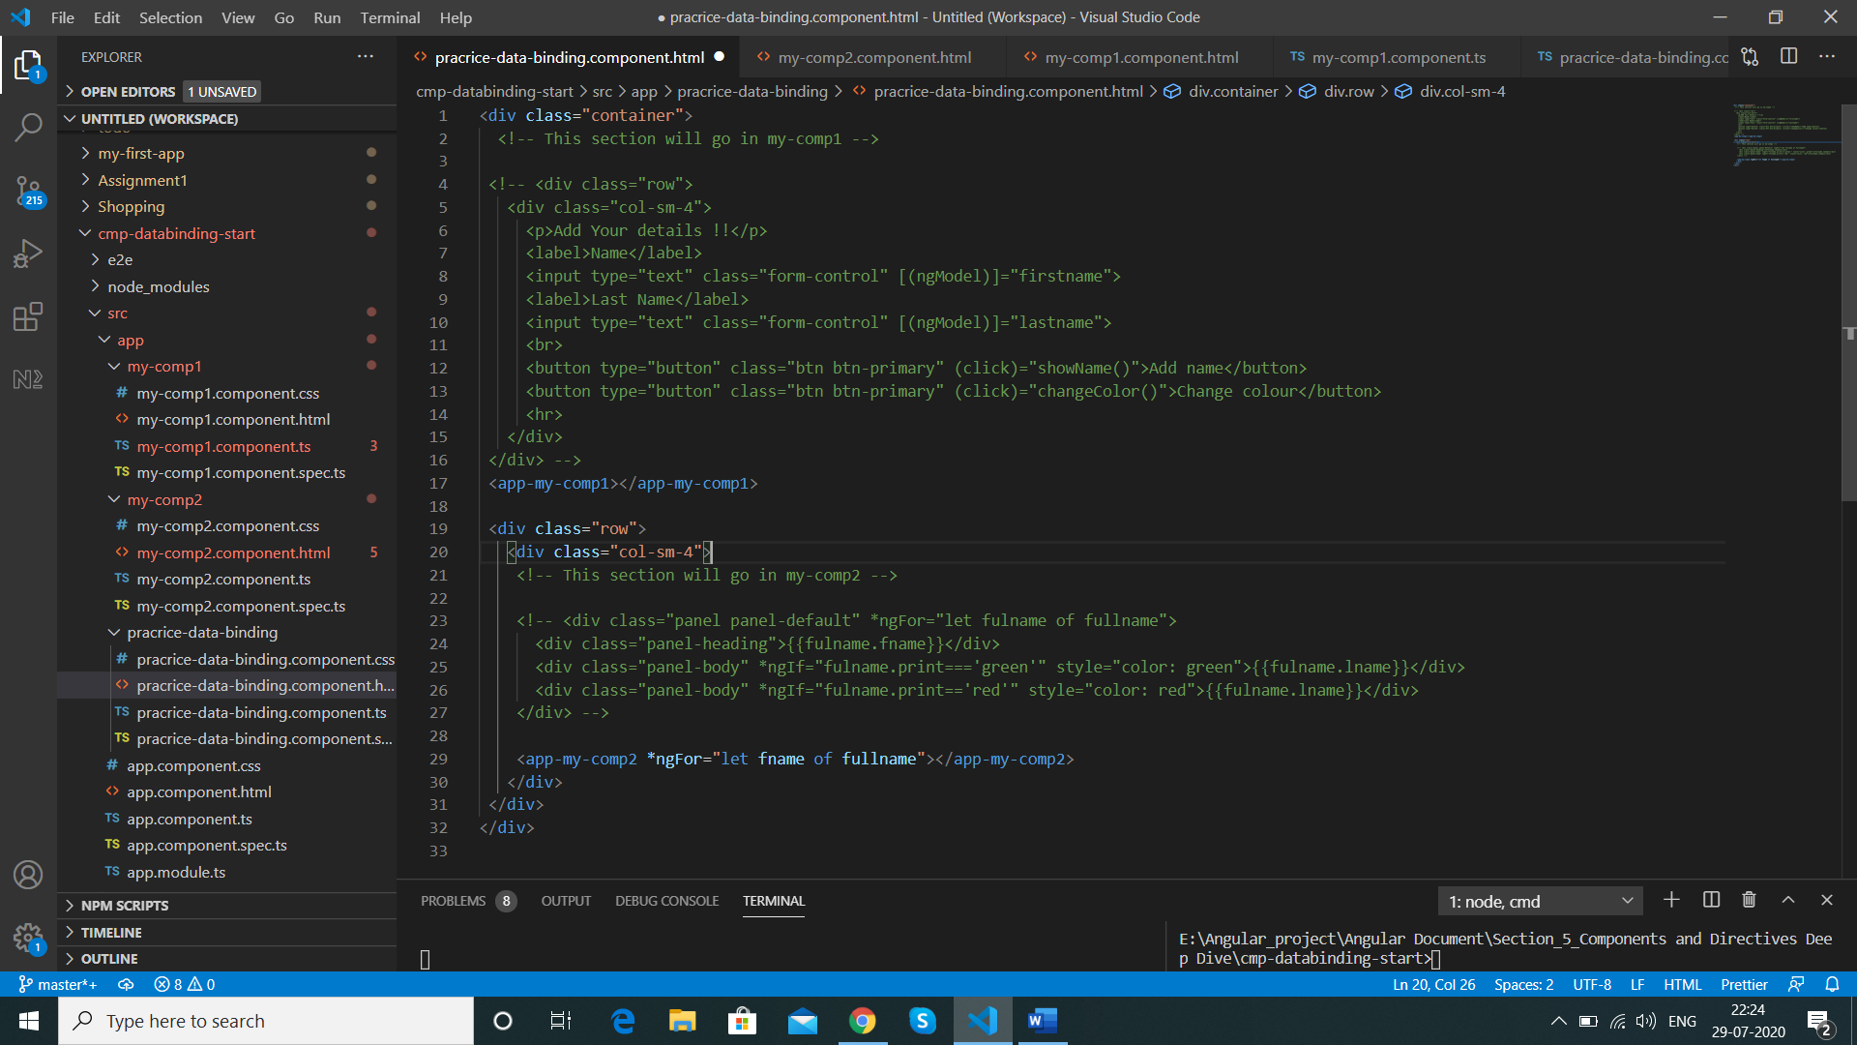

Now we need to send data from one component and receive in other component which is property and event binding

Property and Event binding

We can bind property with HTML ,Directive and Component we can bind event as well also create our own custom event

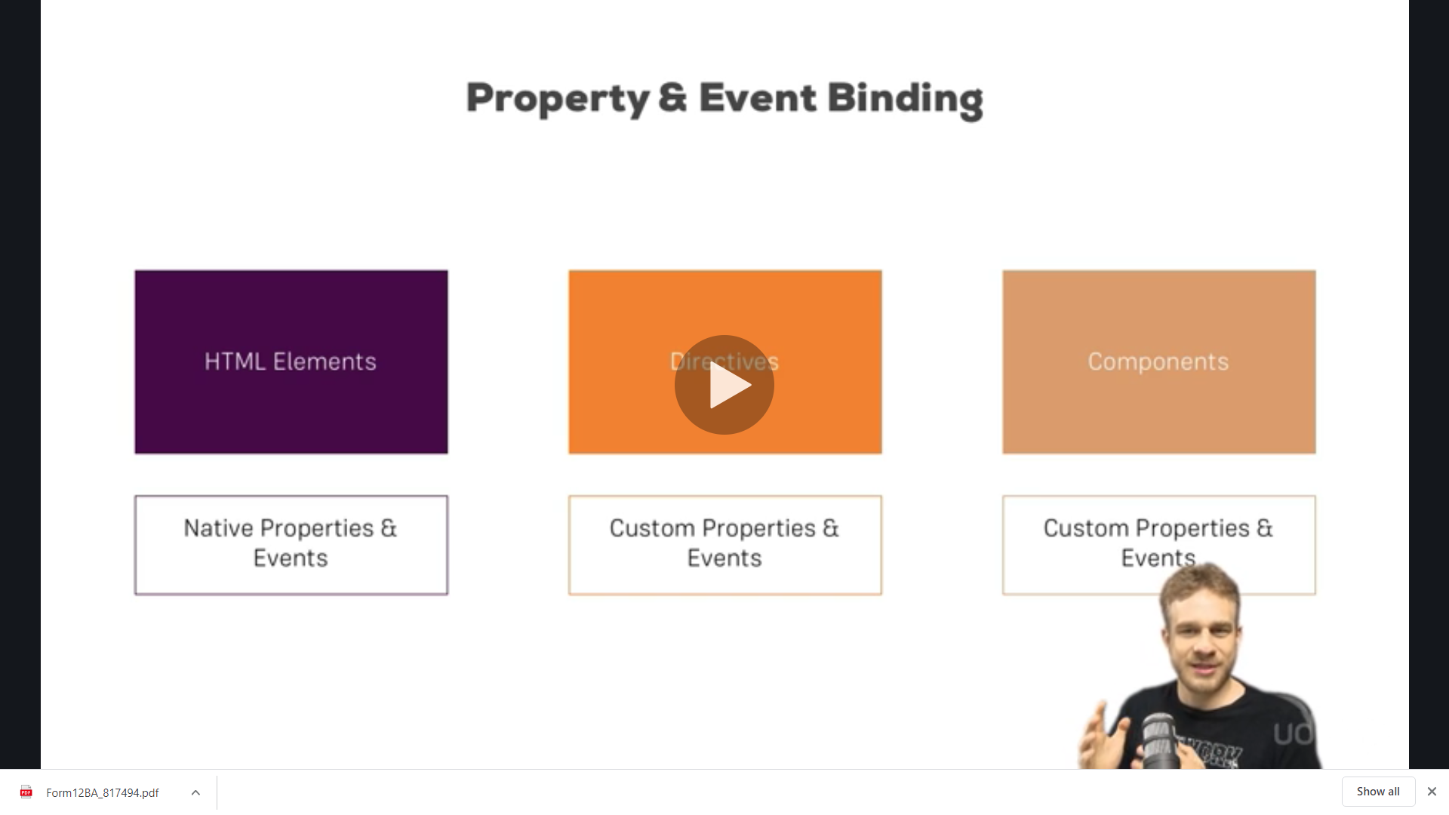

Now as we do not have fullName[] of loop

*ngFor="let fname of fullname"

we define fname as below in my-comp2 components so that we have value in its html

fulname :{} The {} here is not value its typescript syntax of showing that the element will be only of the above type ie

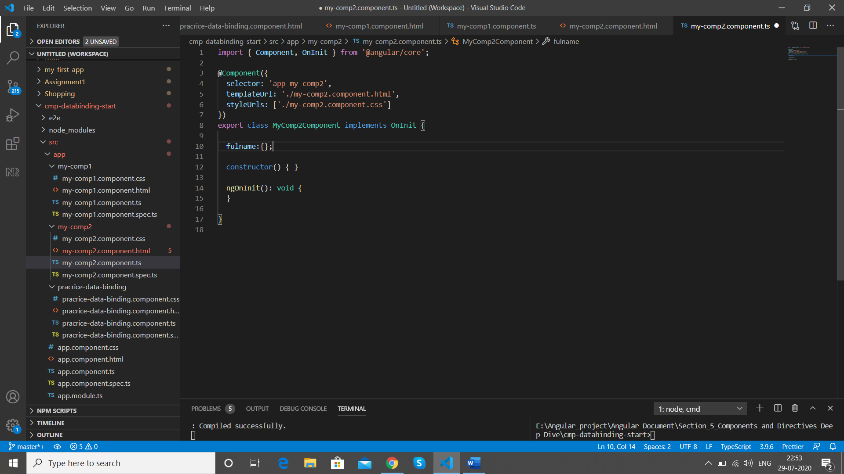

We define the type of elements that we had

print:string,fname:string,lname:string

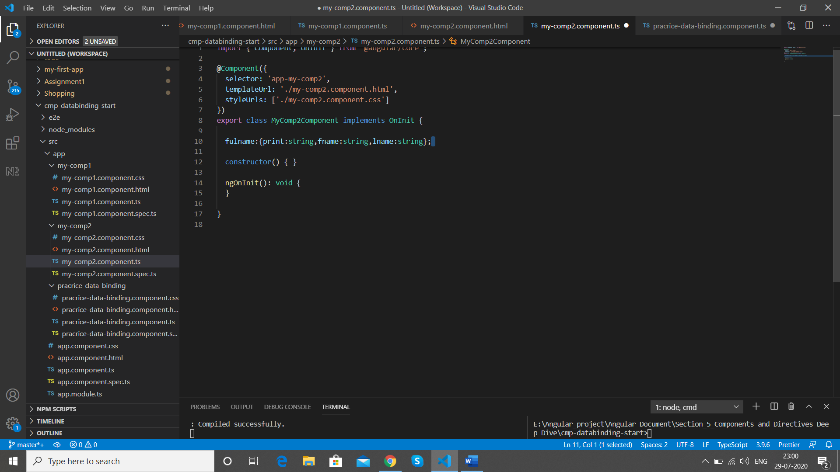

Now out type definition is done and below error is gone in my-Comp2

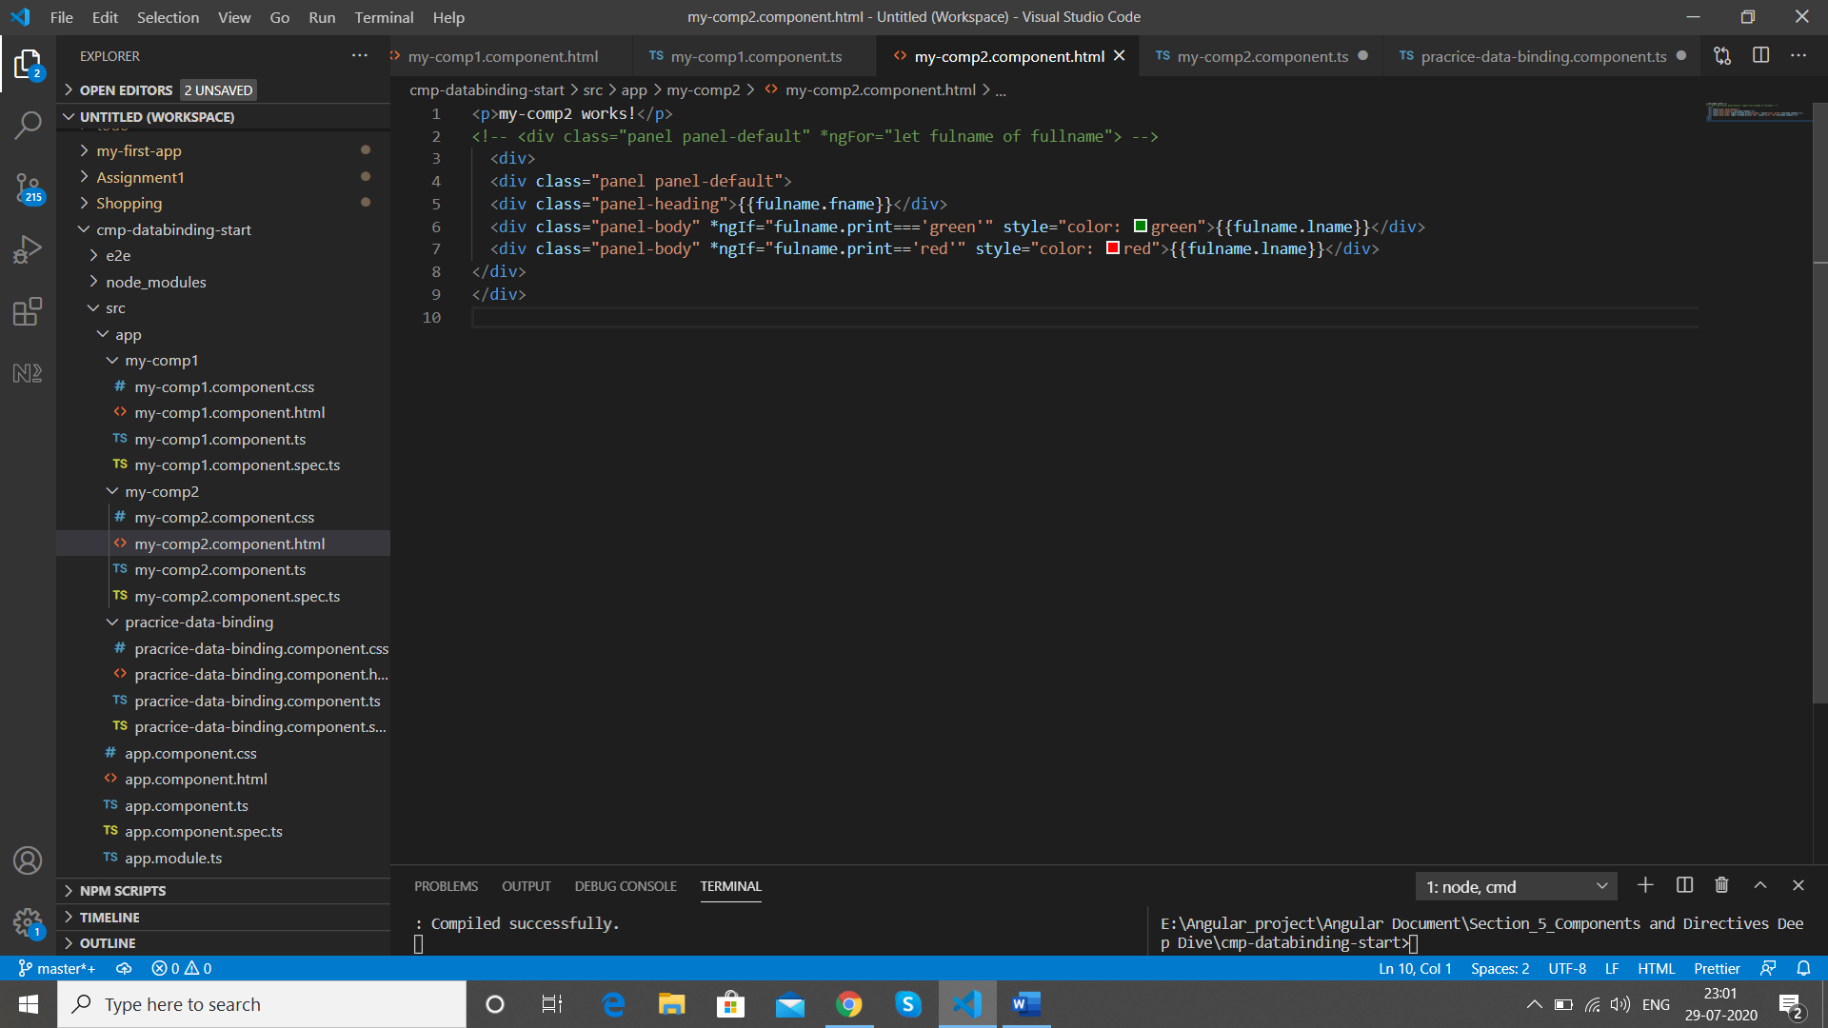

But still fulname is only accessible in my-comp2 component only

fulname:{print:string,fname:string,lname:string};

Now in our practice-data-binding-component

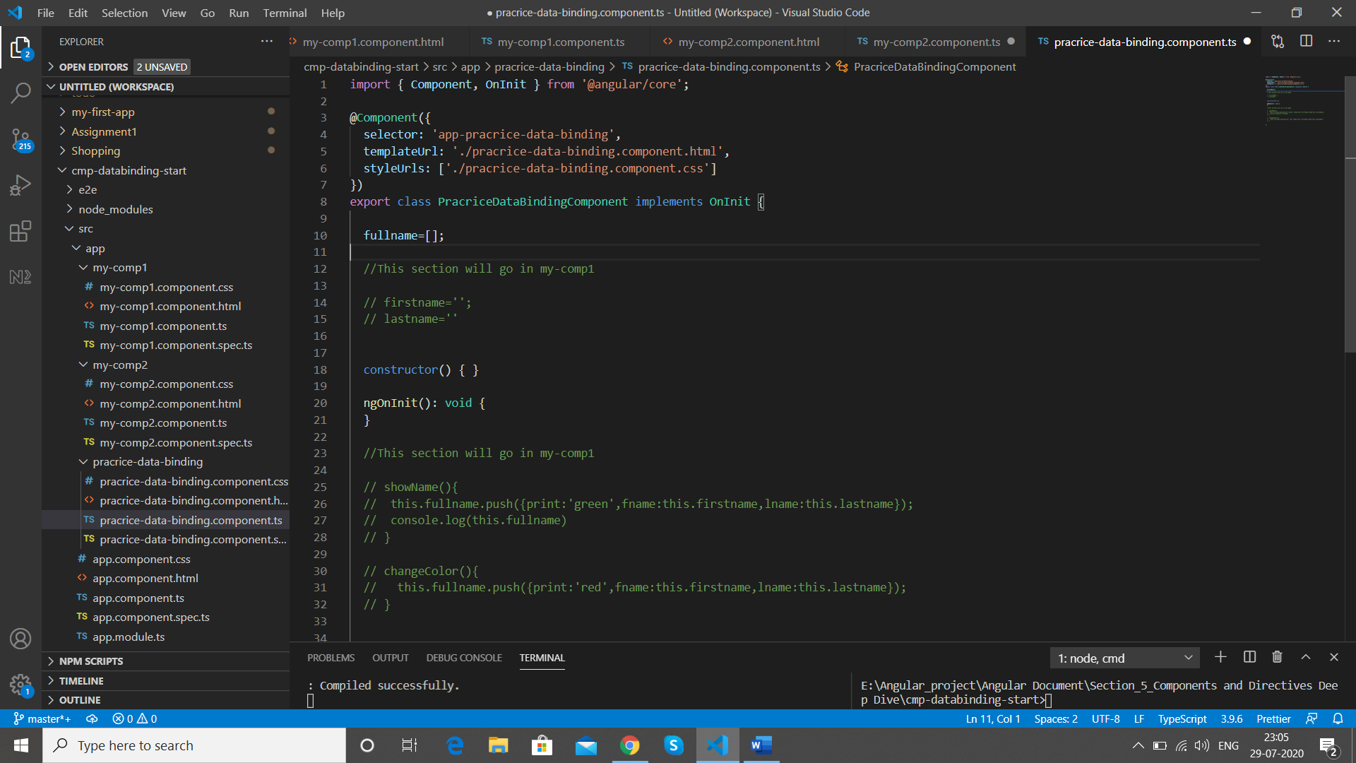

We provide the value in json( key/value) form as we have the same form in fulname

Now wehave our fullname array

 fullname=[{print:'green',fname:'Ikhlas',lname:'Kazi'}];

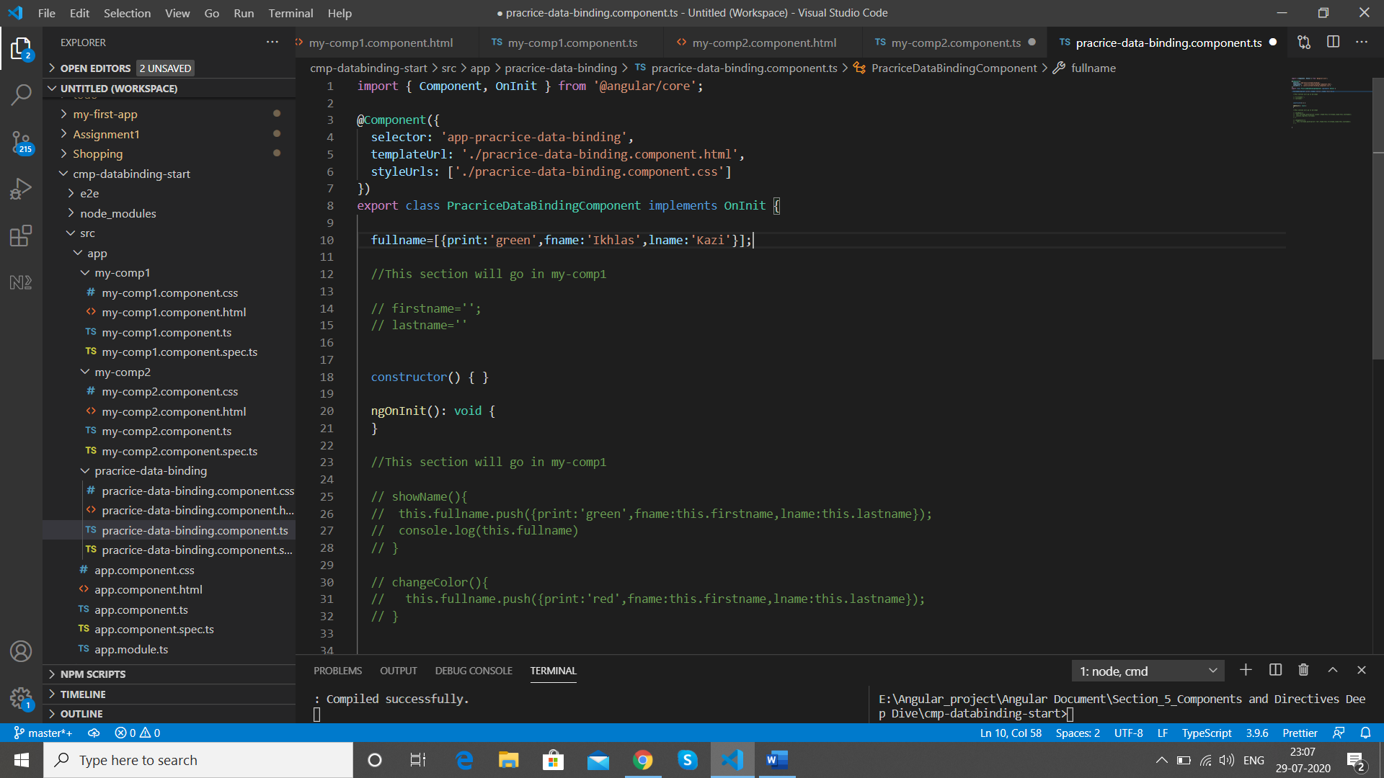

We are looping it on app-my-comp2

<app-my-comp2 *ngFor="let fname of fullname"></app-my-comp2>

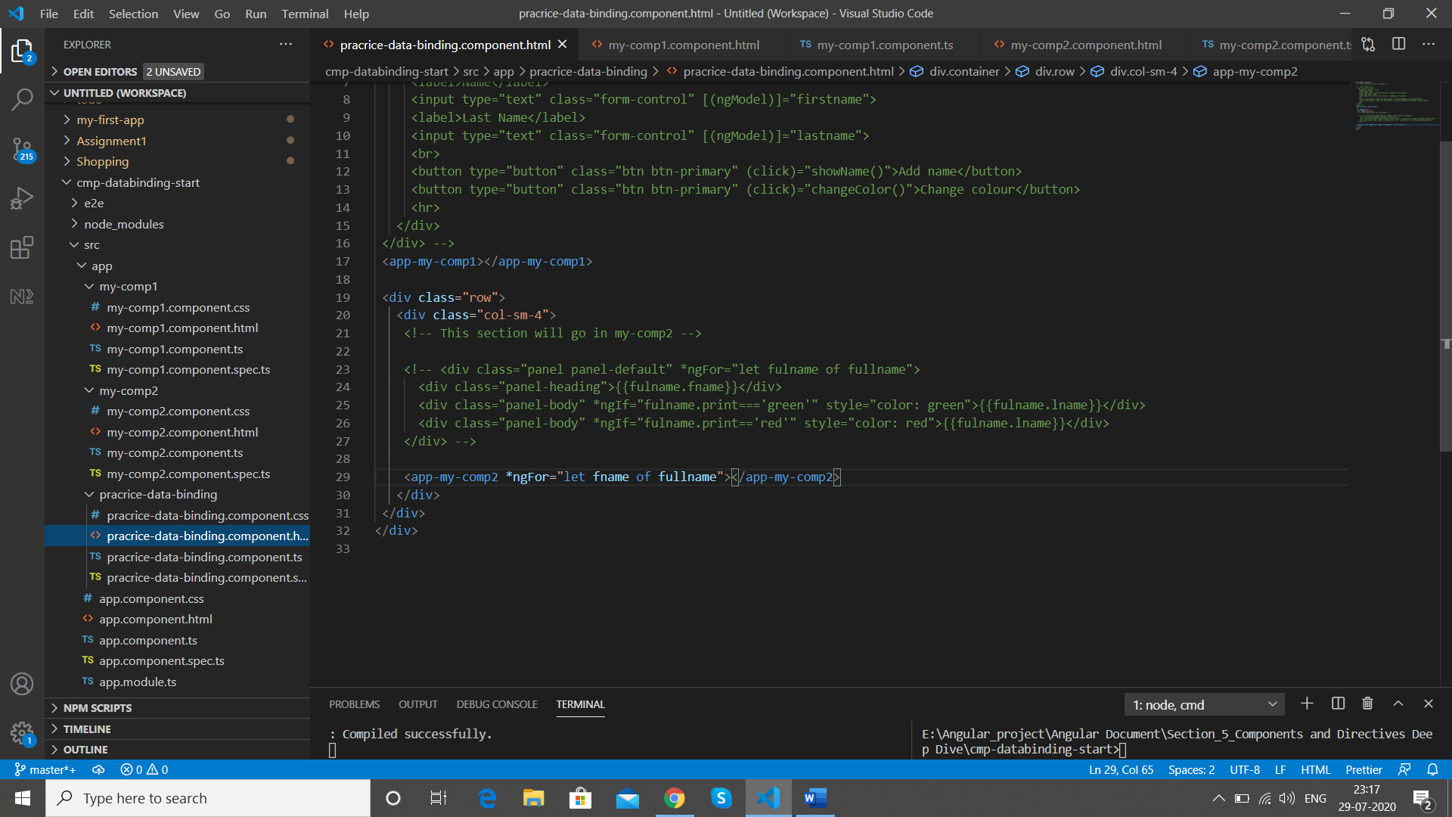

And in app-my-comp2 we

fulname:{print:string,fname:string,lname:string};

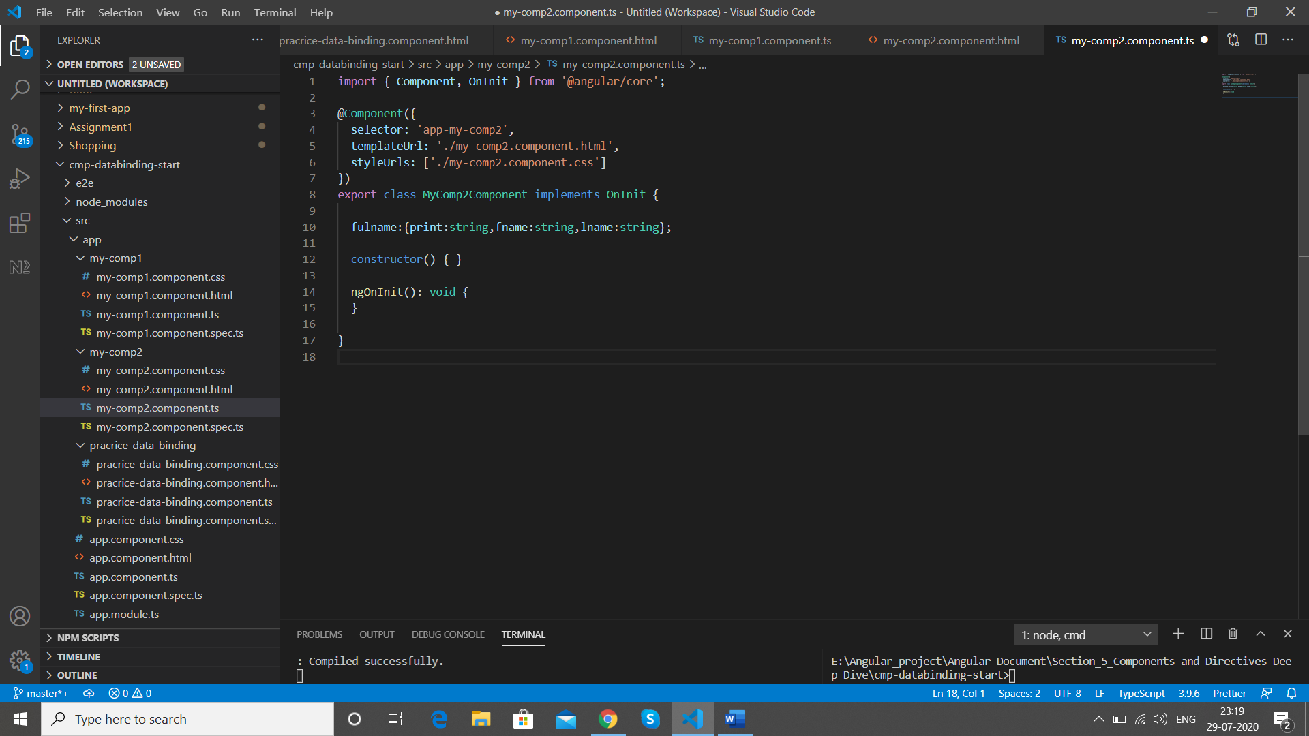

Now we bind the property **[fulname]** in practice-data-binding coponent

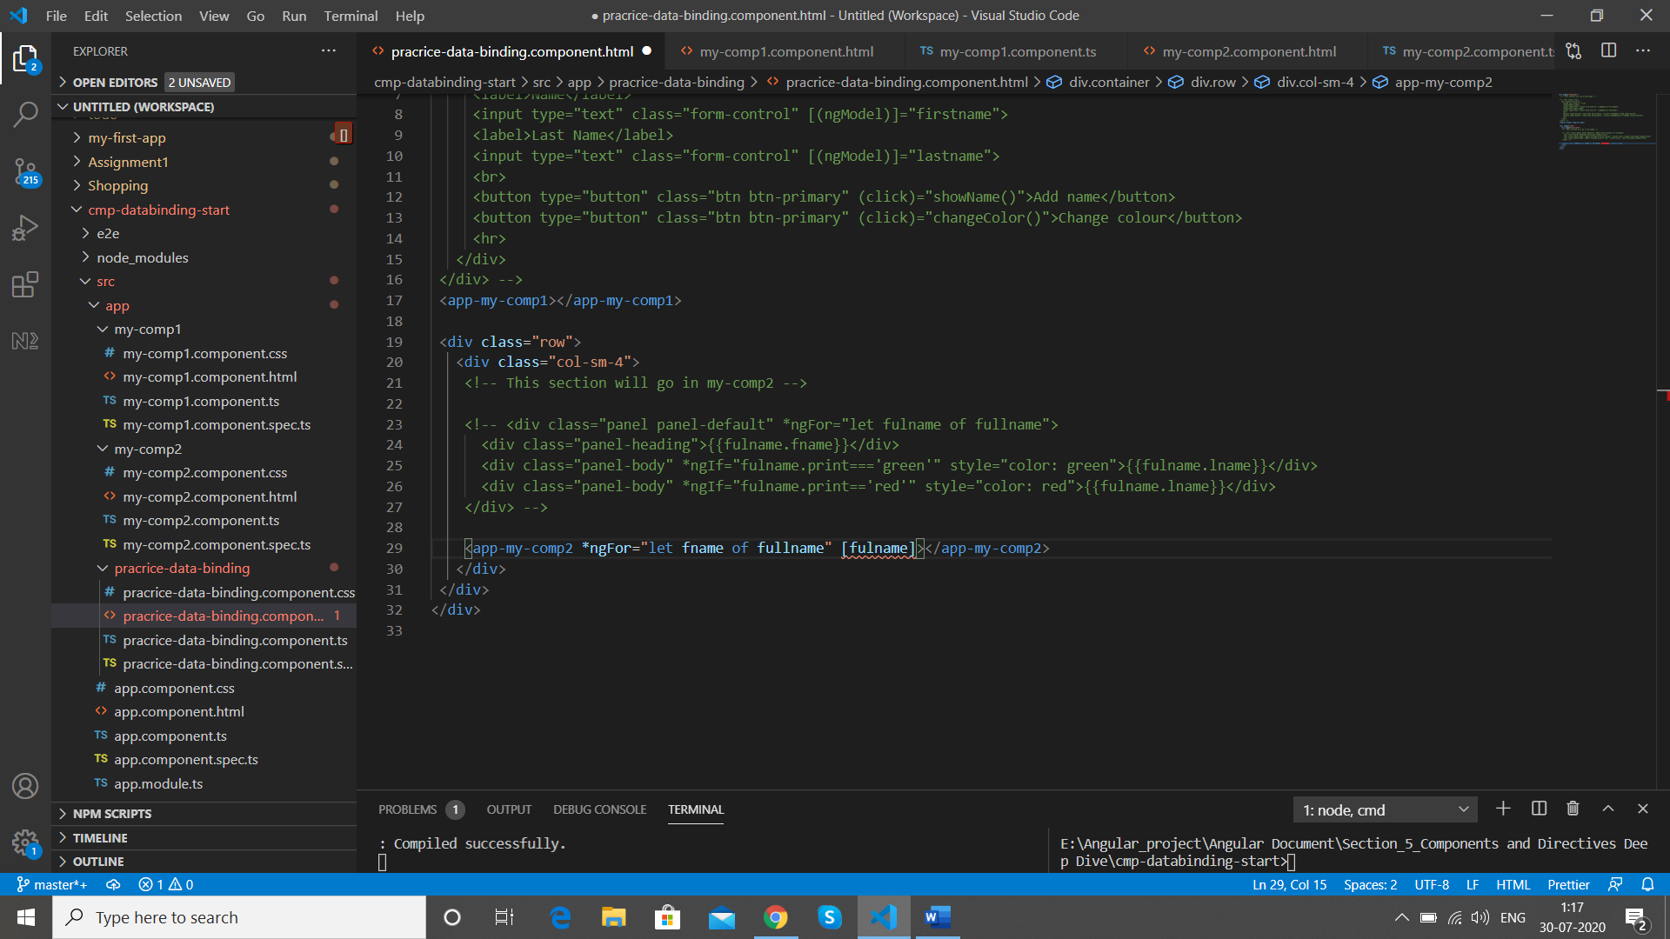

We bind the property with the variable we have to loop ie **fname**

<app-my-comp2 *ngFor="let fname of fullname" [fulname]="fname">

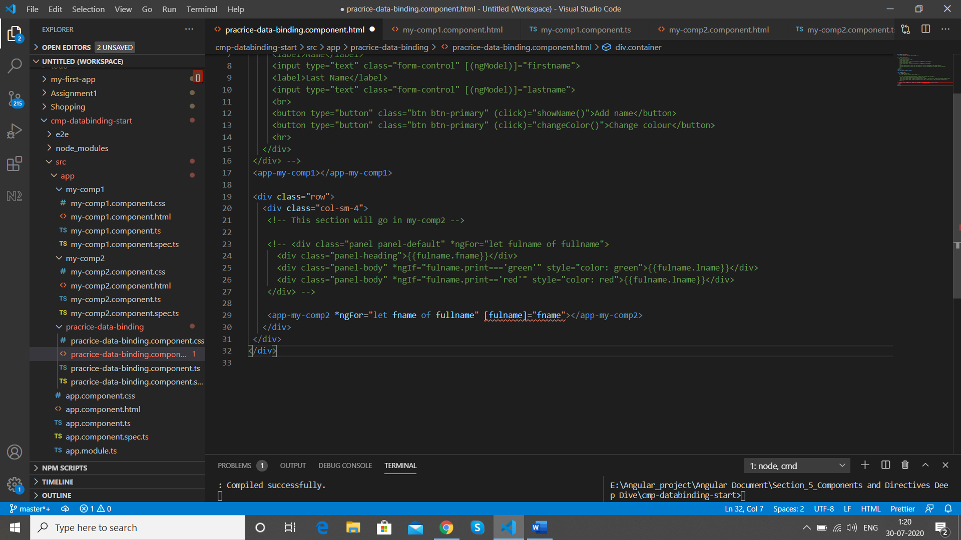

We get below error

core.js:4127 ERROR TypeError: Cannot read property 'fname' of undefined

at MyComp2Component_Template (template.html:5)

Now we want to bind the parent component with our property for that we use decorator @Input

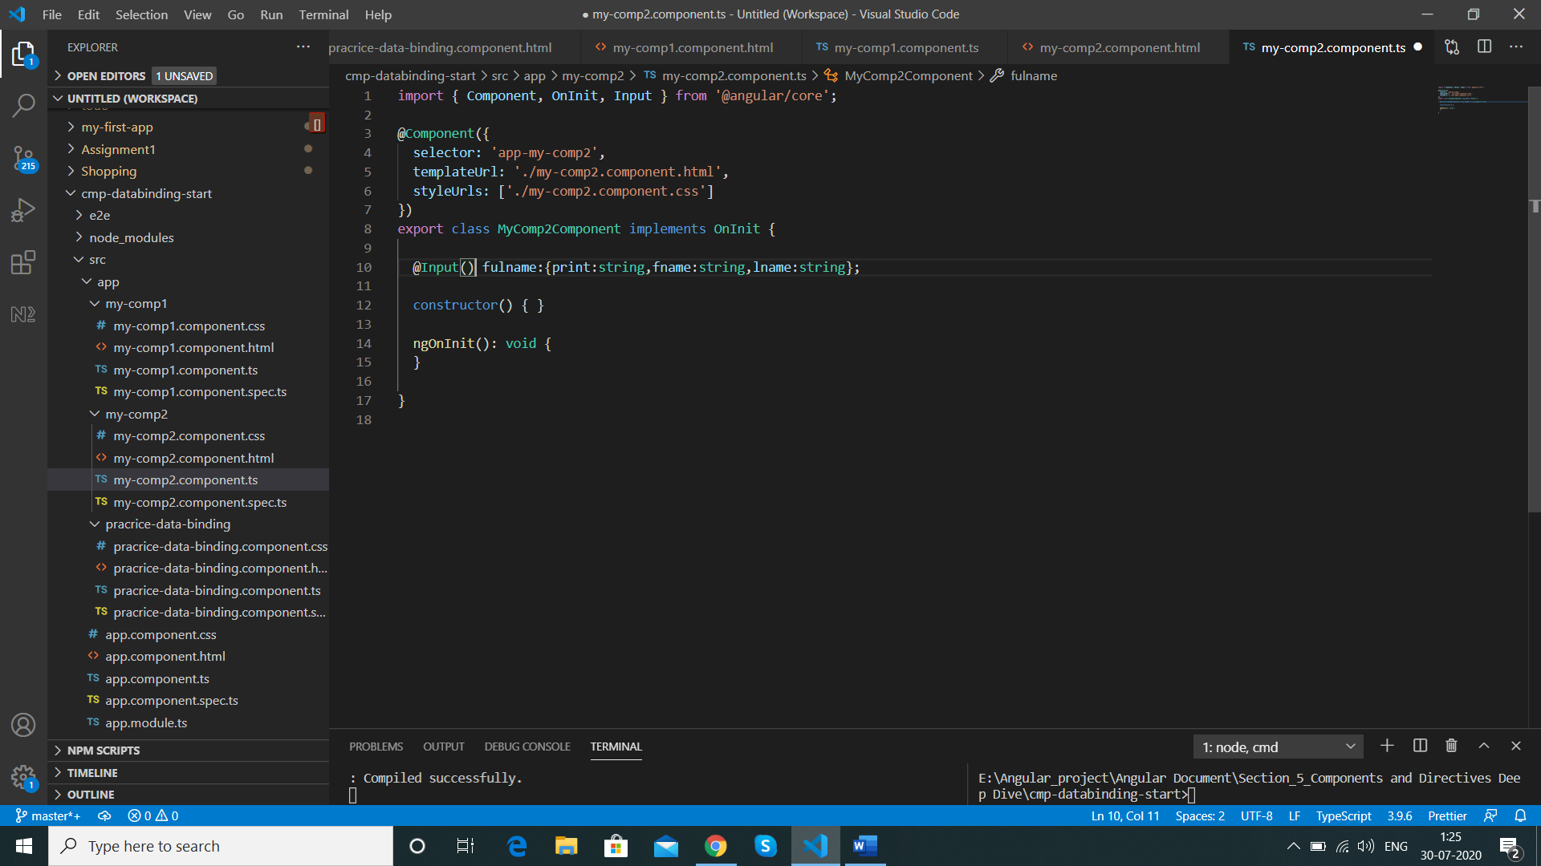

import { Component, OnInit, Input } from '@angular/core';

  @Input() fulname:{print:string,fname:string,lname:string};

Result

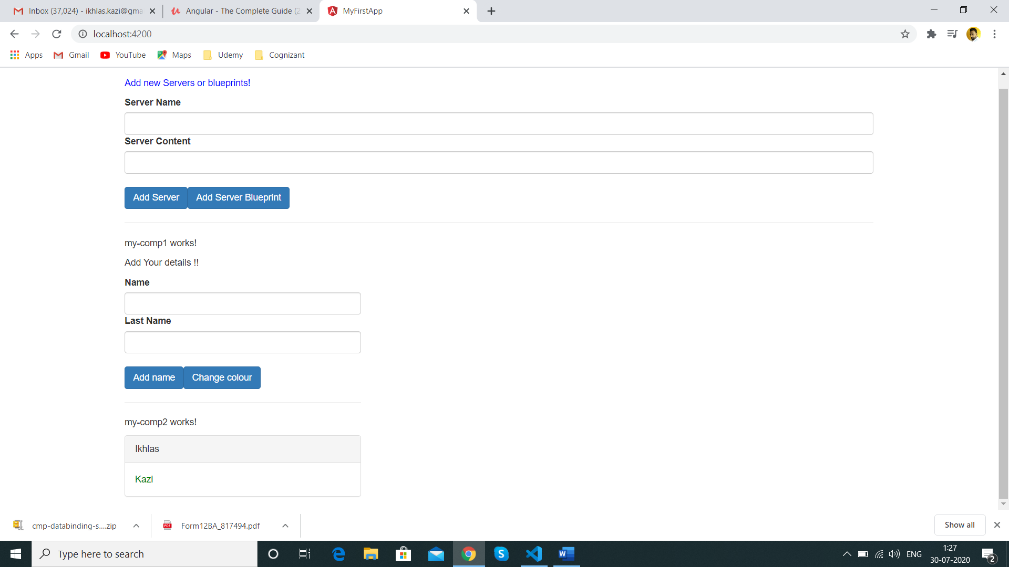

If we don’t want to use the same property name which is inside the component outside the component we can use alias as well in @Input(**‘ myFullName’**)

  @Input('myFullName') fulname:{print:string,fname:string,lname:string};

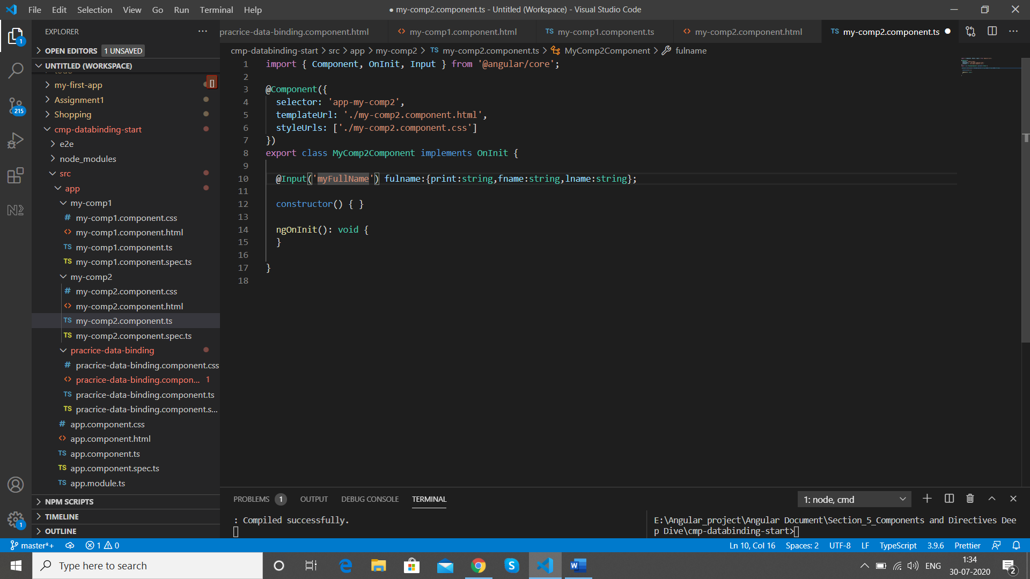

Replace below

<app-my-comp2 *ngFor="let fname of fullname" [fulname]="fname"></app-my-comp2>

With

app-my-comp2 *ngFor="let fname of fullname" [myFullName]="fname"></app-my-comp2>

Now the name fulname will no longer work instead use myFullName to access same element

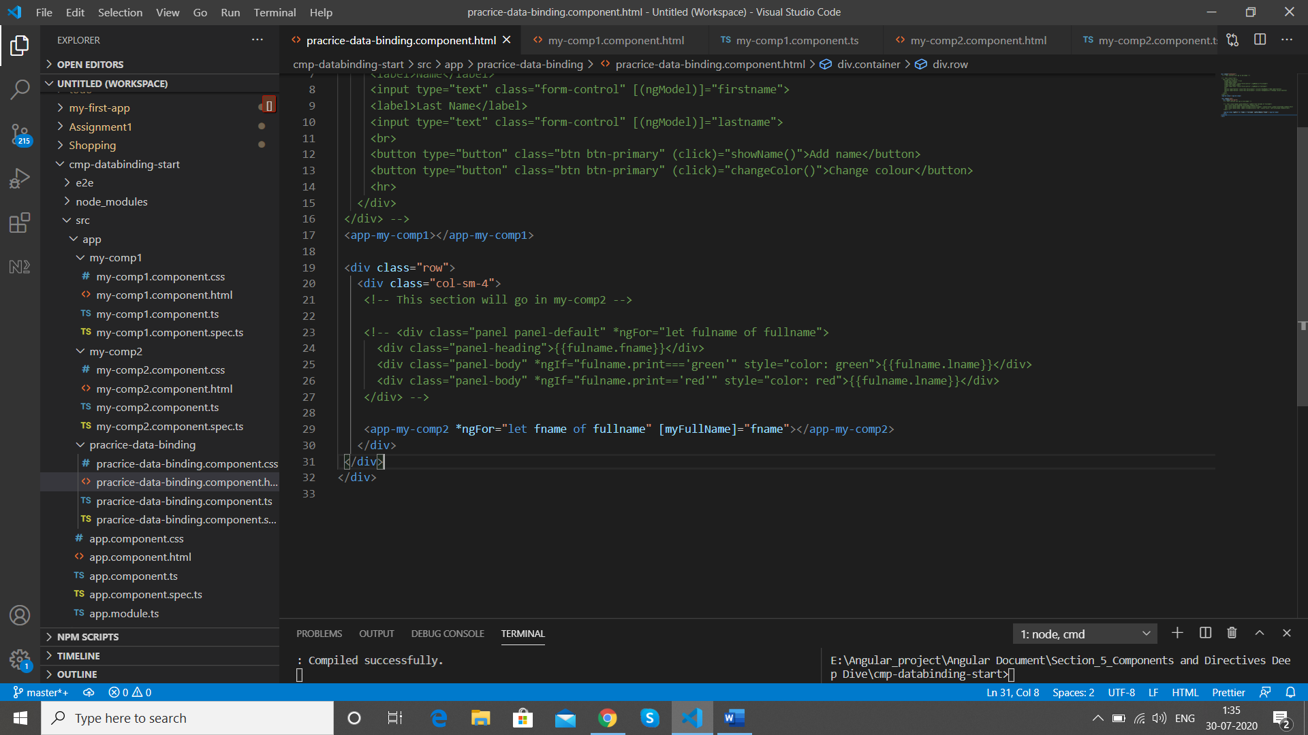

Result is same



Till here we were looking at how to pass data to the component ,Now we will look at what if we change anything in the child component how to send data to the parent component so that the changes are reflected

Once the button clicked then we should be able to see the values in the parent and child components

So in Below data-binding-component

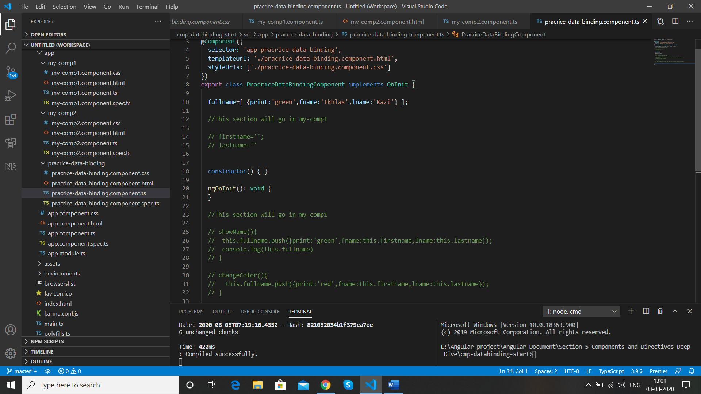

We change the names of the methods just to be more specific

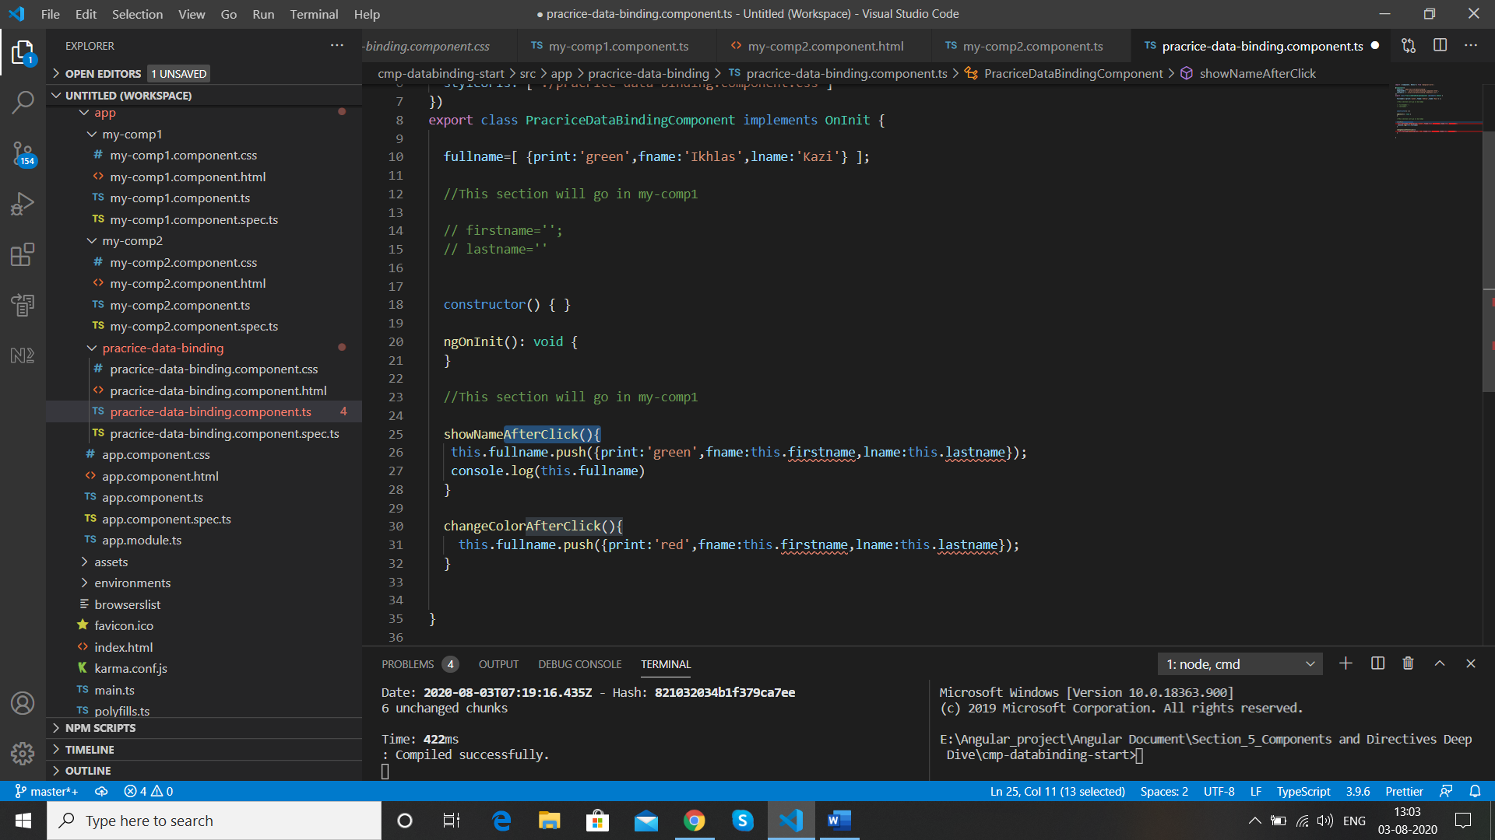

Now the firstname and lastname are not available in our component this is the information that we need from the my-comp1-component

So here we will need an Event (ur own event) to achieve it

In our Parent component ie practice-data-binding

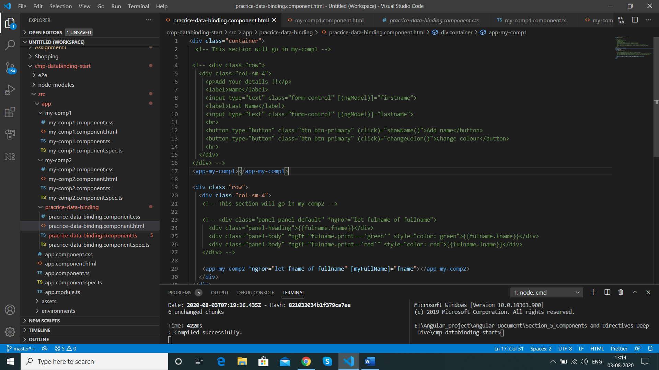

We create an event “ ( )” with any name we want ie the event we want to listen to this is just like click event but this is our event which does not exists ,once we define our event we call method on it just like click event

(nameCreated)="showNameAfterClick()"

We catch the event with the help of $event

 <app-my-comp1 (nameCreated)="showNameAfterClick($event)"></app-my-comp1>

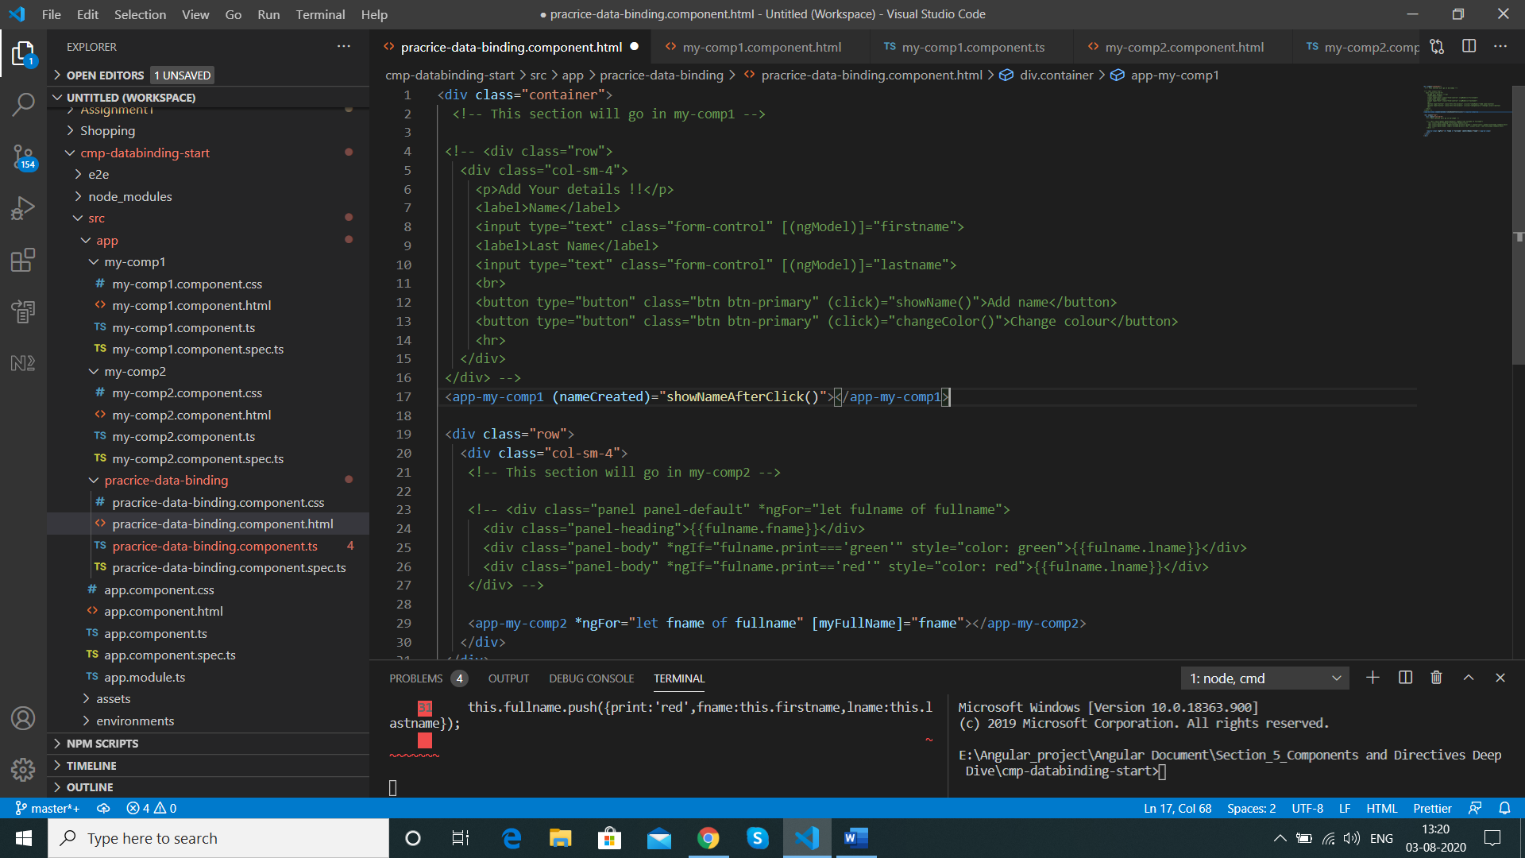

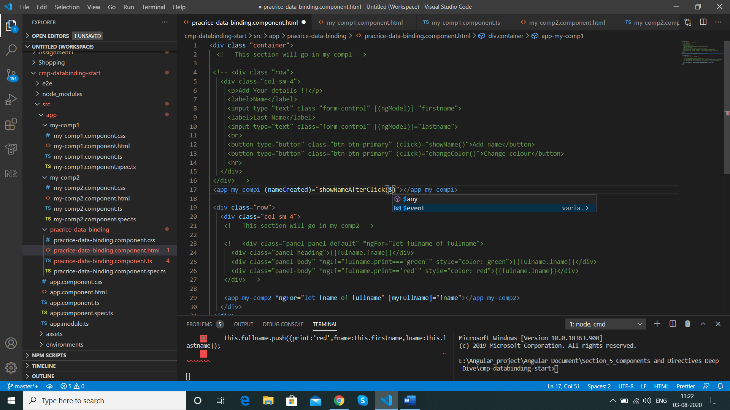

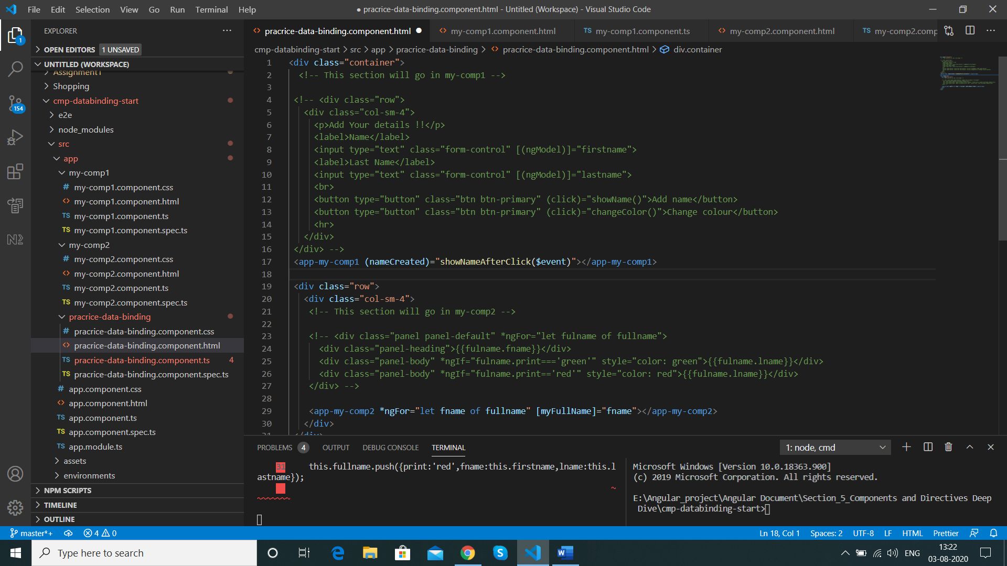

Now in our practice-data-binding-component.ts file we specify the event data

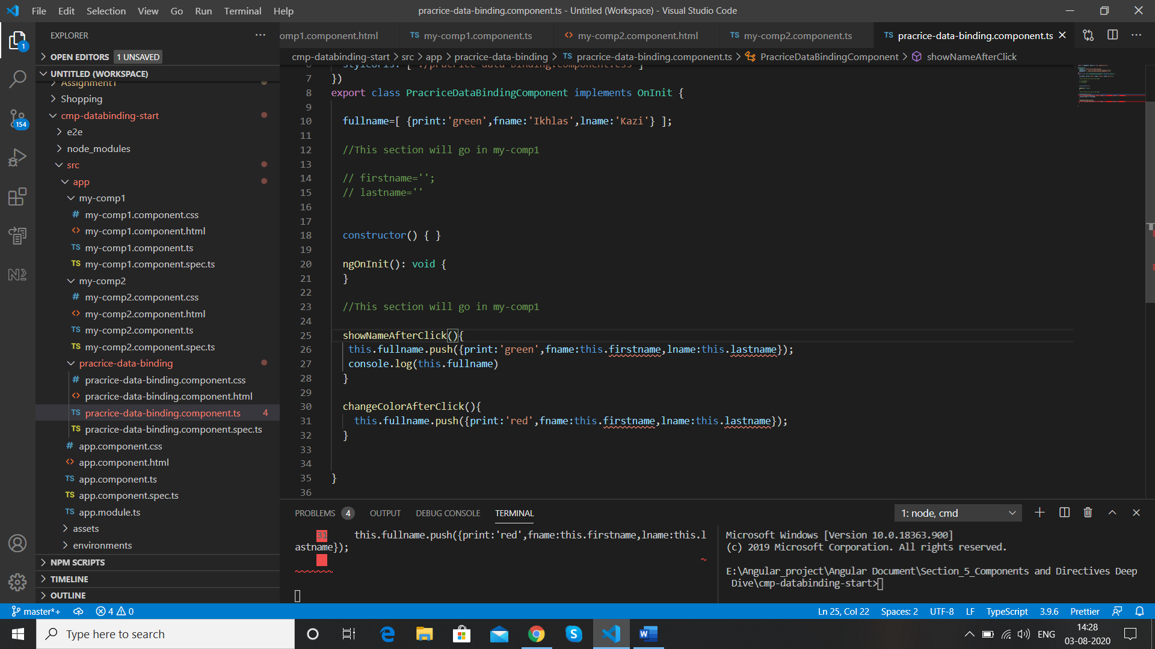

We add below event data to our method

nameData:{firstname:String ,lastname:String}

  showNameAfterClick(nameData:{firstname:String ,lastname:String}){

This is the type of object er expect to get in this method

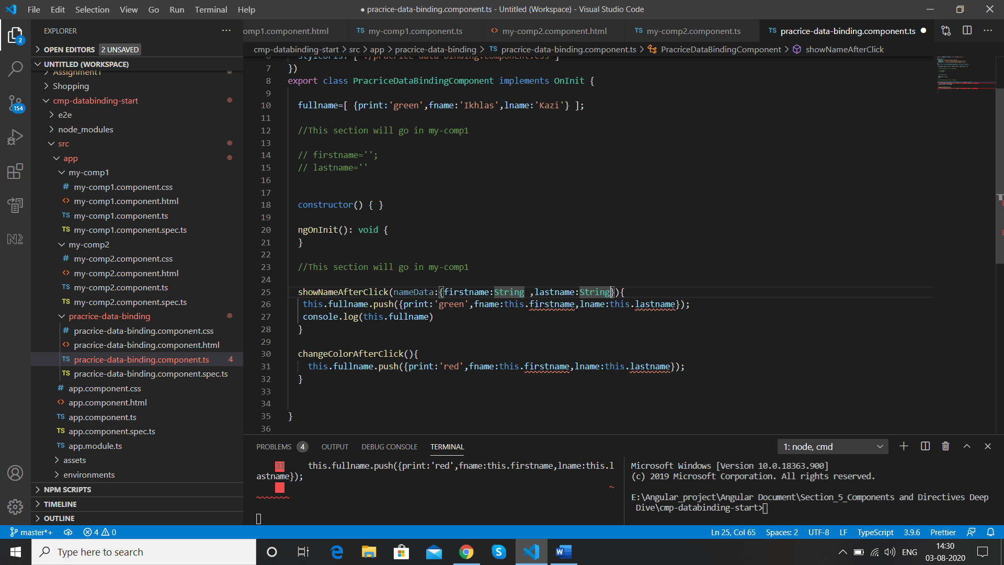

Now we change below method array to use the event data that we created

Before

 showNameAfterClick(nameData:{firstname:String ,lastname:String}){

   this.fullname.push({print:'green',fname:this.firstname,lname:this.lastname});

   console.log(this.fullname)

  }

After

  showNameAfterClick(nameData:{firstname:string ,lastname:string}){

   this.fullname.push({print:'green',fname:nameData.firstname,lname:nameData.lastname});

   console.log(this.fullname)

  }

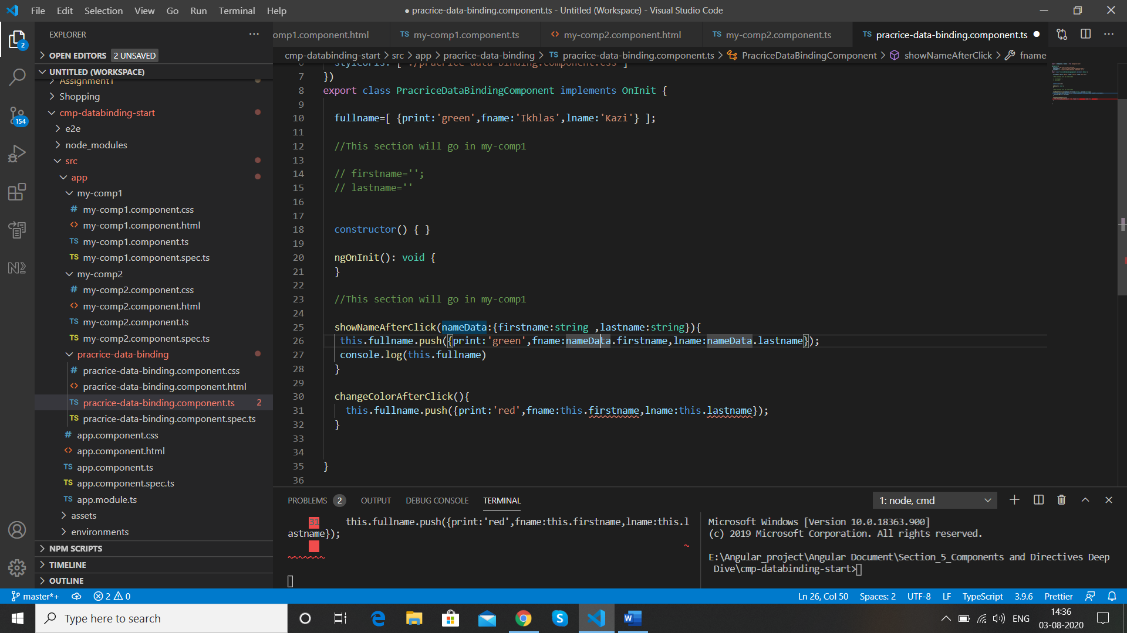

Now we do the same with our other method

(nameColorChange)="changeColorAfterClick($event)"

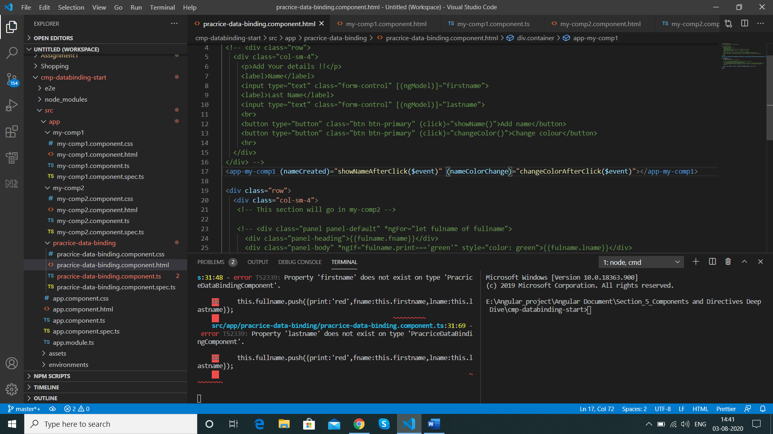

  changeColorAfterClick(colorData:{firstname:string,lastname:string}){

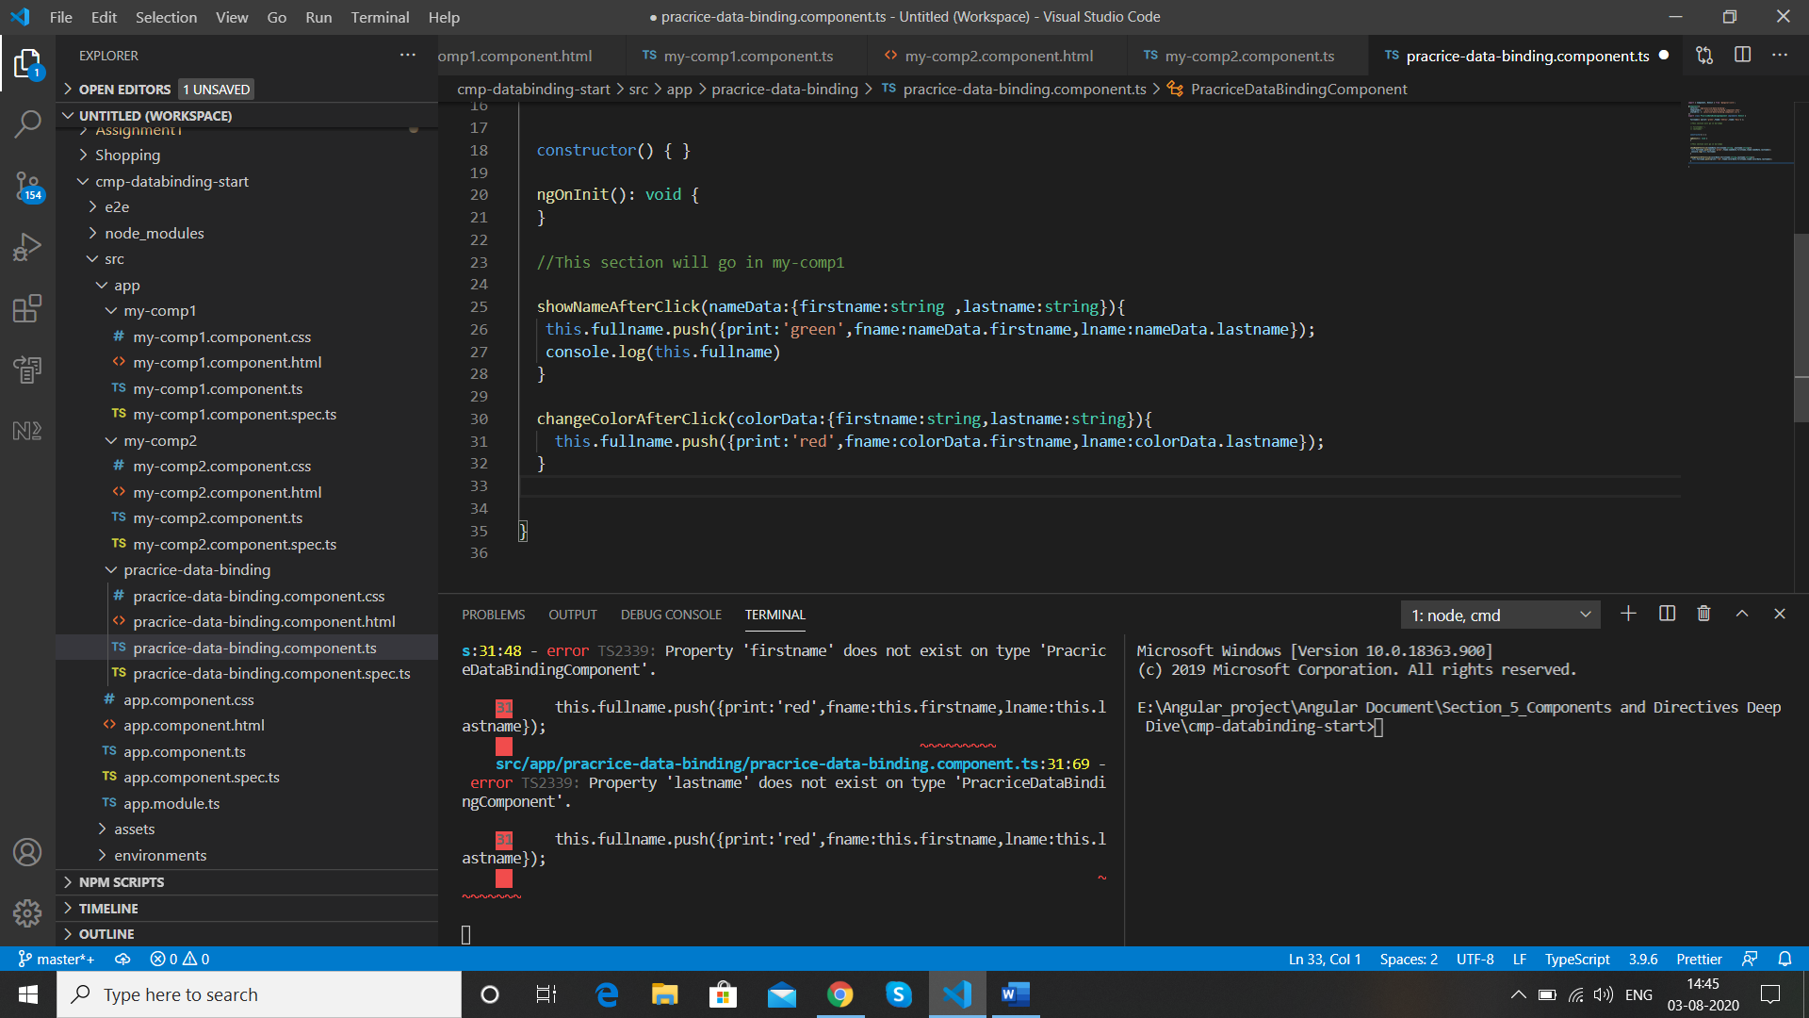

Now we need to map our created events in the my-comp1 component , we will create 2 properties whith the event name

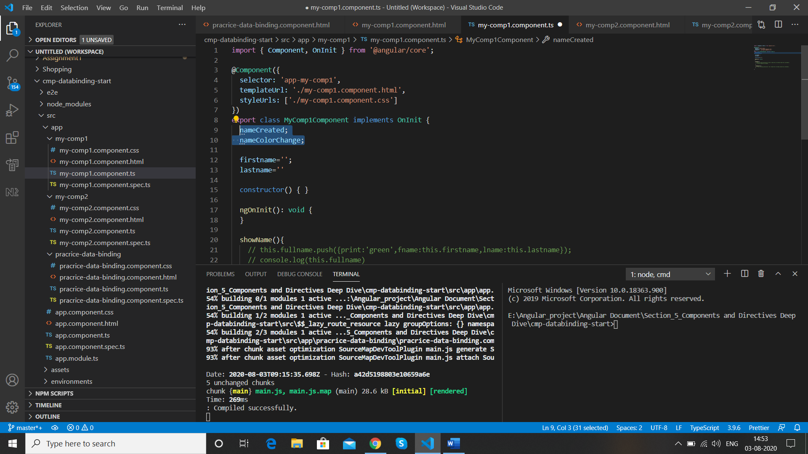

Now before we mark @Input so that these are properties we can set from outside ,these properties are kind of events that we can emit so to make them event we need EventEmitter from @angular/core

import { Component, OnInit, EventEmitter } from '@angular/core';

export class MyComp1Component implements OnInit {

  nameCreated= new EventEmitter

  nameColorChange;

EventEmitter is of Generic type so we use <> and in between we provide the type of data we emit

{firstname:string ,lastname:string}

  nameCreated= new EventEmitter<{firstname:string ,lastname:string}>;

At the end call the constructor “()”

 nameCreated= new EventEmitter<{firstname:string ,lastname:string}>();

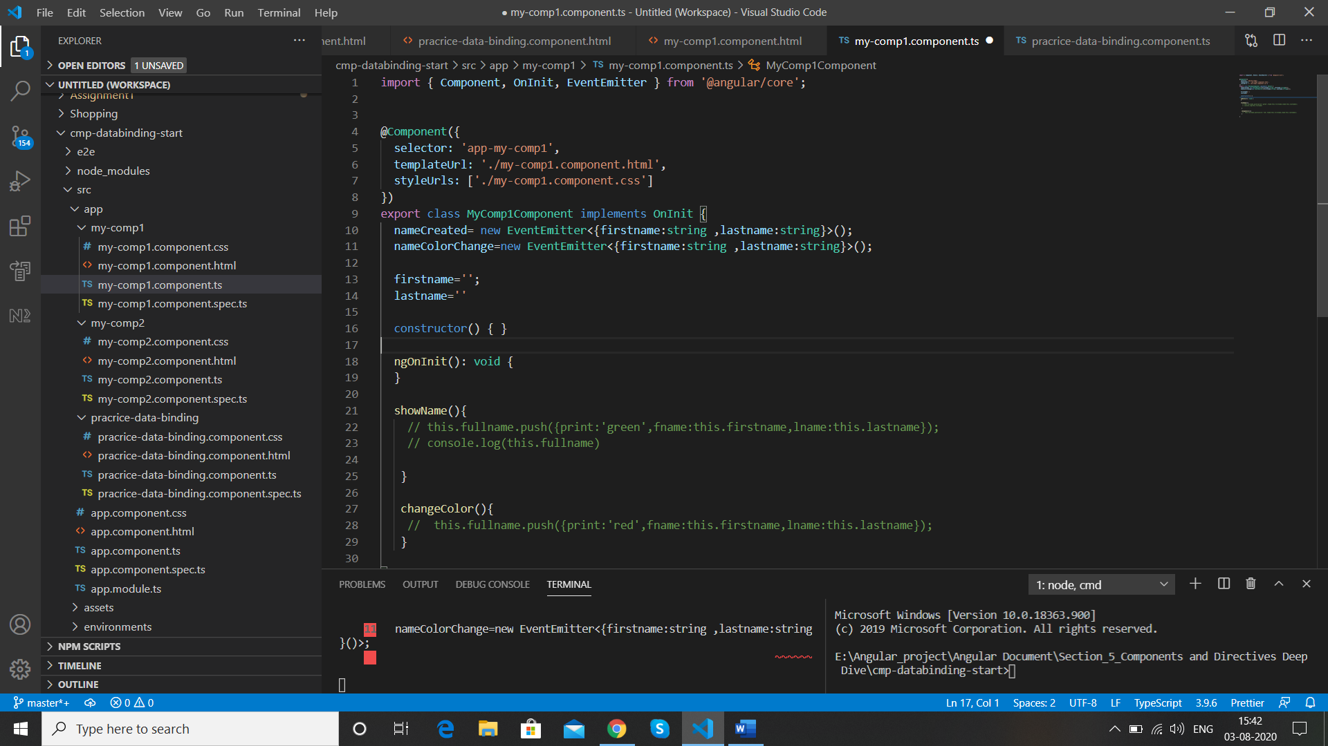

This creates a new object of EventEmitter which is now stored in “ nameCreated” , Do the same for nameColorChange

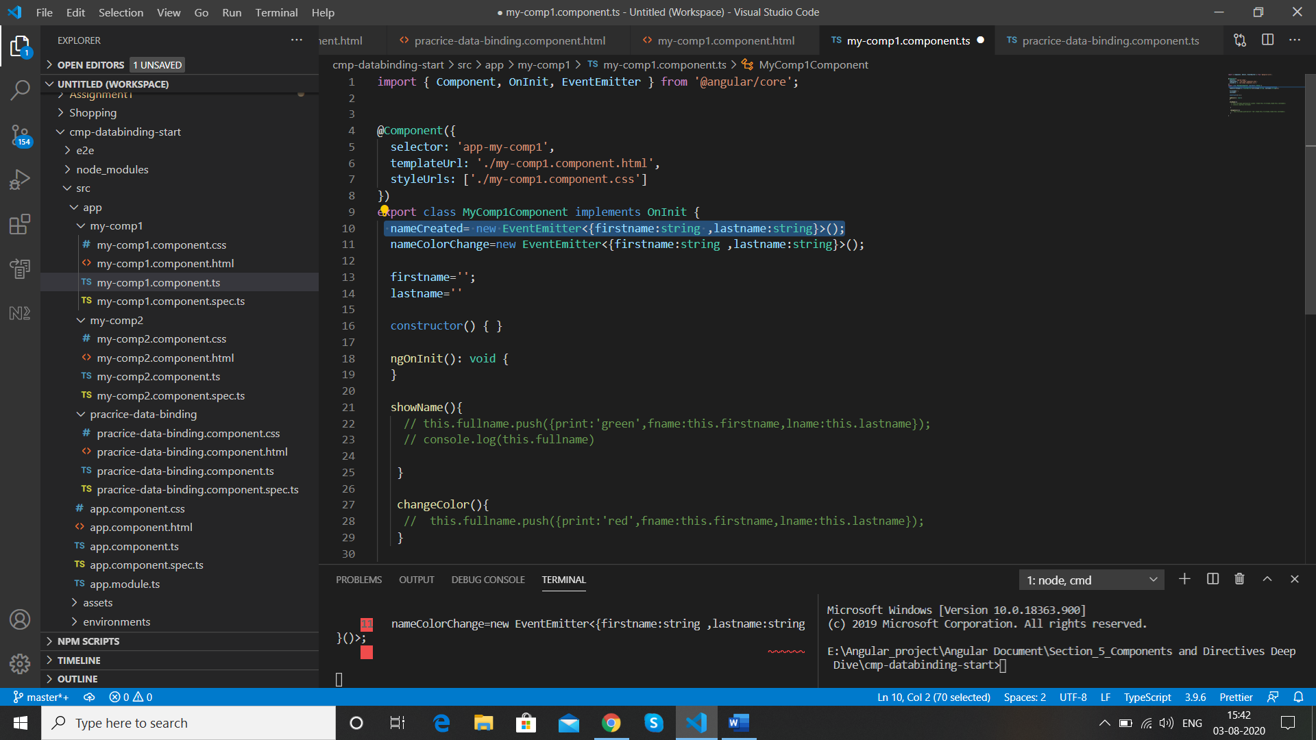

Now we use this event to emit

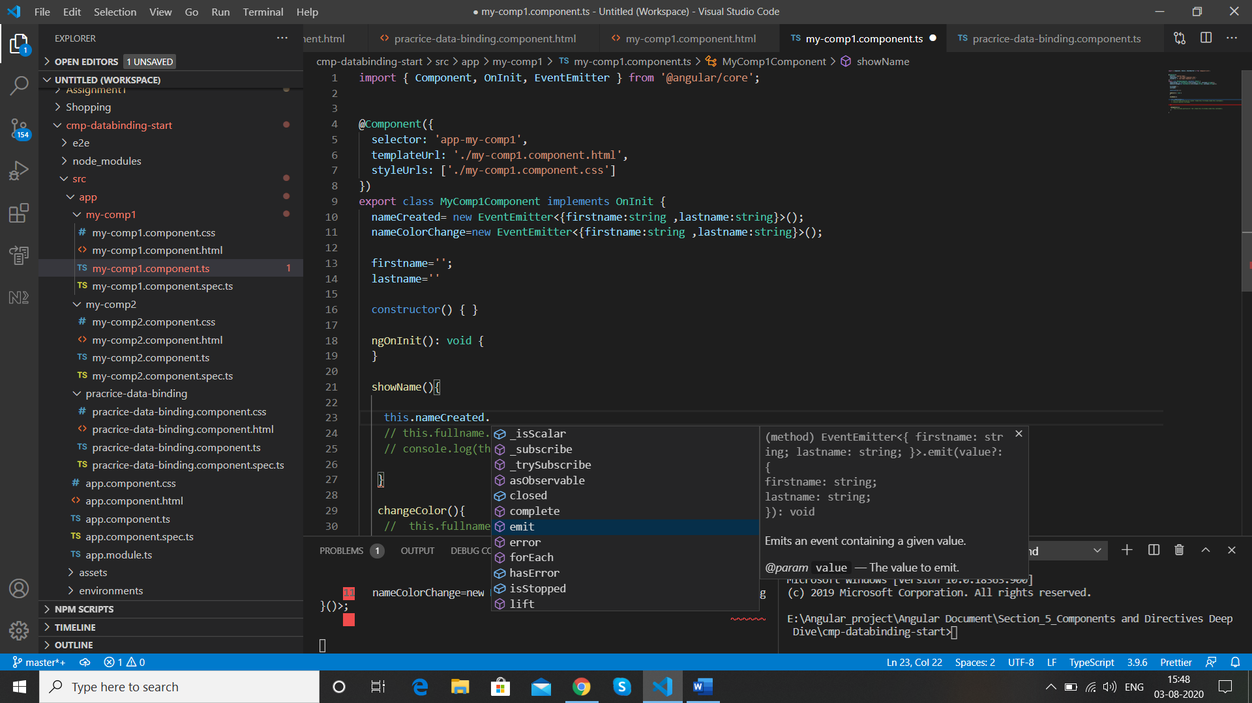

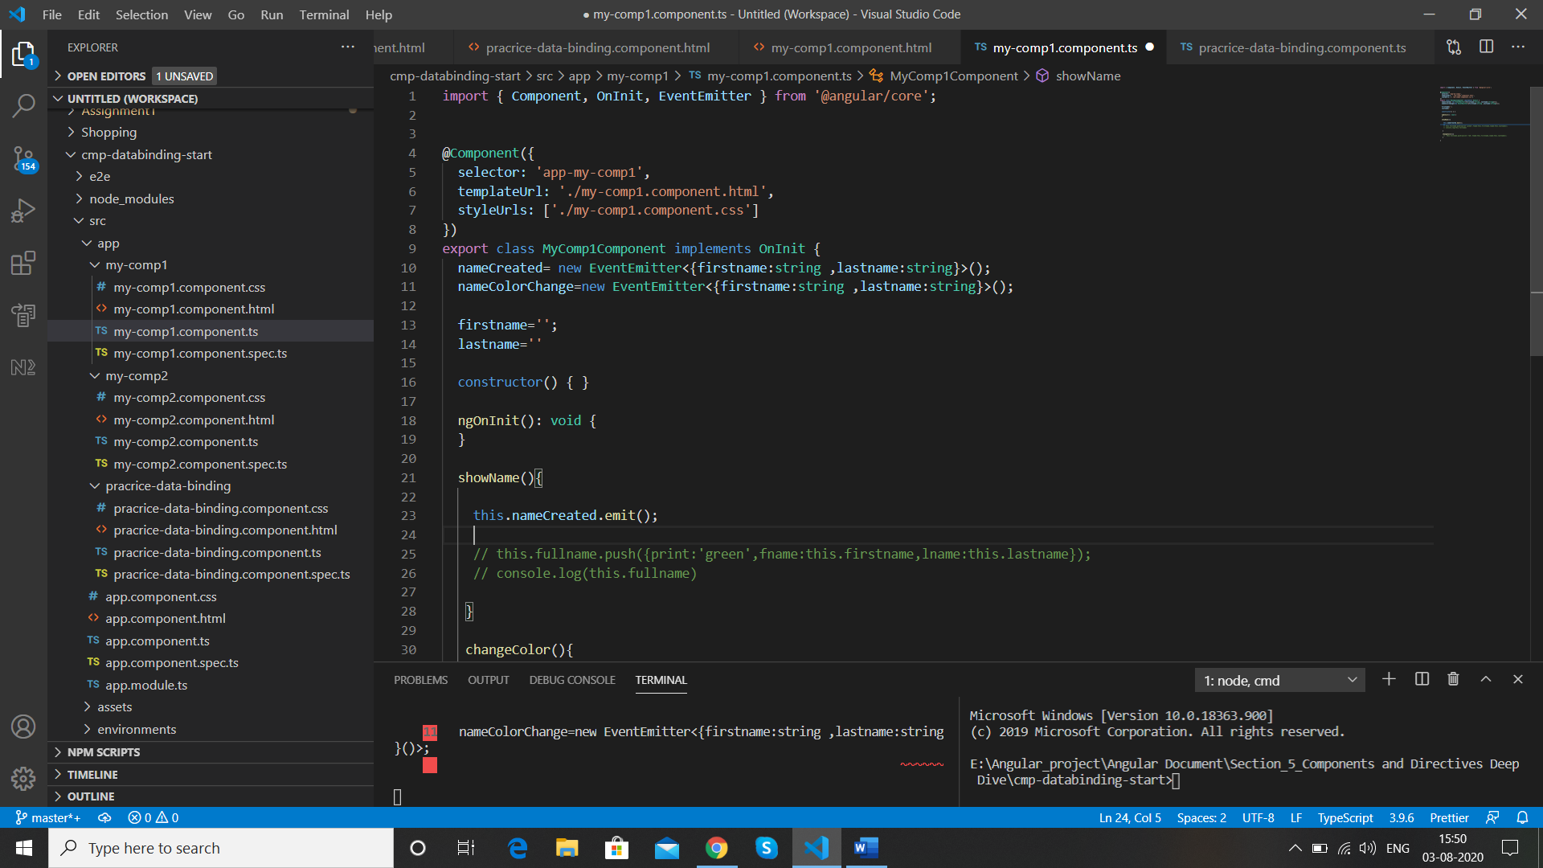

Now we pass the object and assign it to a variable as a value

 this.nameCreated.emit({firstname:this.firstname,lastname:this.lastname});

We do it for other as well

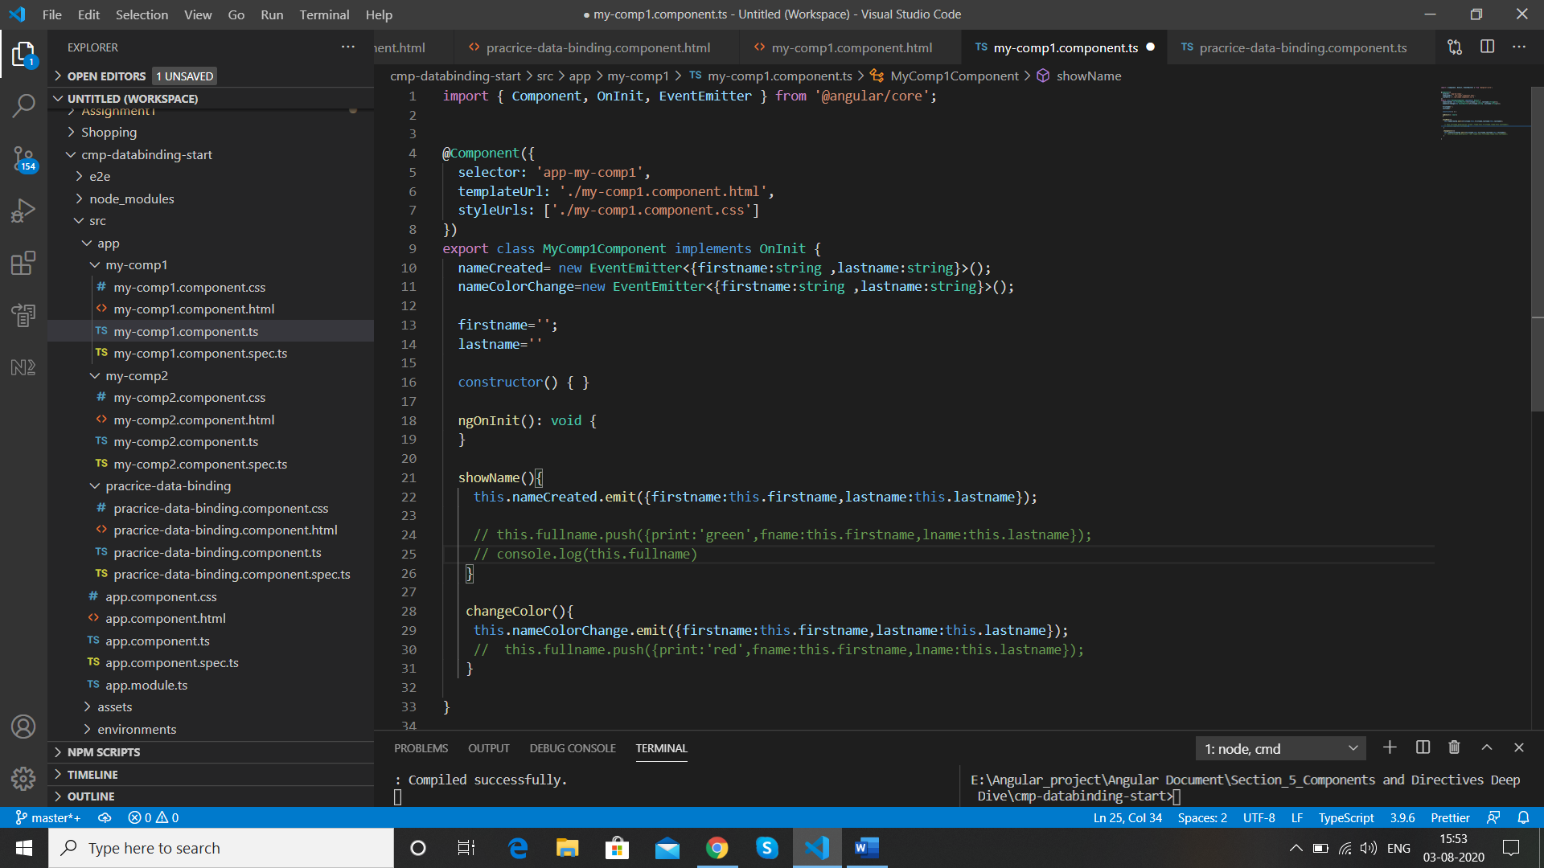

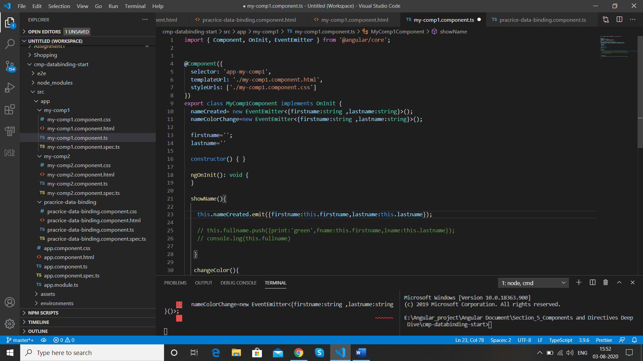

Now we use @Output() to send the event outside the component , @Output() is from @angular/core

Decorator that marks a class field as an output property and supplies configuration metadata. The DOM property bound to the output property is automatically updated during change detection.

import { Component, OnInit, EventEmitter, Output } from '@angular/core';

  @Output() nameCreated= new EventEmitter<{firstname:string ,lastname:string}>();

  @Output() nameColorChange=new EventEmitter<{firstname:string ,lastname:string}>();

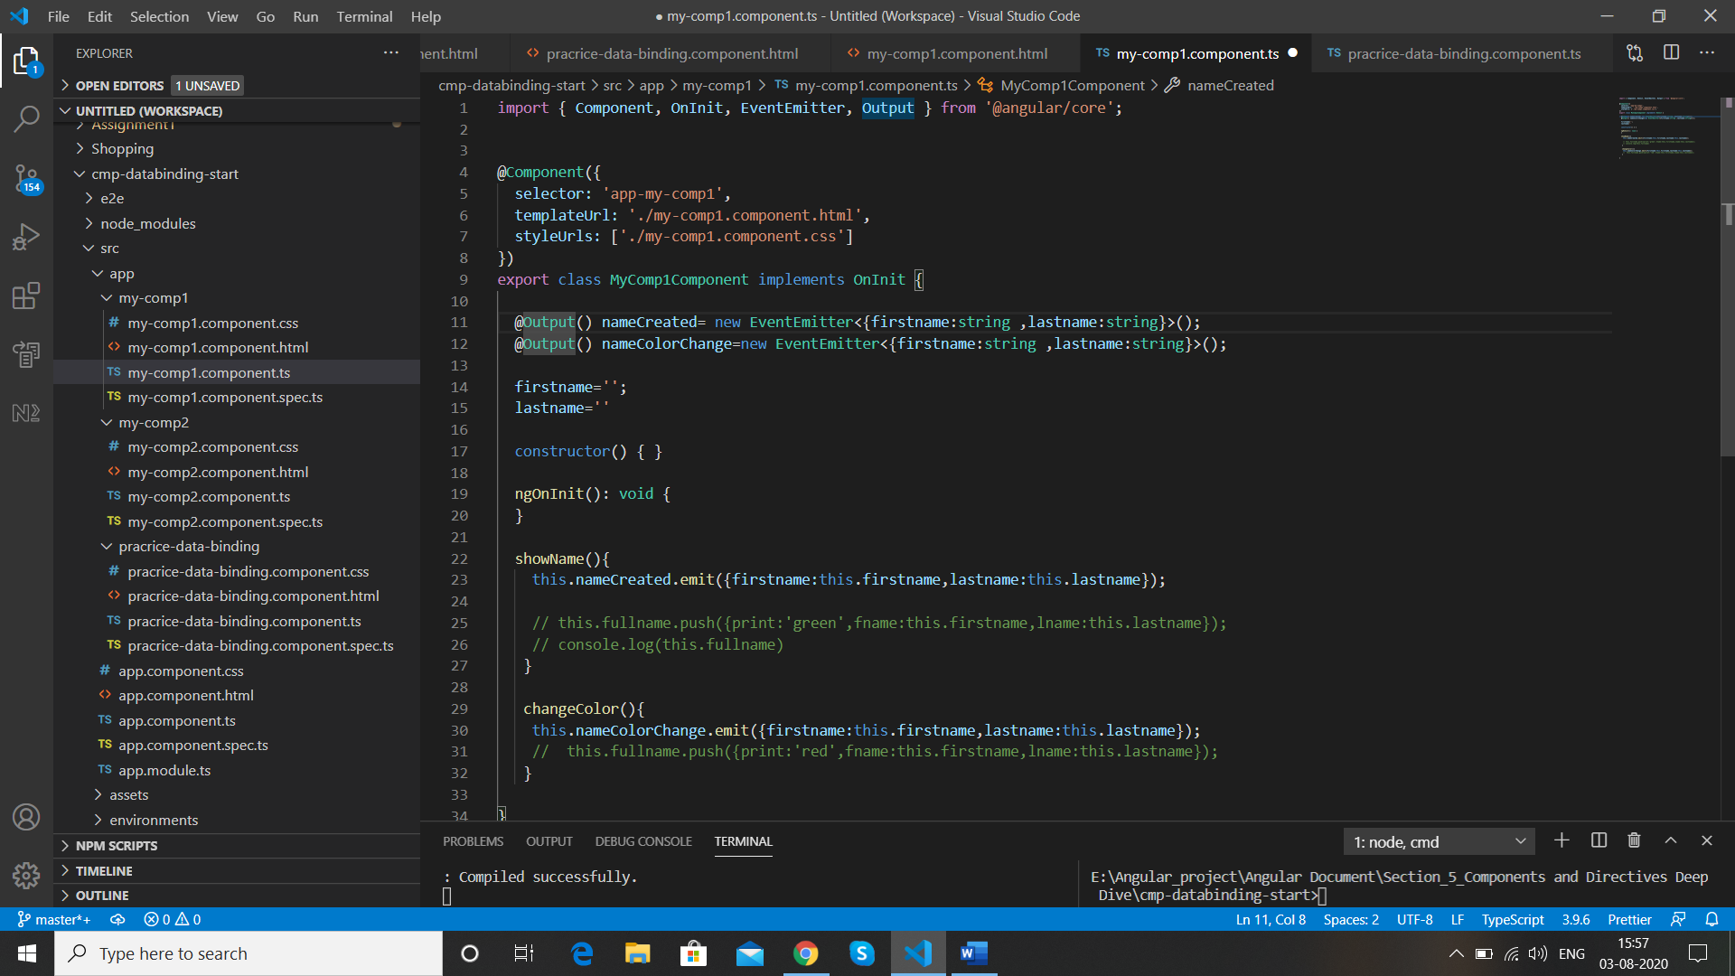

Result

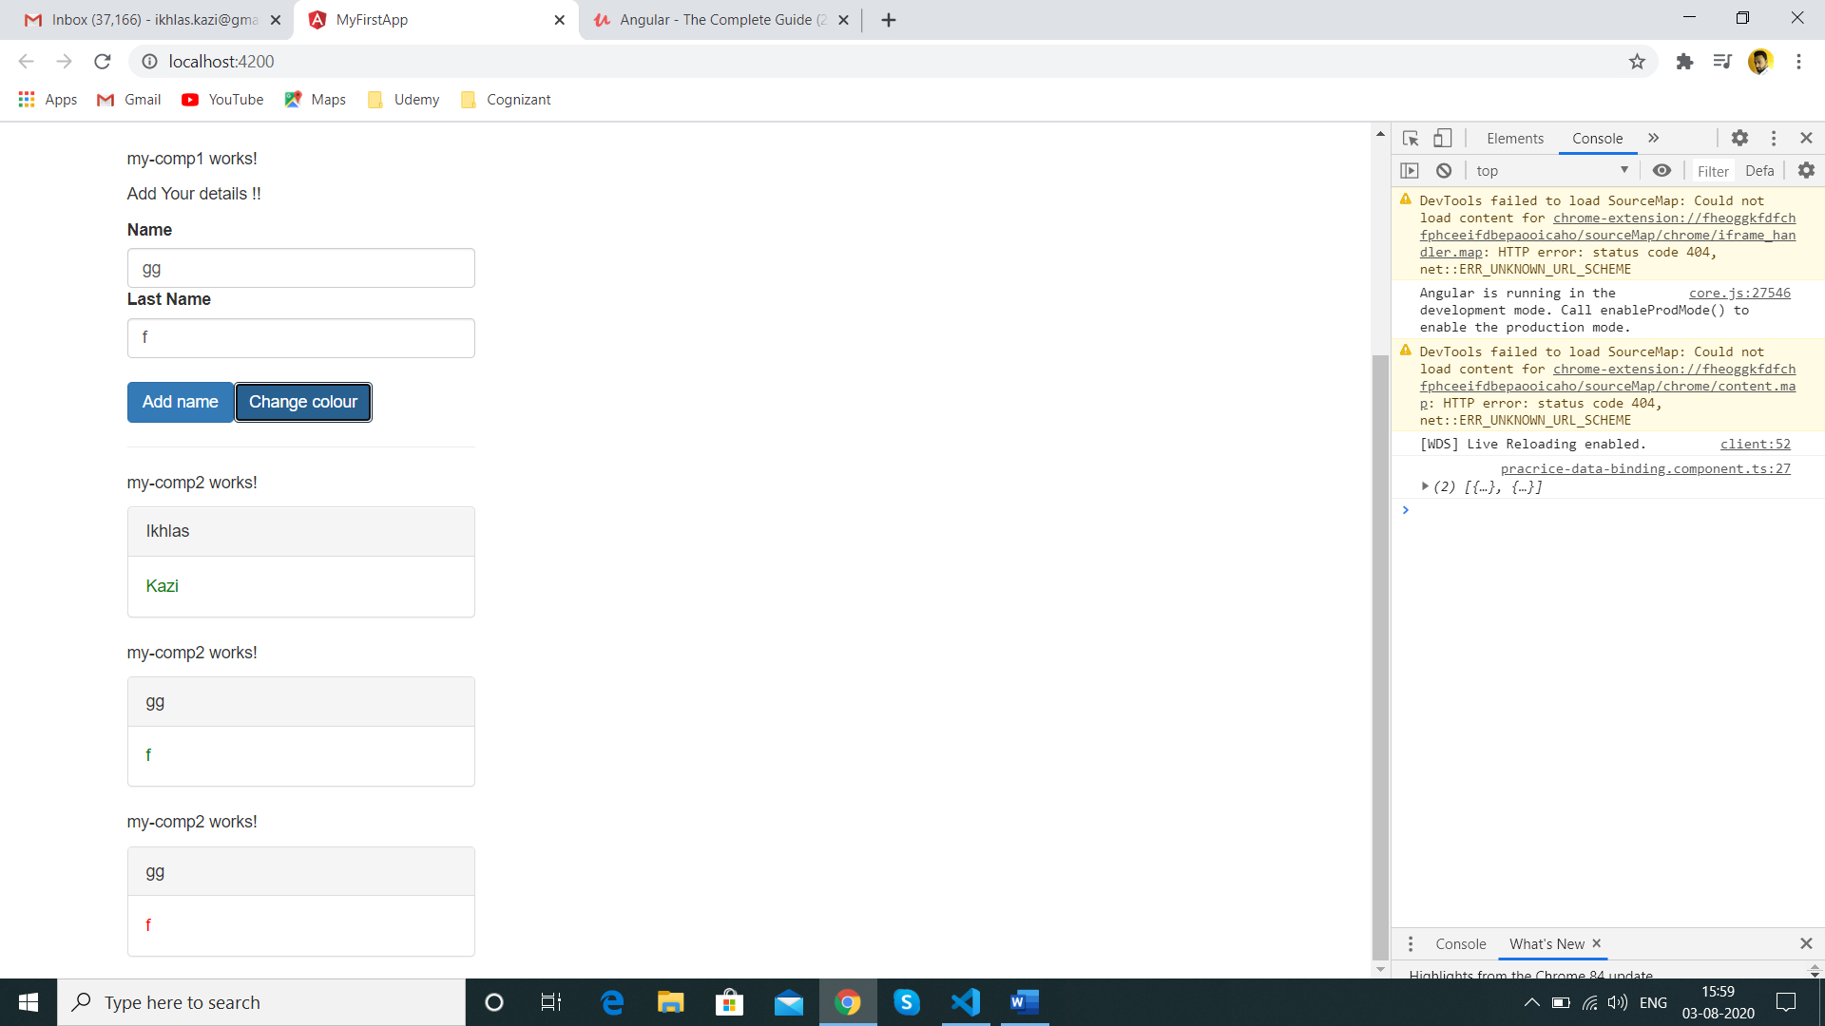

We can use Alias on @Output() the same way as we did for @Input()

@Output('nmCreated')

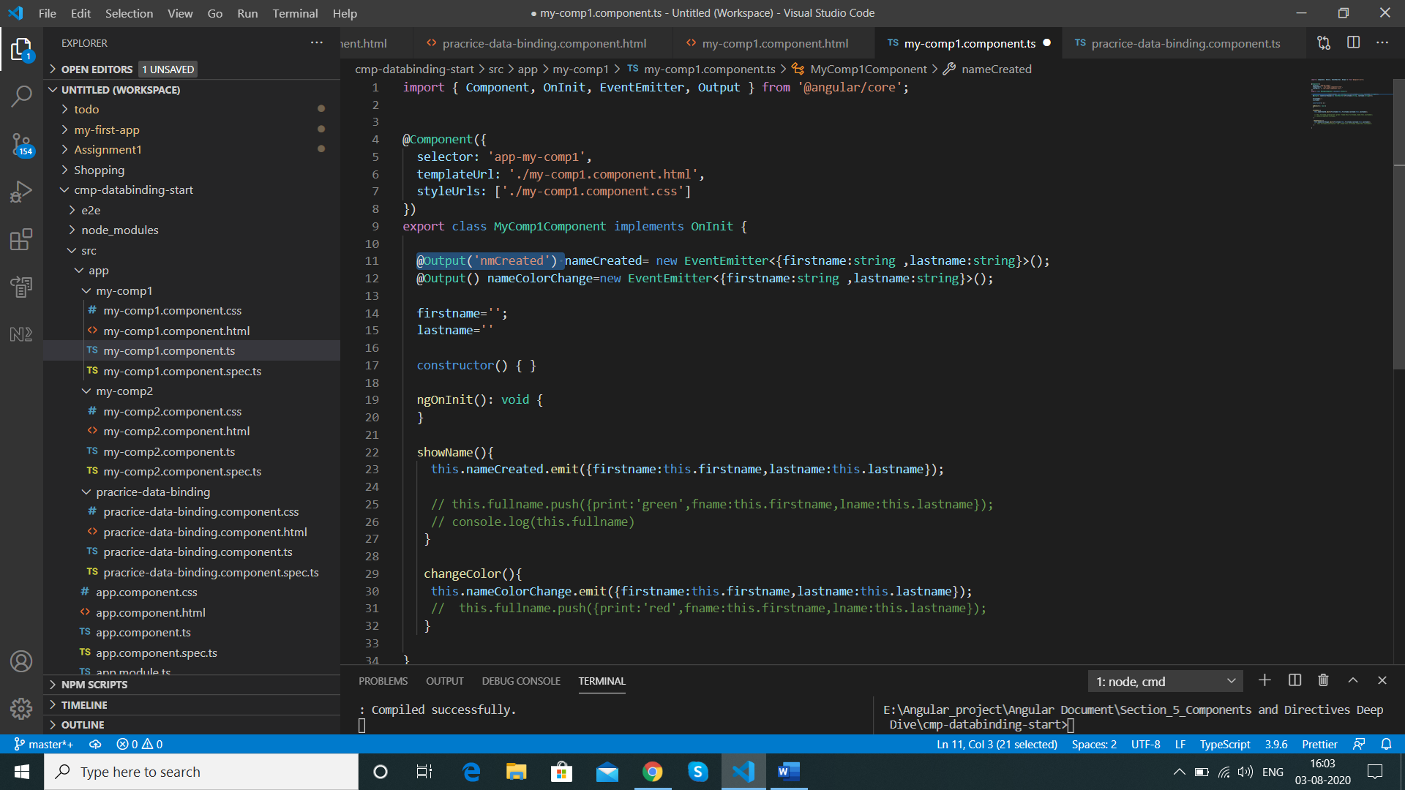

In parent component

  (nmCreated)="showNameAfterClick($event)"

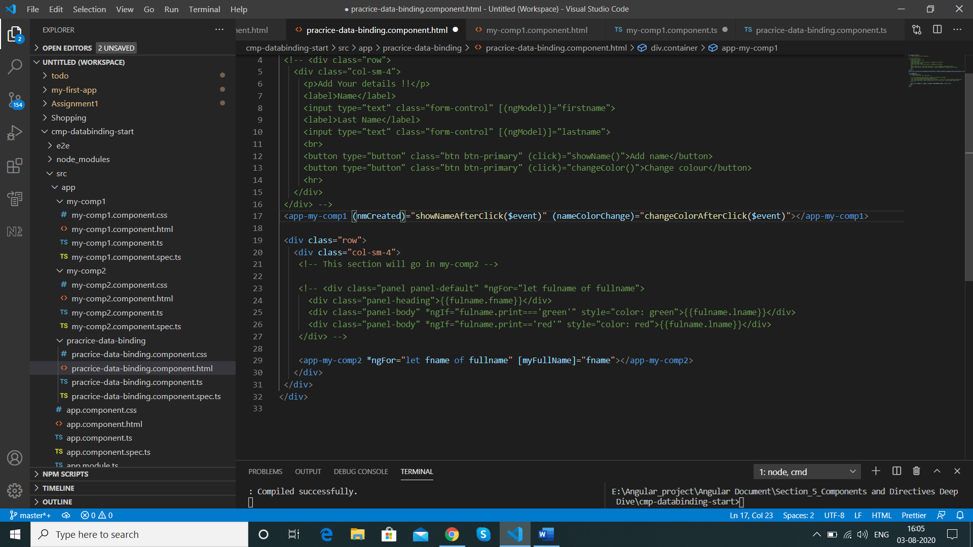

Result is same

Summary

1)@Input() allows the property to bind from outside so that parent component (practide-data-binding-component) can use this component (my-comp2)

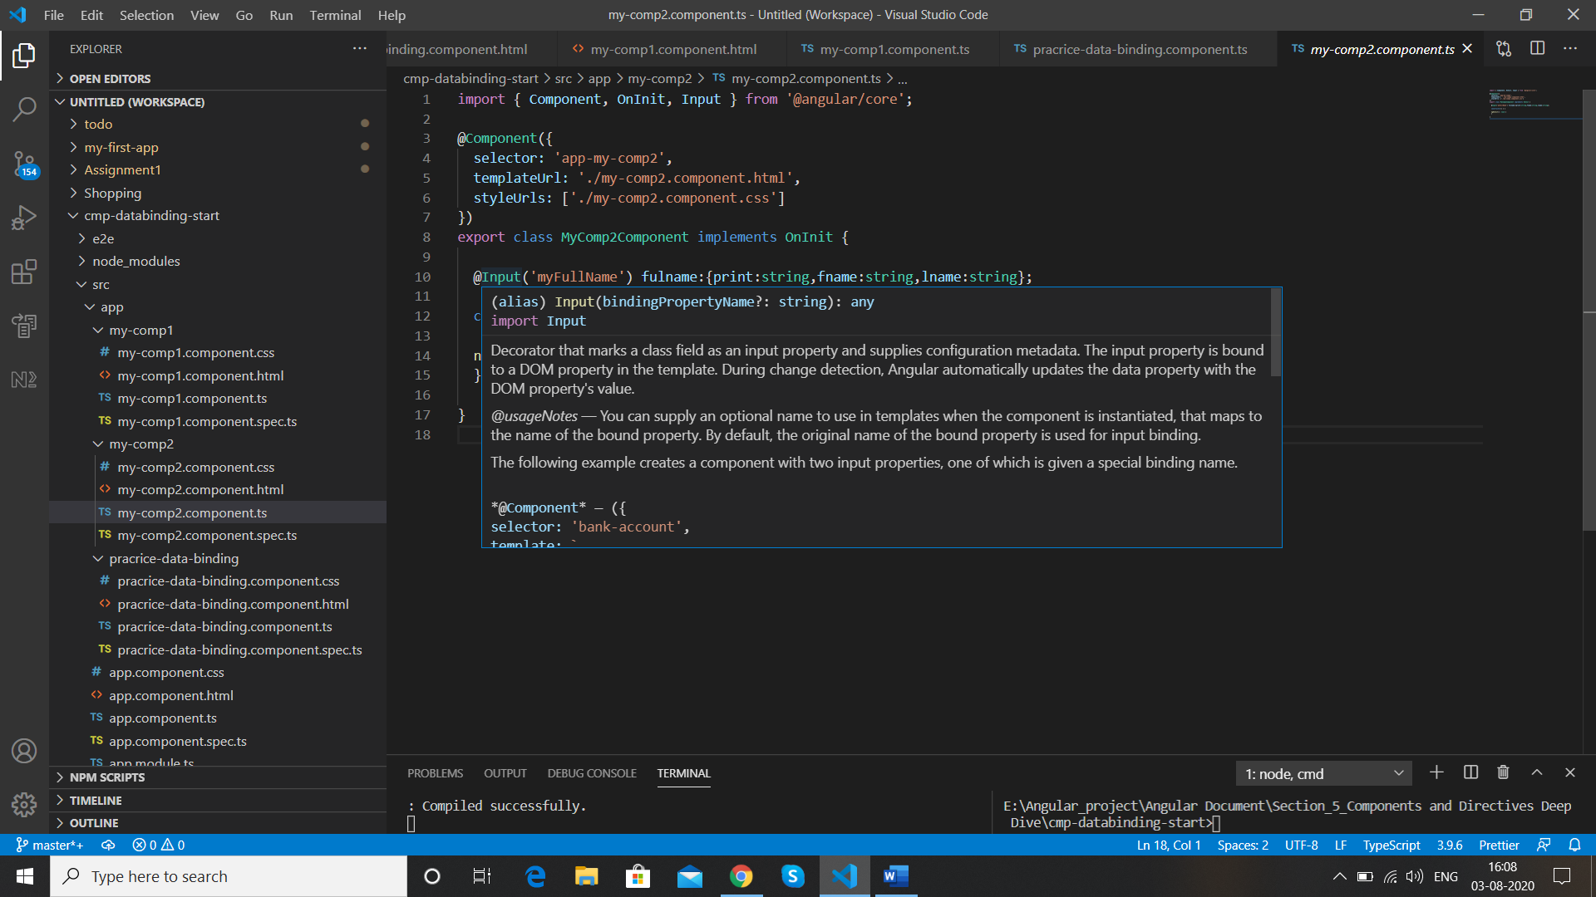

2)@Output which allows parent component to listen to this component own event(nameCreated and nameColorChange) that we created with new EventEmitter

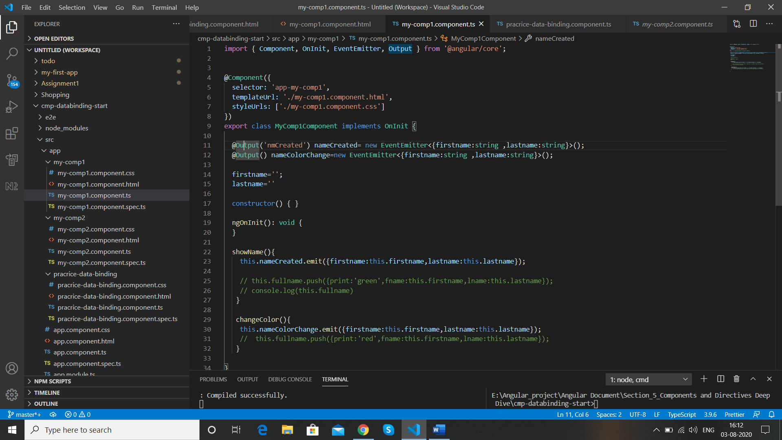

The input and output chain can grow and sometimes the distance between 2 components is very much away so this approach is not feasible for that we can use “service”, but for the usecase like above this approach is feasible

**View Encapsulation of style**

Now Our blue Prargraph “my comp2 works” css is not working after our event and component binding because they are no longer part of our parent component on which below css was applied

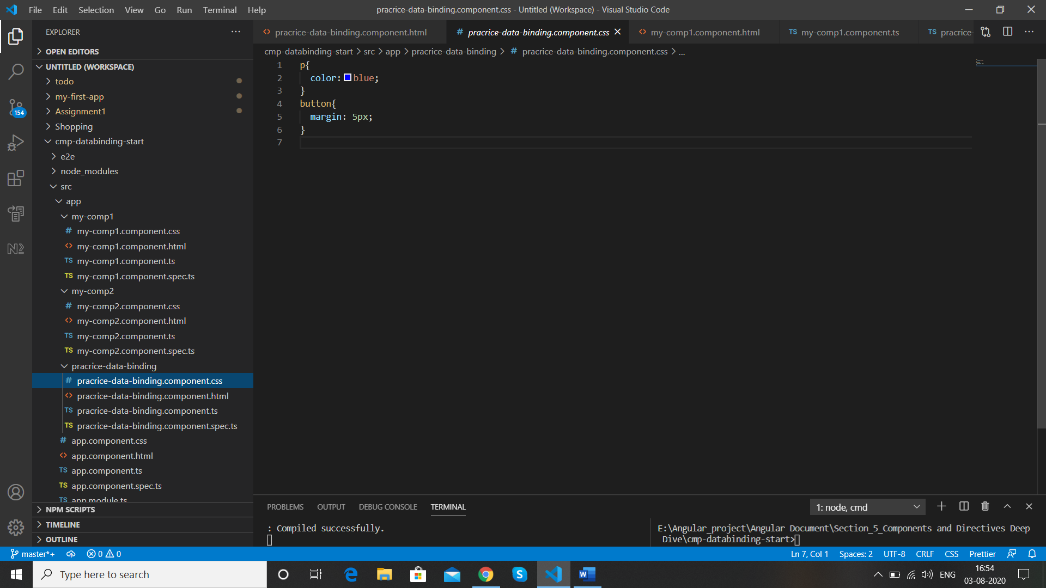

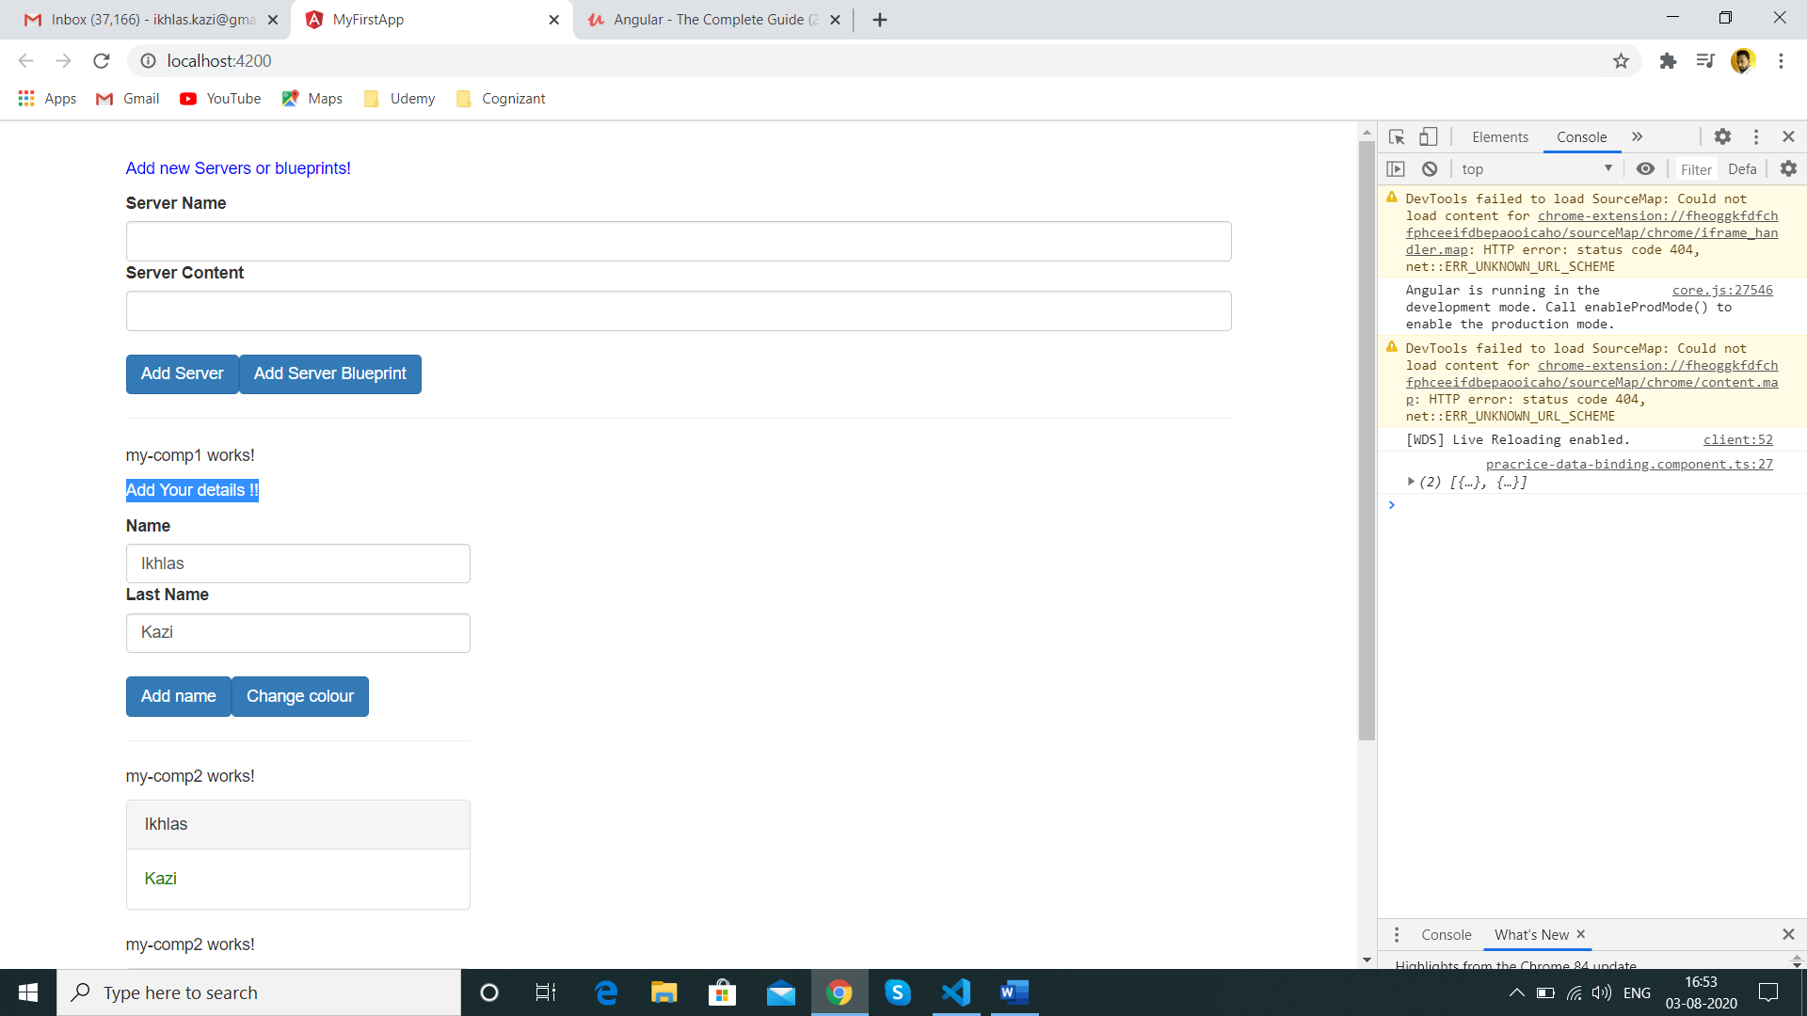

This is not defaiult behaviour of Css angular gives this behaviour to css ,

We add the below css again in my-comp2 component

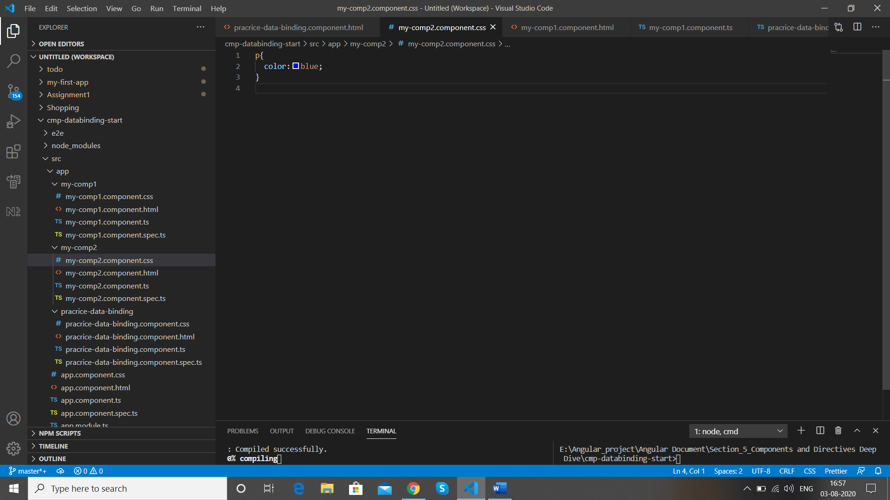

After adding we get the css effect back ,my-comp2 works is blue again

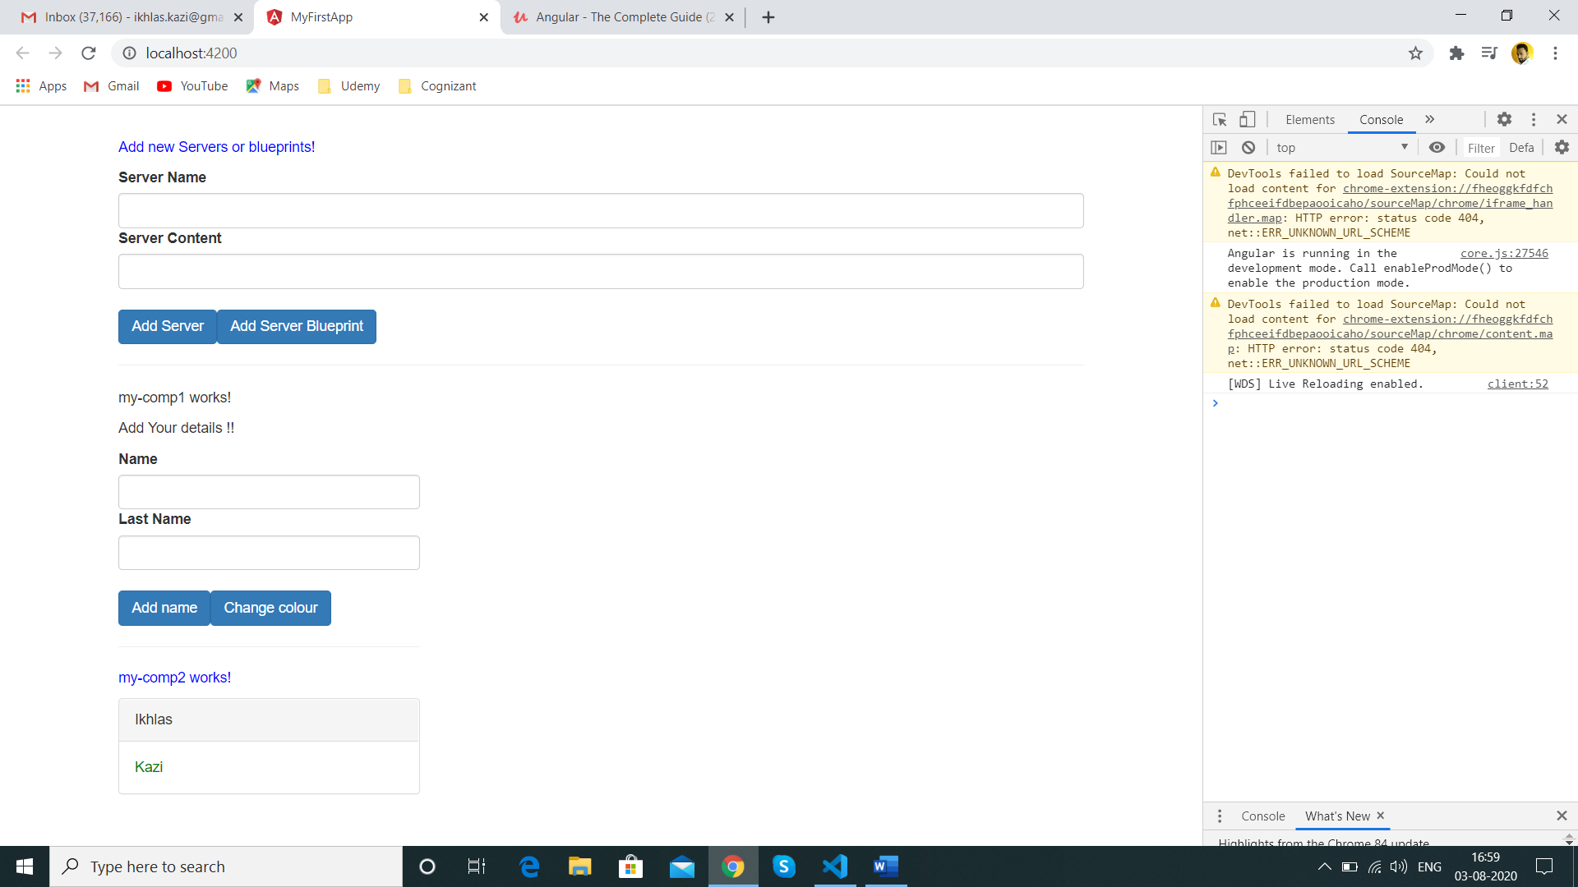But now when we inspect we get more value with P in

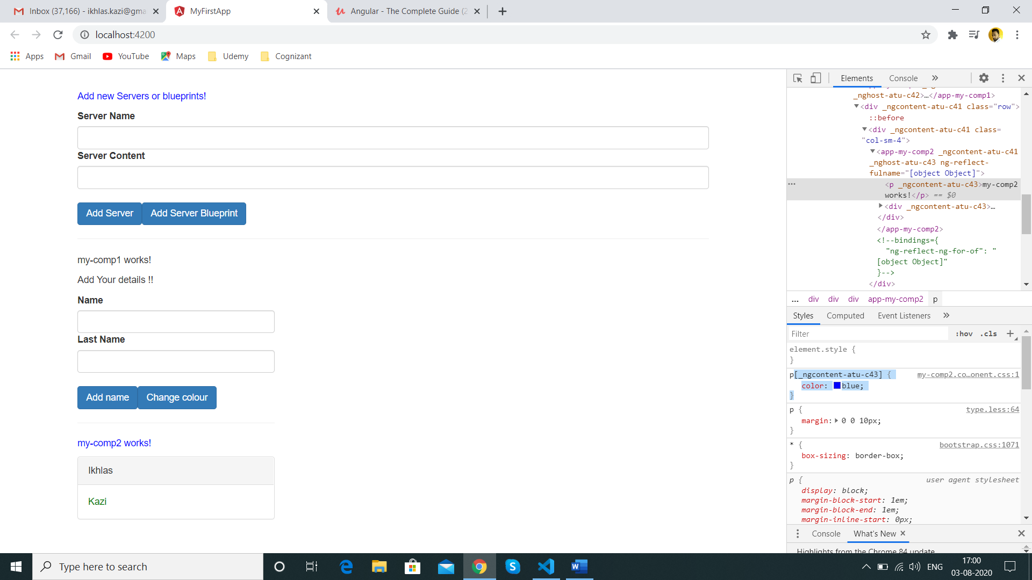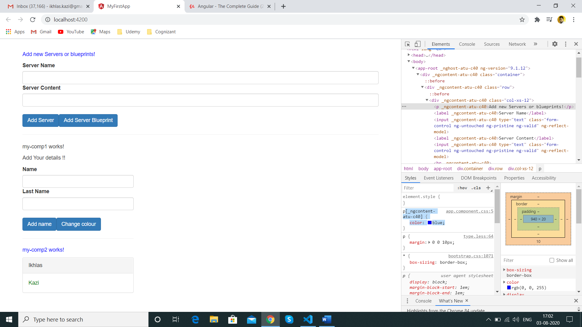

Paragraphs and elements in different components will have unique values in inspect

<p _**ngcontent-atu-c40**="">Add new Servers or blueprints!</p>

<p _**ngcontent-atu-c43**="">my-comp2 works!</p>

All elements in the same component will have the same value eg: my-comp2 component will have **ngcontent-atu-c43 ,** this is how css is applied only to the specific component after the components are sharing data

The unique selector name is a concept of Shadow DOM .

More on view encapsulation

If we don’t want to have unique values of elements in components we define as below in the my-comp2.component below style

import { Component, OnInit, Input,ViewEncapsulation } from '@angular/core';

encapsulation:ViewEncapsulation.None

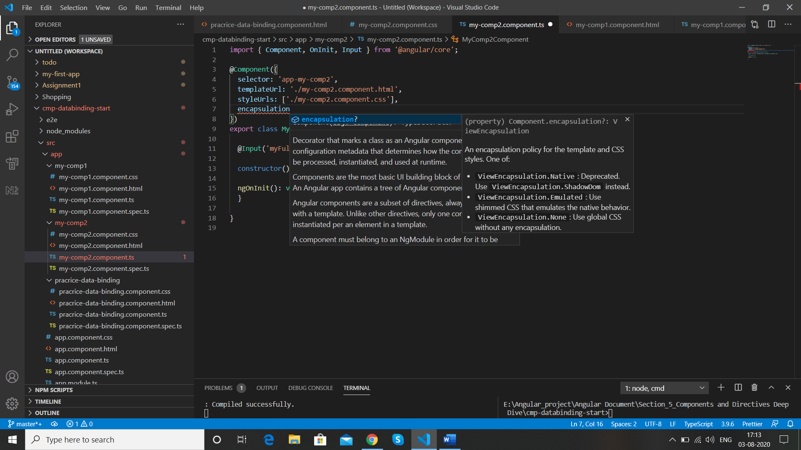

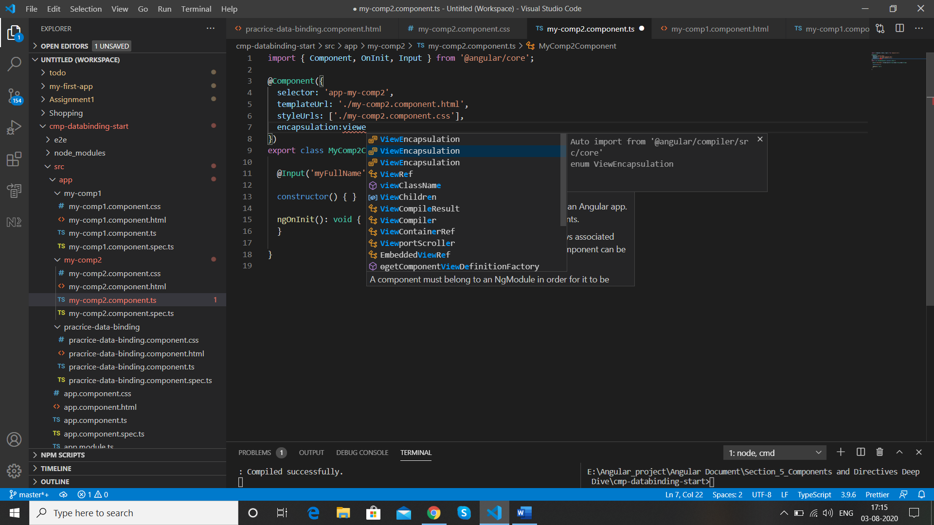

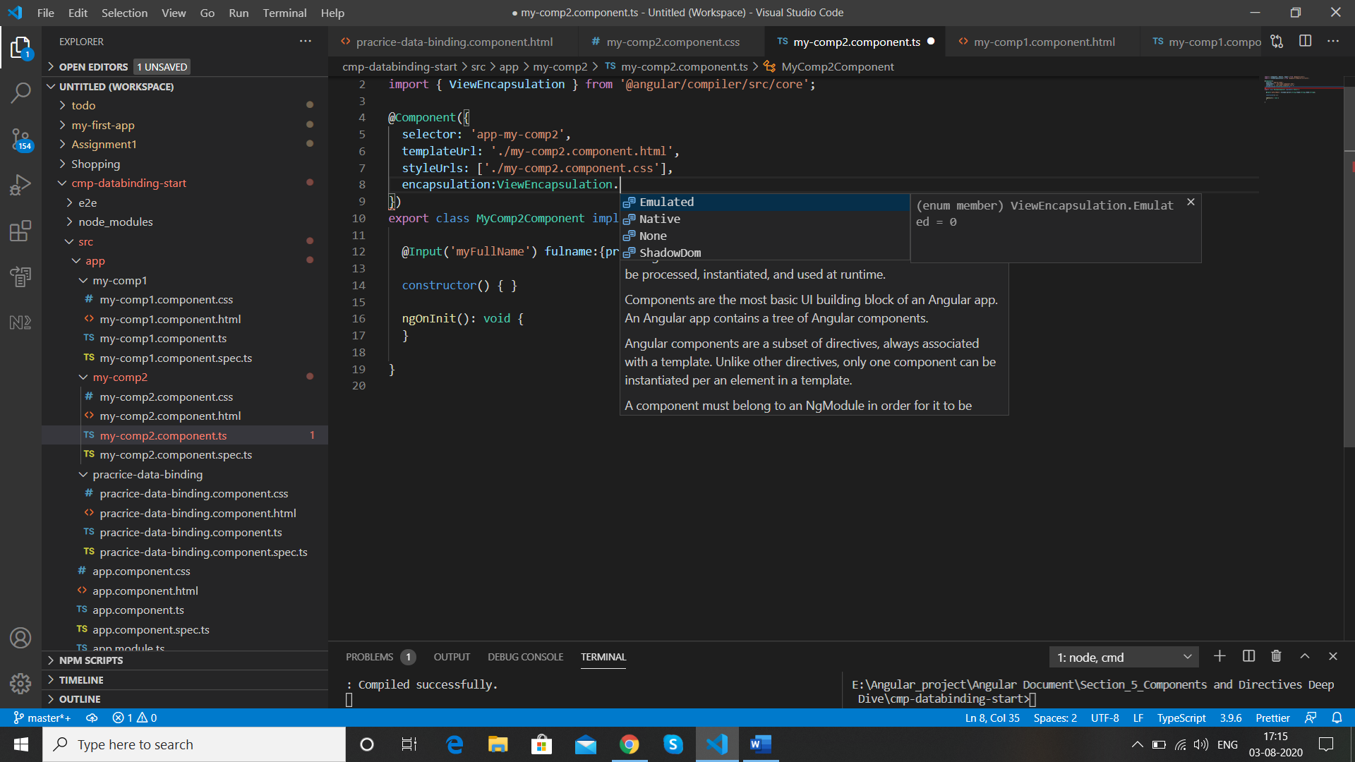

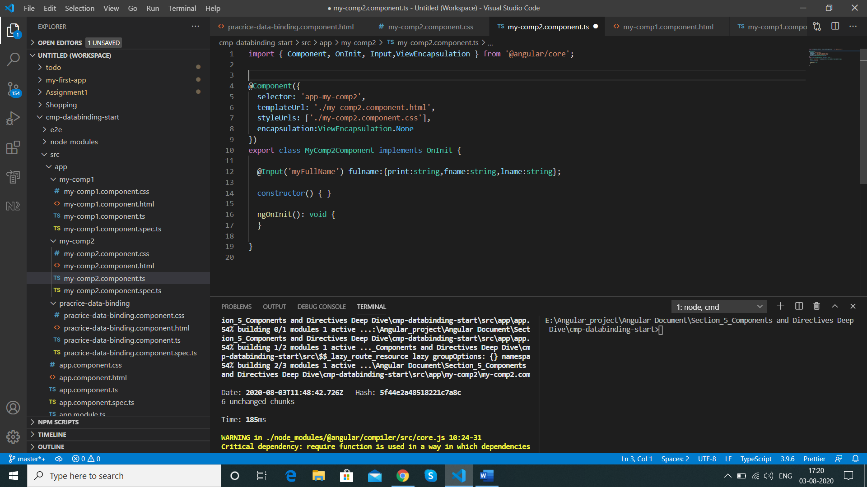

Now when you check the inspect element then the unique values are not available for the my-comp2.component

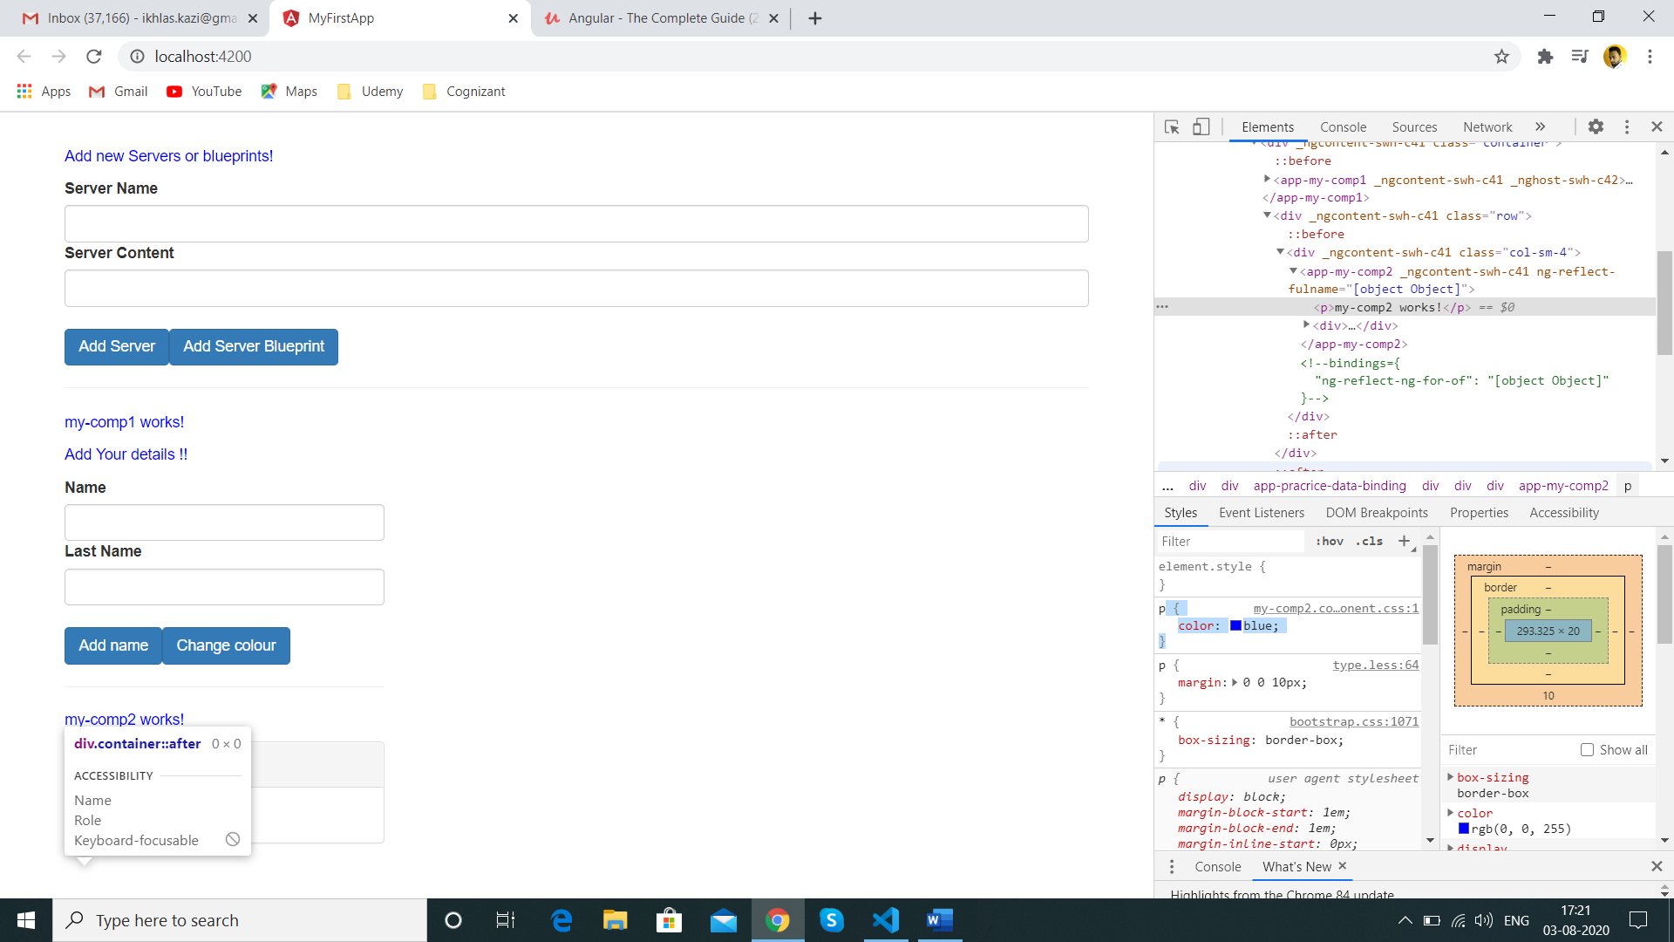

Now after this change in this component any CSS you change will be applicable to all components

Eg we have changes the colour of label

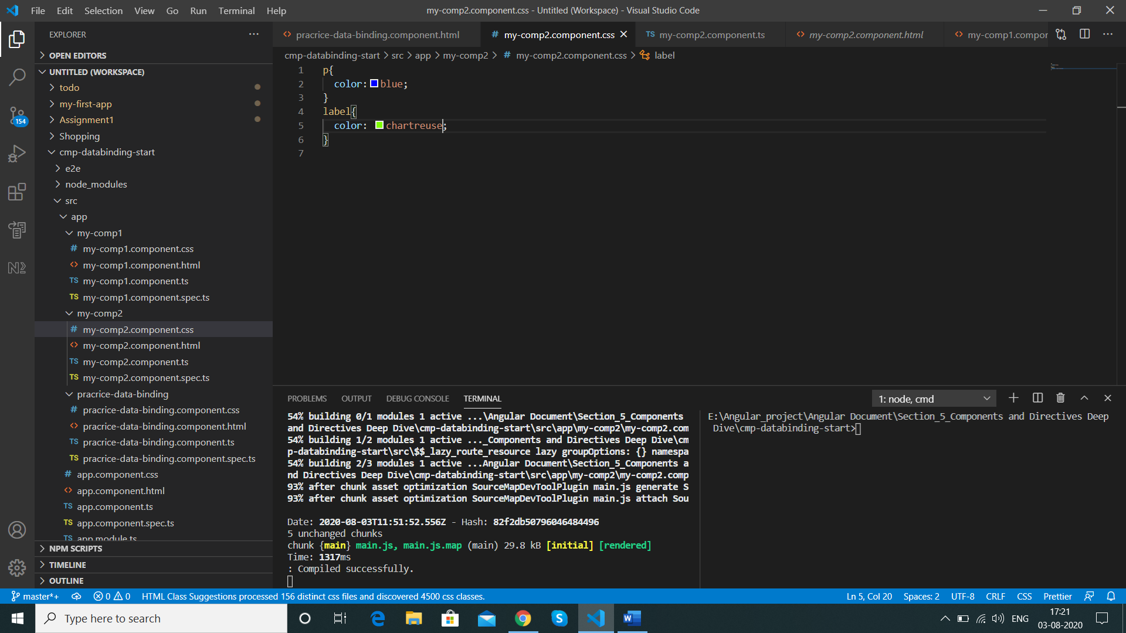

It gets applicable to all the labels in the app

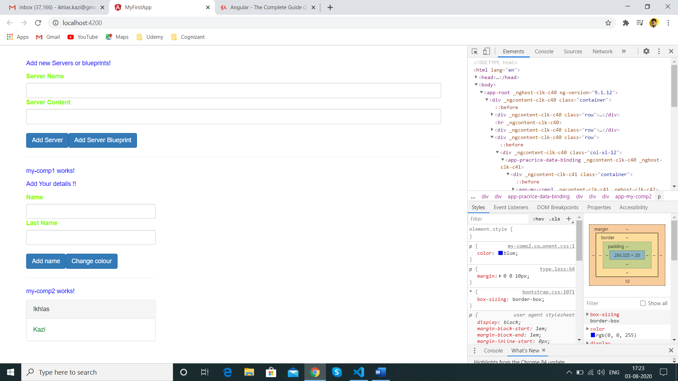

To avoid this behaviour use emulated to make the css work in same component only

encapsulation:ViewEncapsulation.Emulated

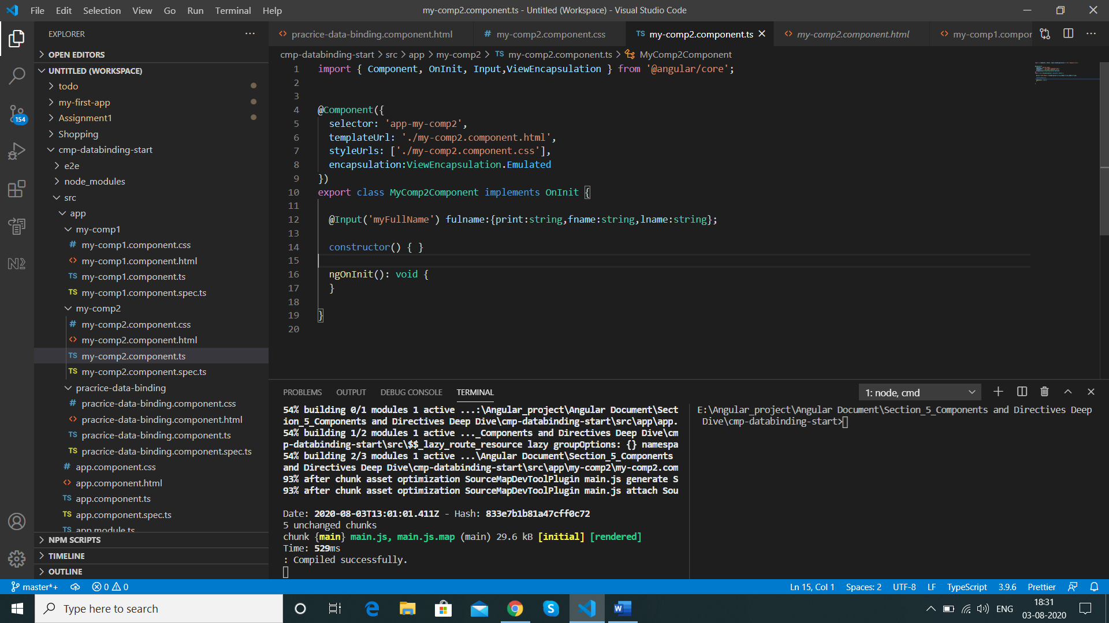

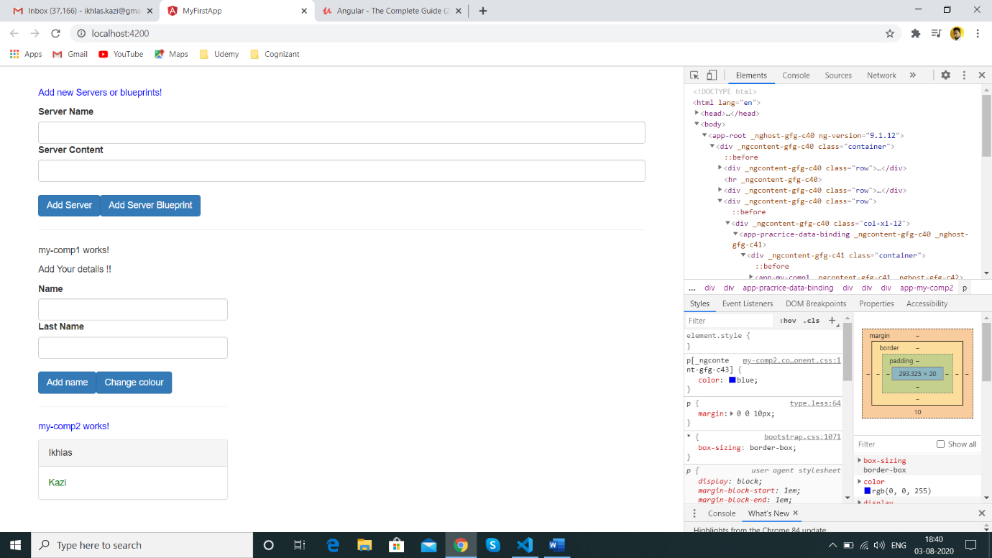

**Using Local Reference and templates**

The local reference can be placed on any HTML element .In this example we will add it in place of 2 way data Binding we have commented the below and created our local reference in its place

<input type="text" class="form-control" [(ngModel)]="firstname">

Local references can be used only on the same html file not outside it is denoted by # followed by name eg #firstNameInput

<input type="text" class="form-control" #firstNameInput>

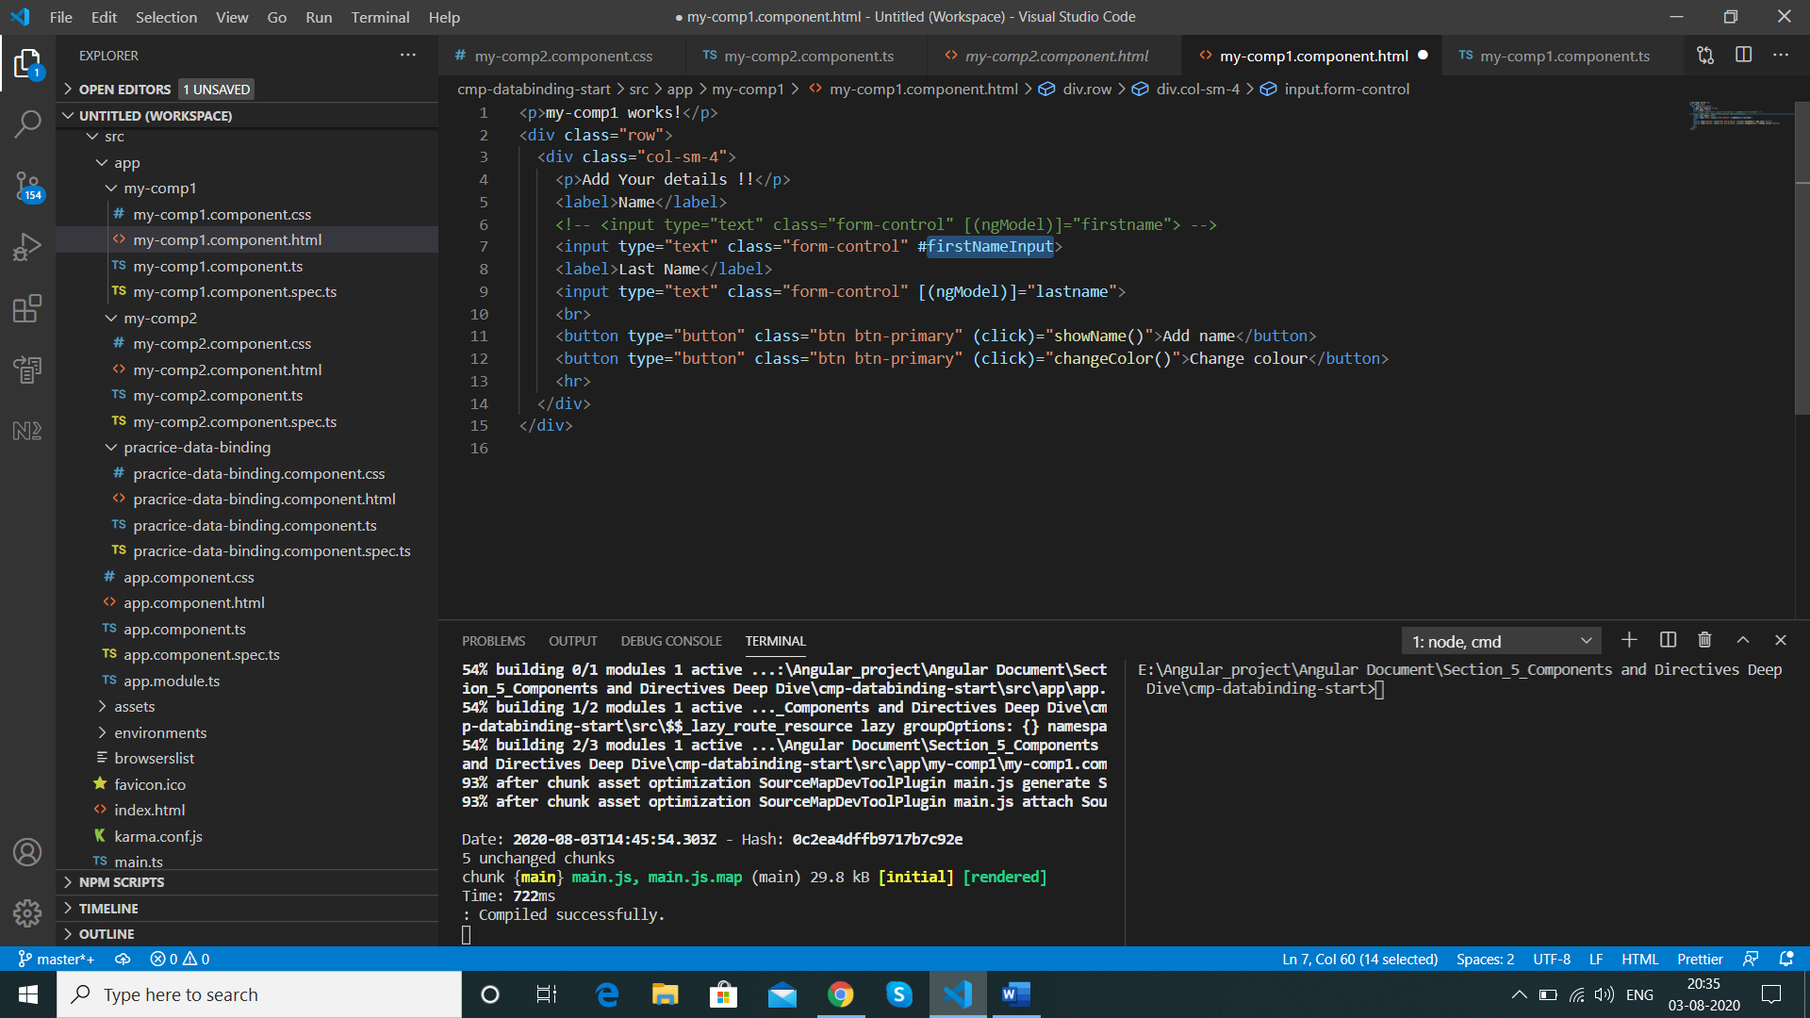

We pass it to the method

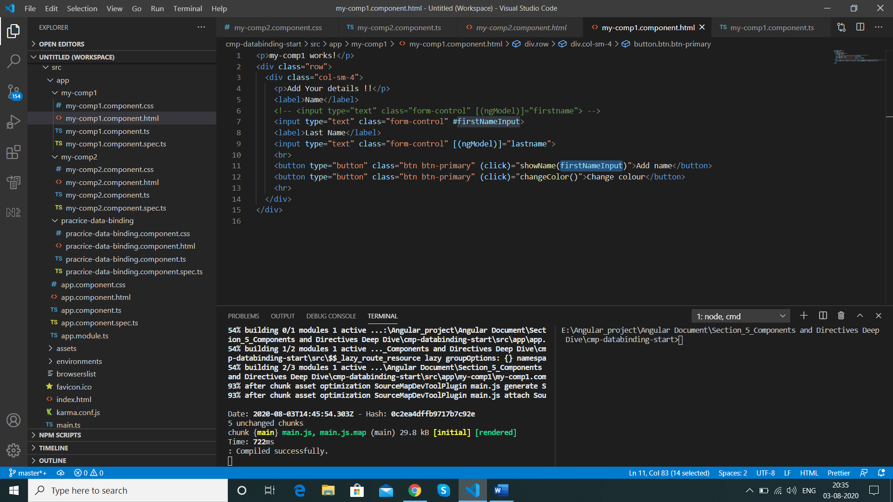

In ts we add a parameter to the method to catch the data

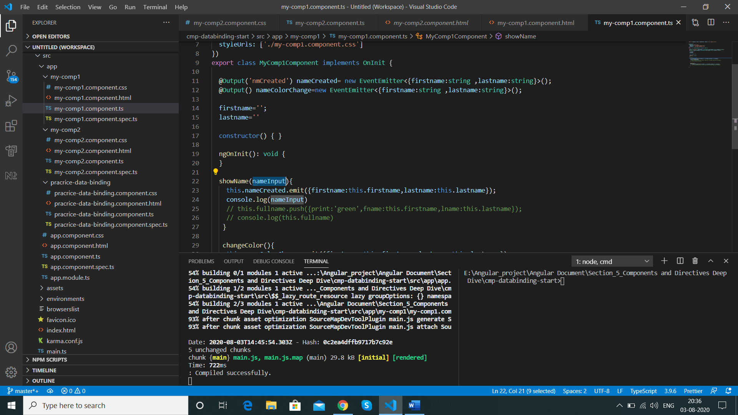

We can see the exact value by nameInput.**value**

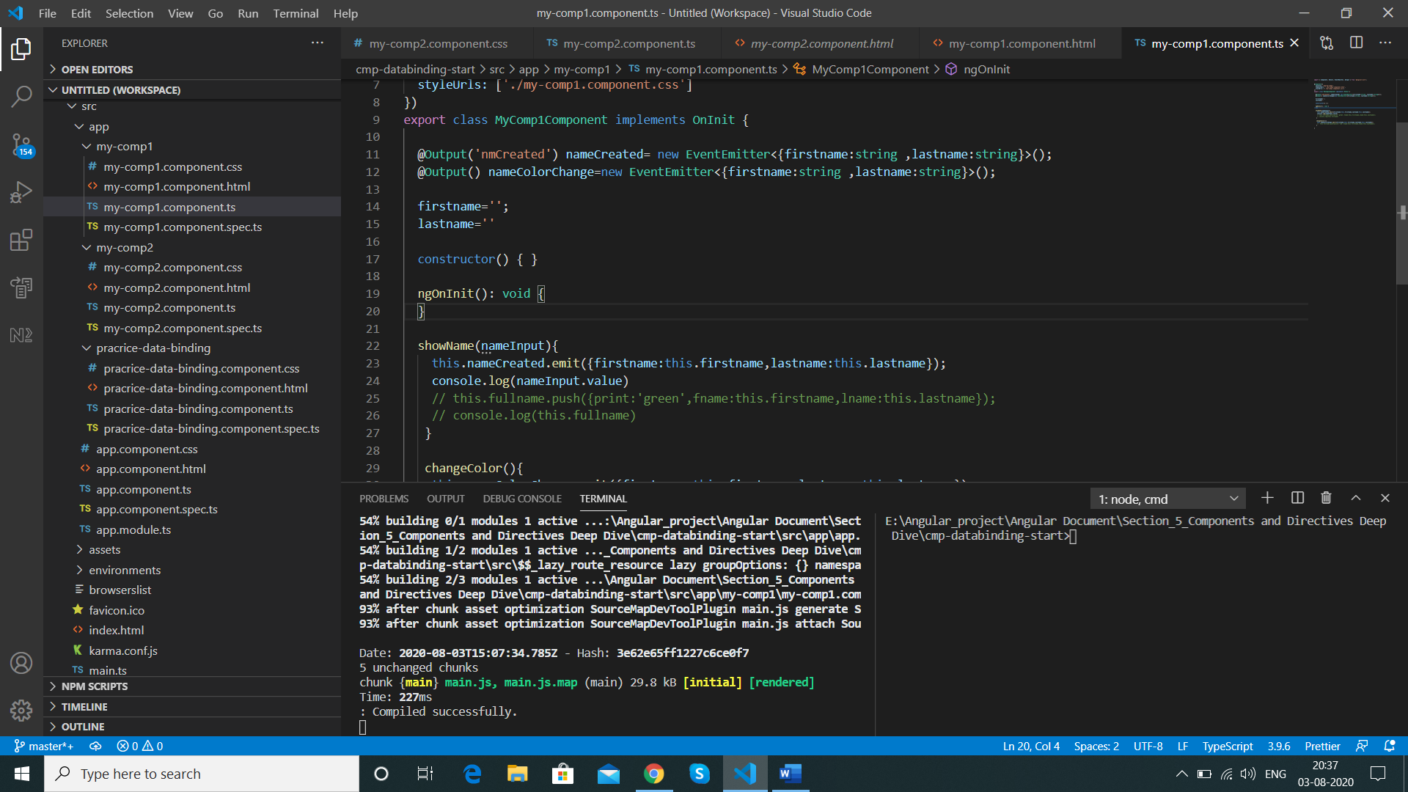

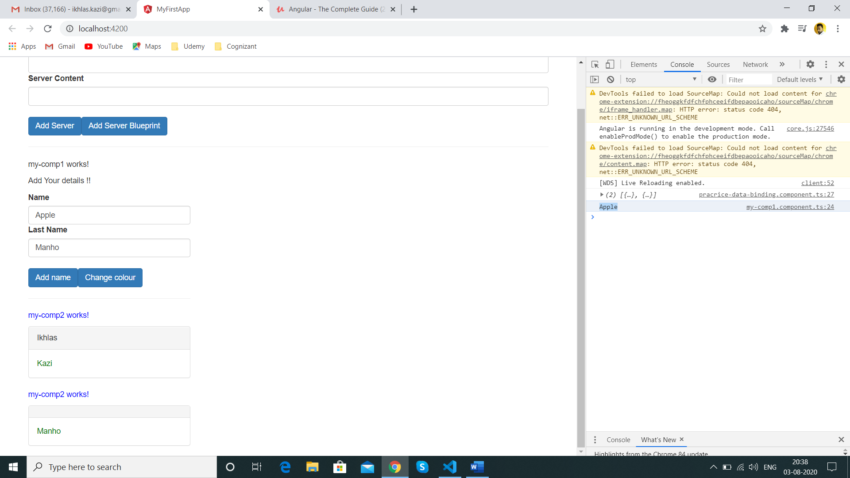

But we are still not getting the value in panel below so , we change the ts method parameter to accept HTMLInputElement and below replacement of existing firstname:this.firstname

 showName(nameInput:HTMLInputElement){

firstname:nameInput.value,

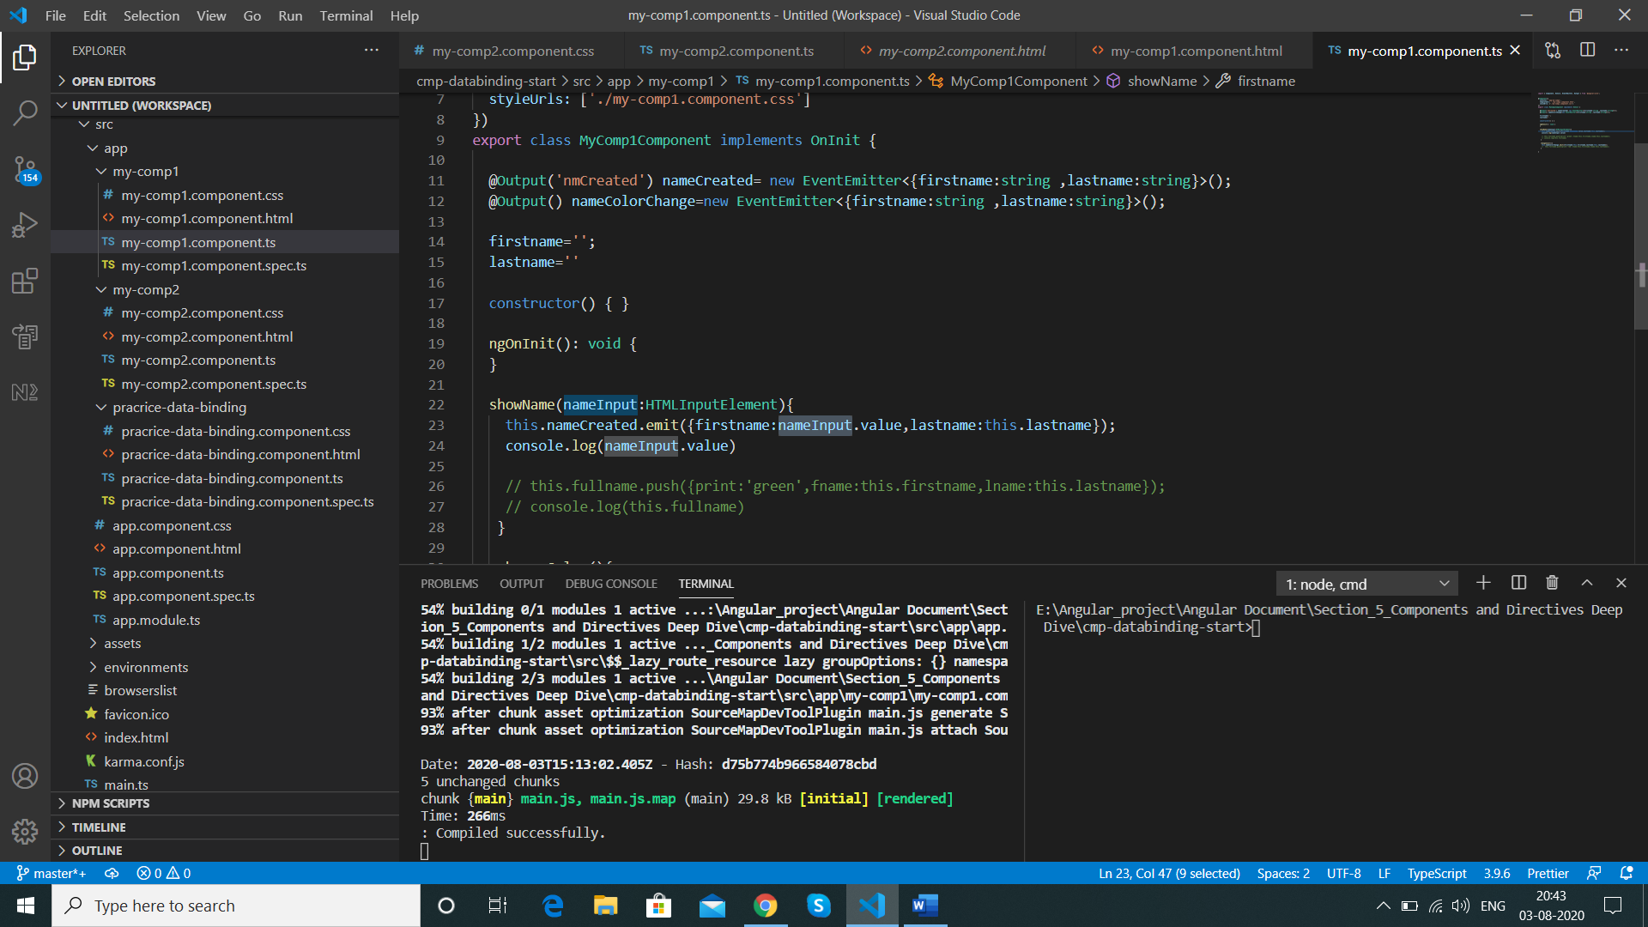

Now we get the value in the panel

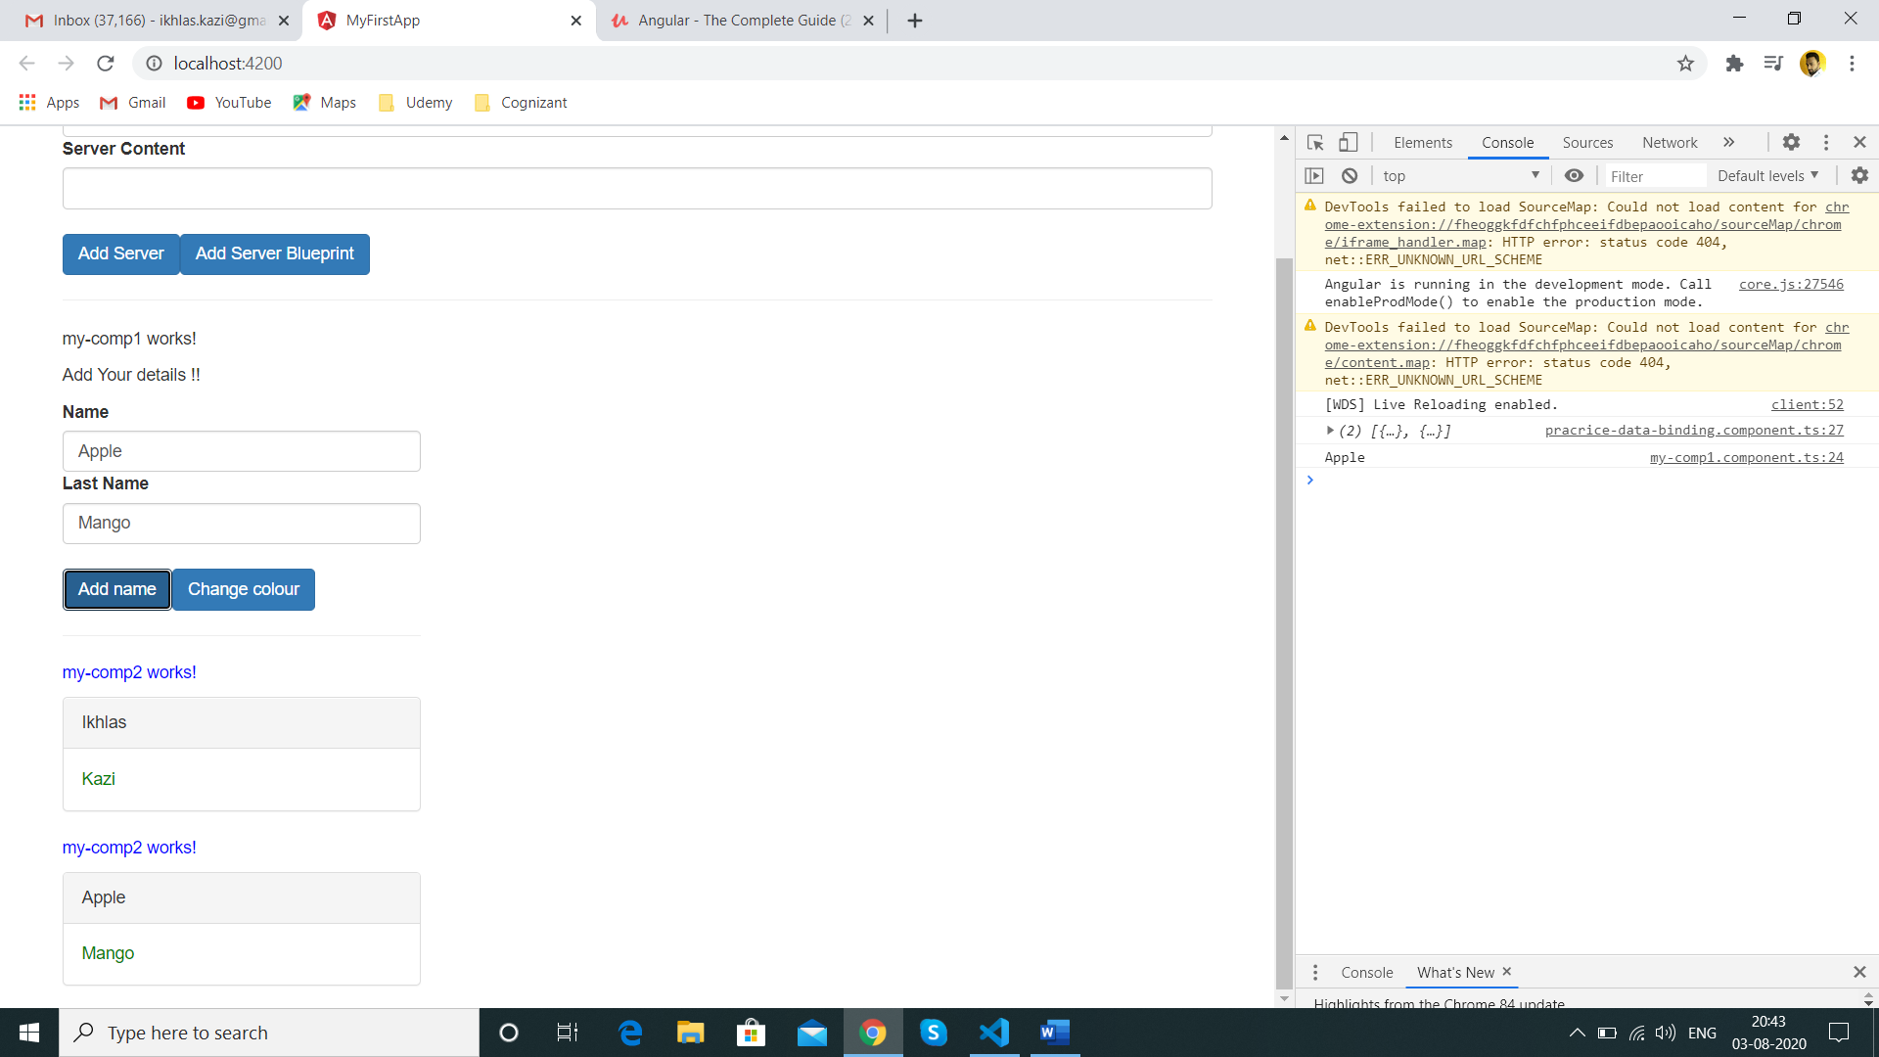

we change the same for other method as well and commented global variable of our component as we do not need it as we have local reference variable now

  // firstname='';

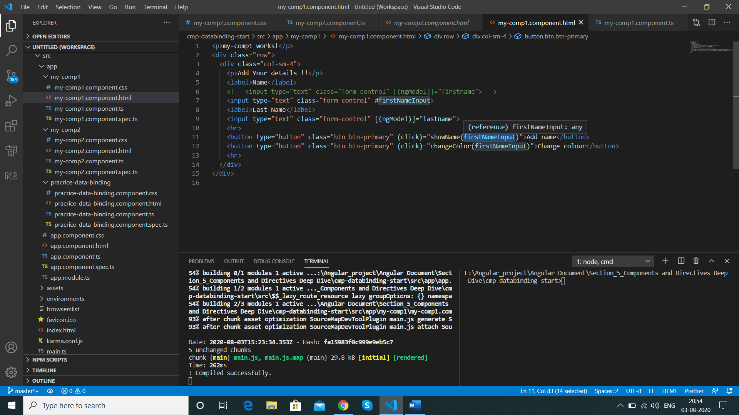

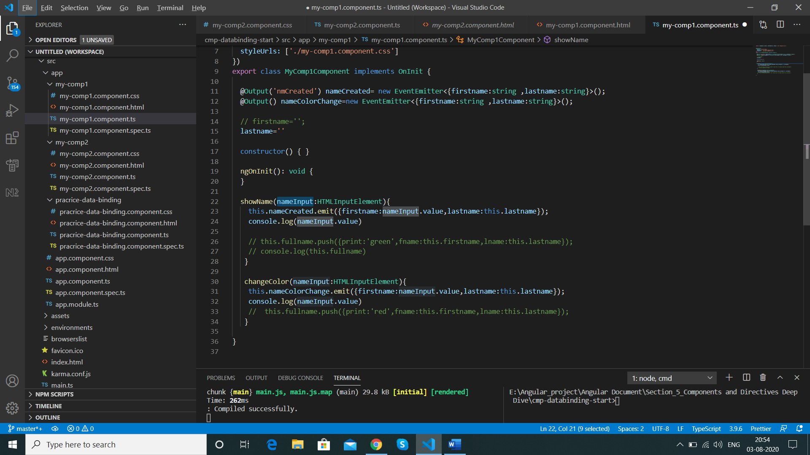

Result will be same

**@ViewChild() in Angular 8+**

In **Angular 8+**, the @ViewChild() syntax which you'll see in the next lecture needs to be changed slightly:

Instead of:

1. @ViewChild('serverContentInput') serverContentInput: ElementRef;

use

1. @ViewChild('serverContentInput', {static: true}) serverContentInput: ElementRef;

The same change (add { static: true } as a second argument) needs to be applied to ALL usages of @ViewChild() (and also @ContentChild() which you'll learn about later) IF you plan on accessing the selected element inside of ngOnInit().

If you DON'T access the selected element in ngOnInit (but anywhere else in your component), set static: false instead!

**Getting access to the Template/local reference orAny element directly from our typescript code with the help of @ViewChild**

Sometimes we want to get access before we call a method

We start by creating the local reference for last name as well

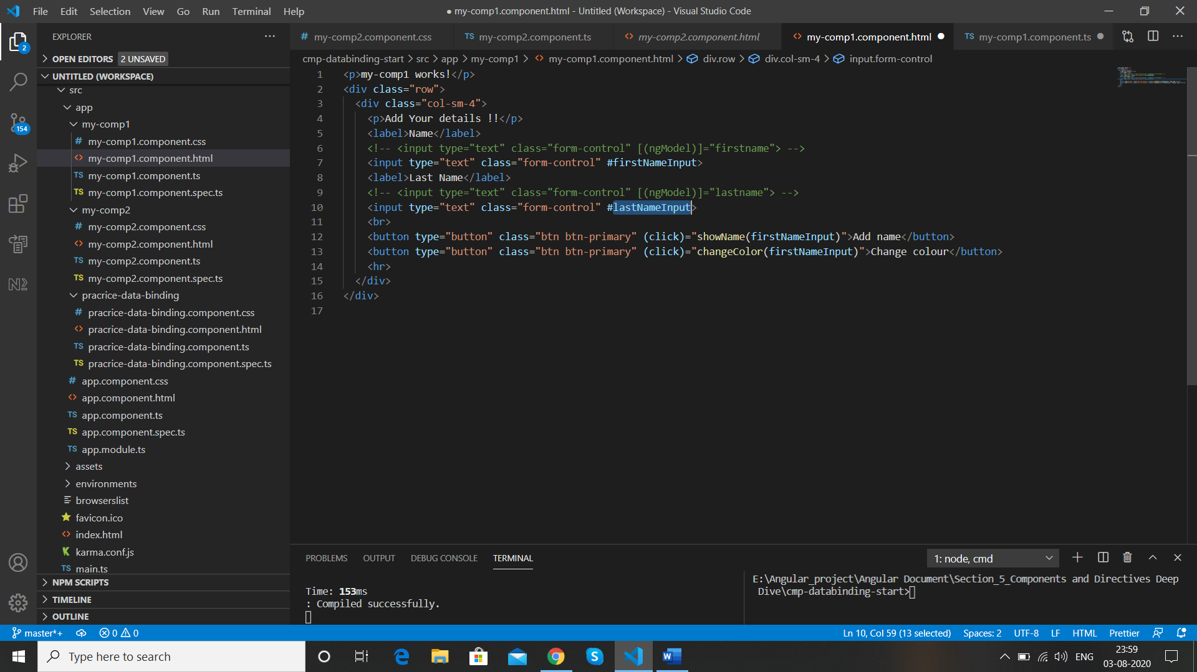

We commented the last name in my-comp1.component.ts as we have local reference now in its place

  //lastname=''

We add just a property and add @ViewChild

myTemplateReference

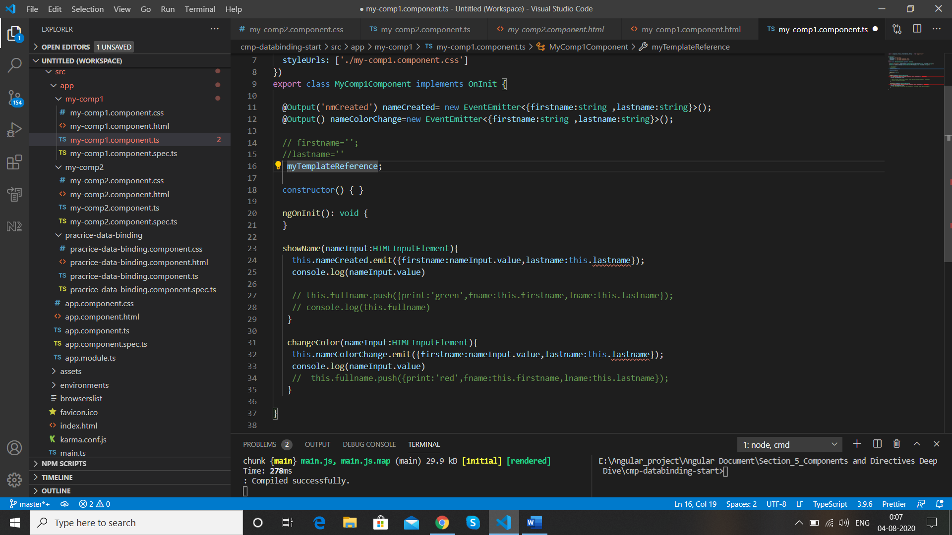

import { Component, OnInit, EventEmitter, Output, ViewChild } from '@angular/core';

   @ViewChild('') myTemplateReference;

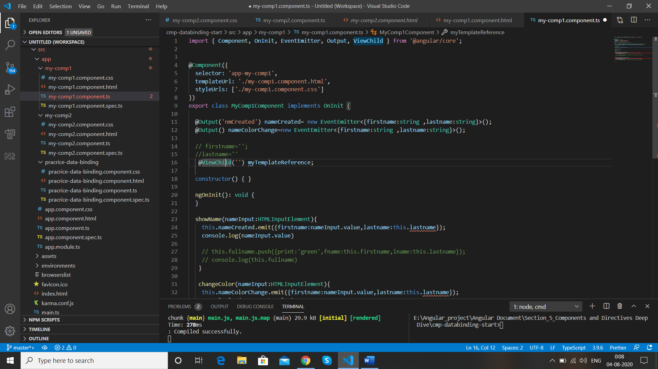

@ViewChild needs parameter ,we pass the New local reference that we have added on my-comp1-html ie below #lastNameInput

 <input type="text" class="form-control" #lastNameInput>

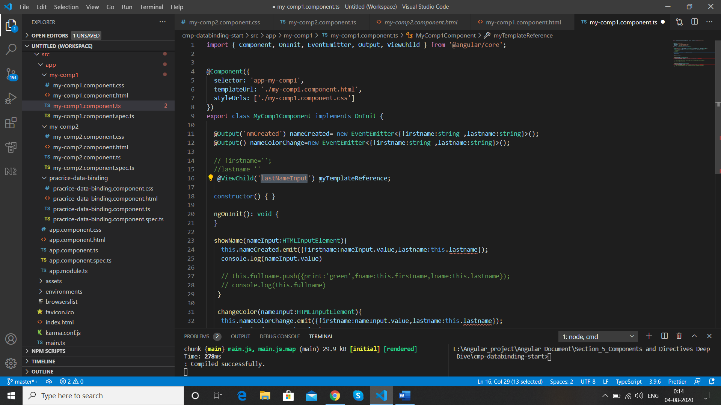

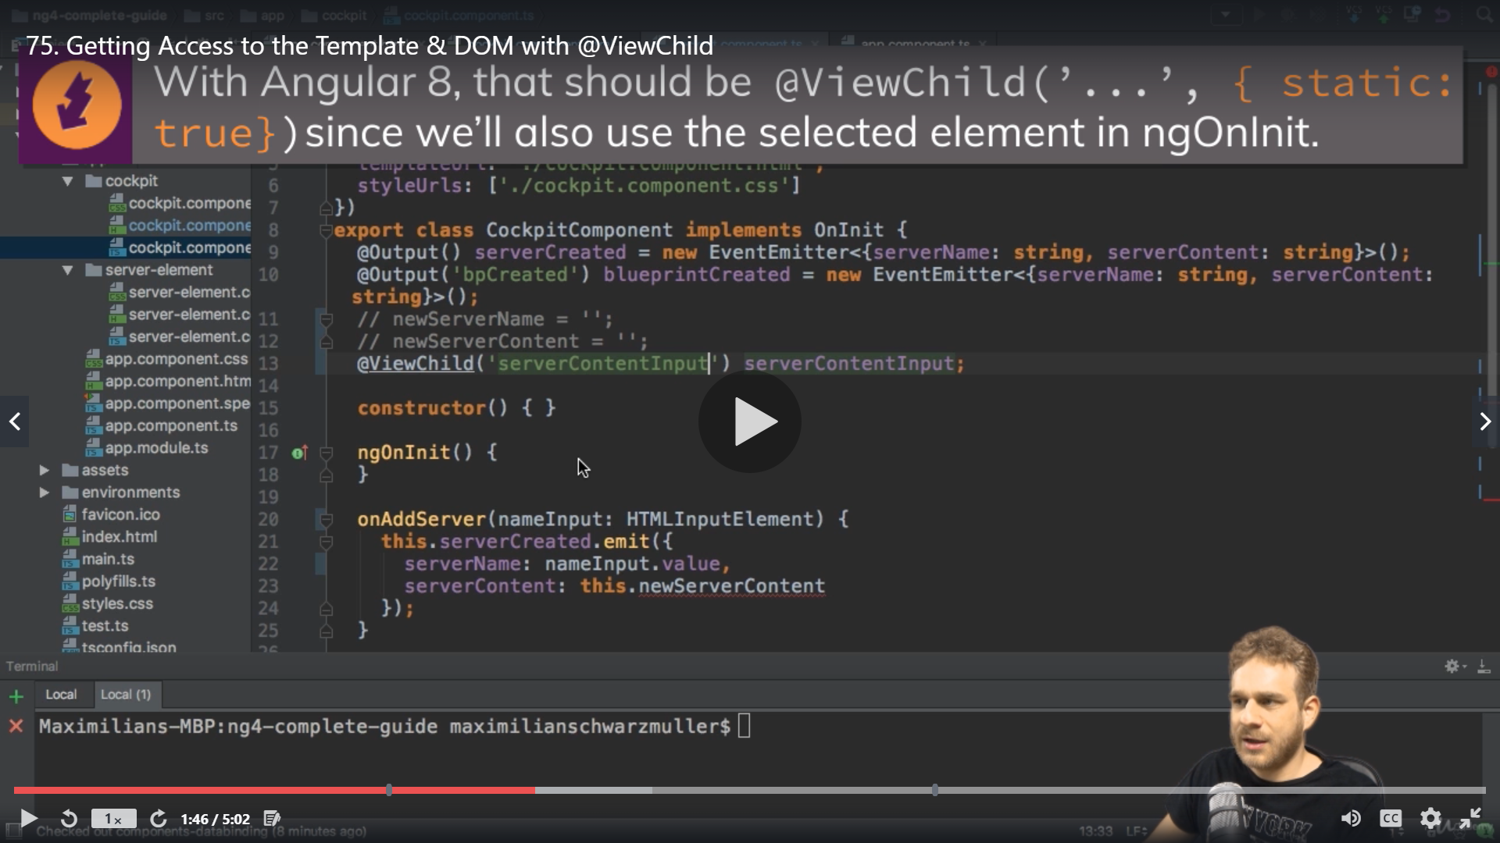

We have made changes for angular 8 viewChild syntax

 @ViewChild('lastNameInput',{static:true}) myTemplateReference;

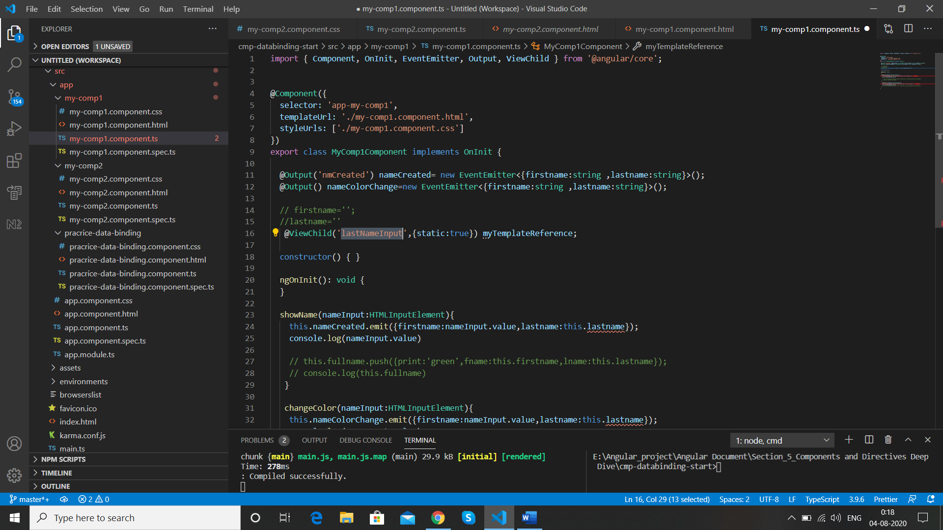

Now we comment the error code which we will fix later and check in console myTemplateReference

myTemplateReference

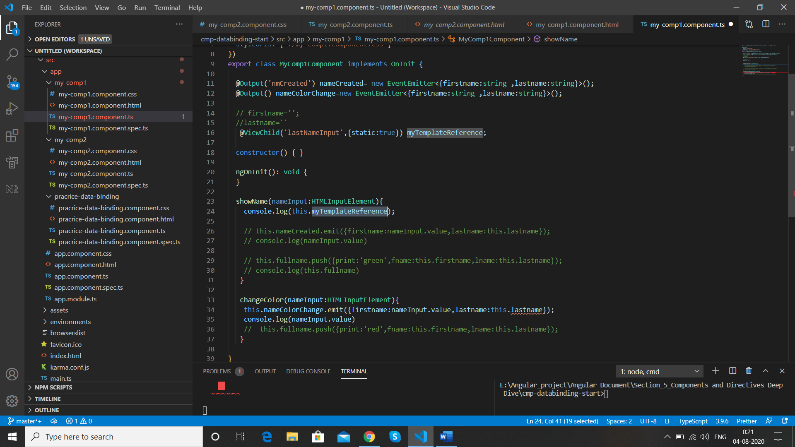

After running the app we get ElemetRef {nativeElement: input.form-control}in console log so the type is ElementRef

1. *ElementRef {nativeElement: input.form-control}*
   1. nativeElement: input.form-control
   2. __proto__: ElementRef

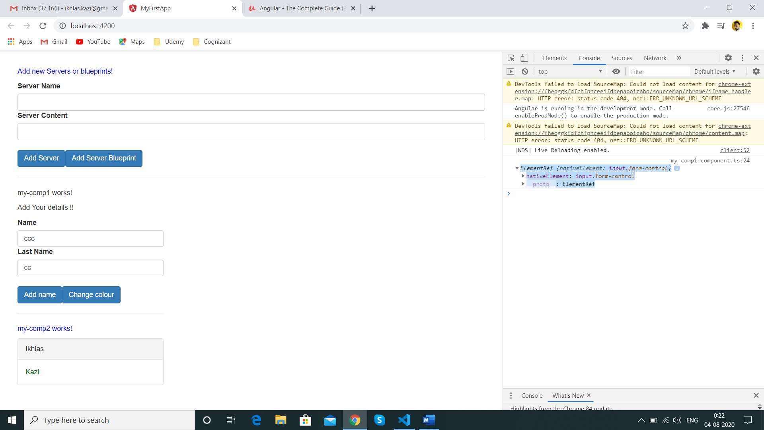

We add type ElementRef from @angular/core to our property myTemplateReference

 @ViewChild('lastNameInput',{static:true}) myTemplateReference :ElementRef;

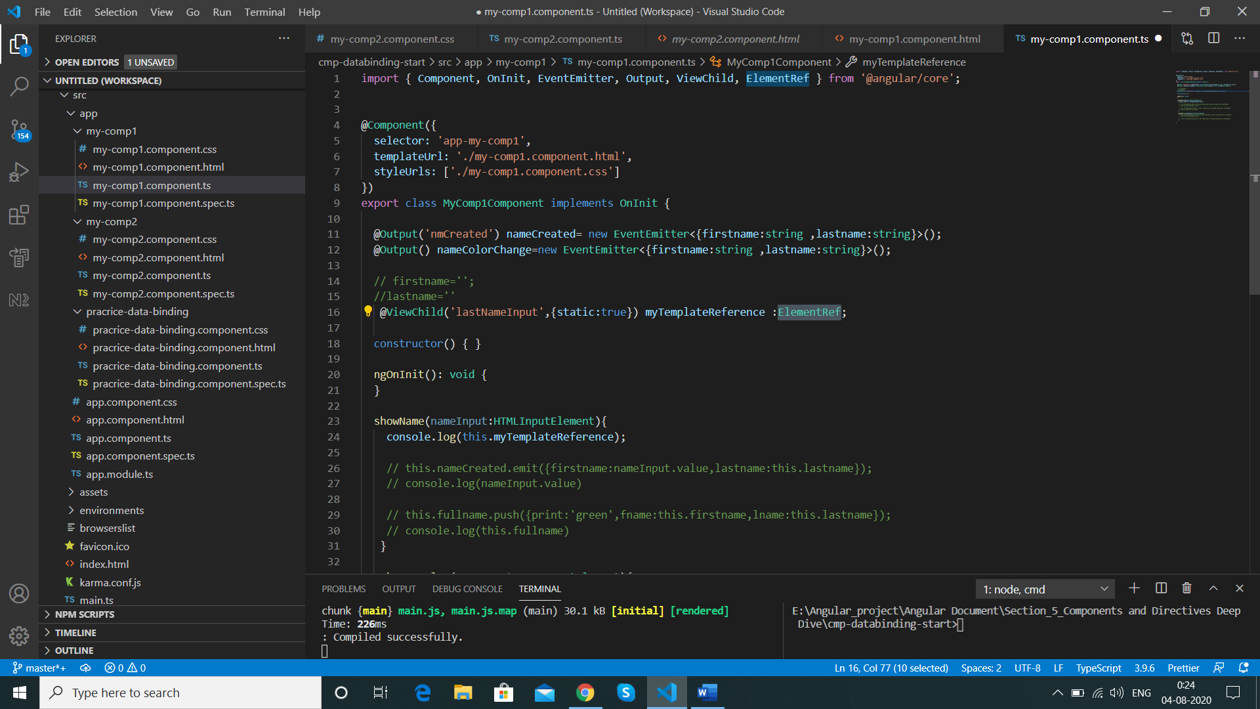

Now we uncomment the code we commented and use the new property in place of this.lastname with nativeElement.value added to it

this.myTemplateReference.nativeElement.value

this.nameCreated.emit({firstname:nameInput.value,lastname:this.myTemplateReference.nativeElement.value});

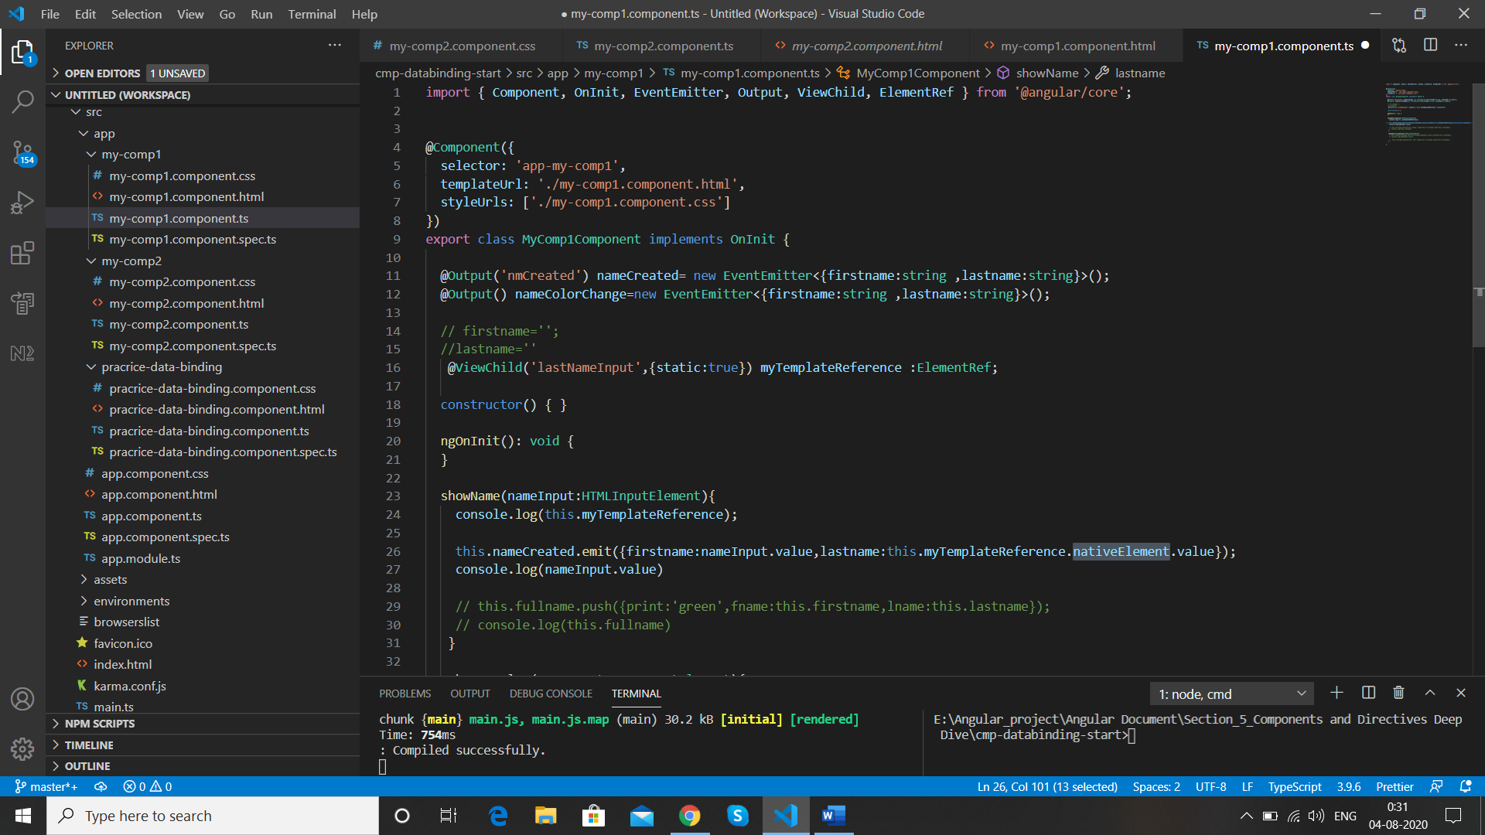

Add same to other method as well

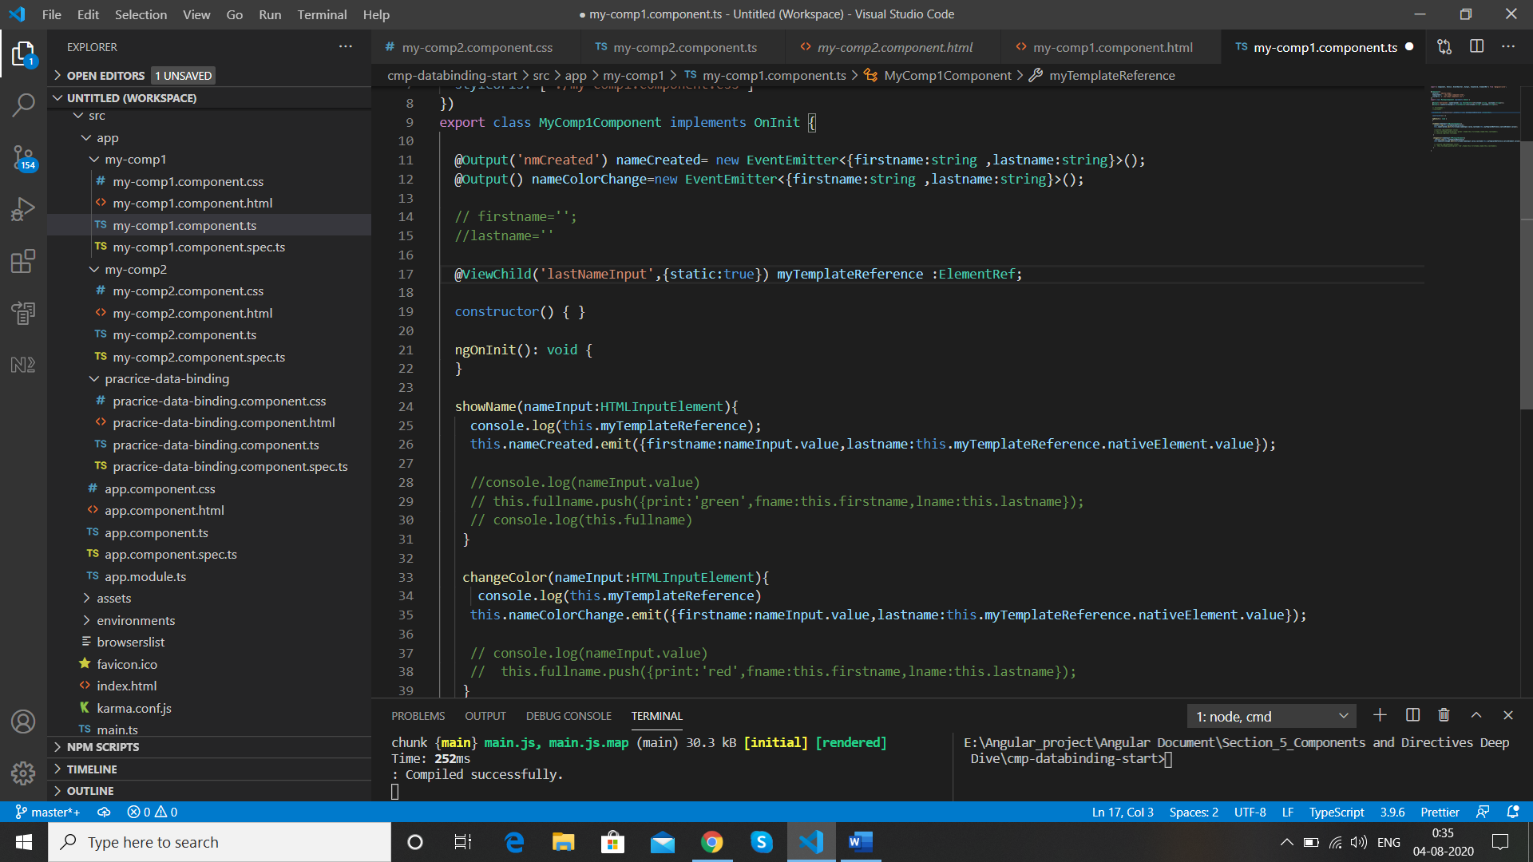

With the help of ViewChild we get direct access to our template in DOM

Result

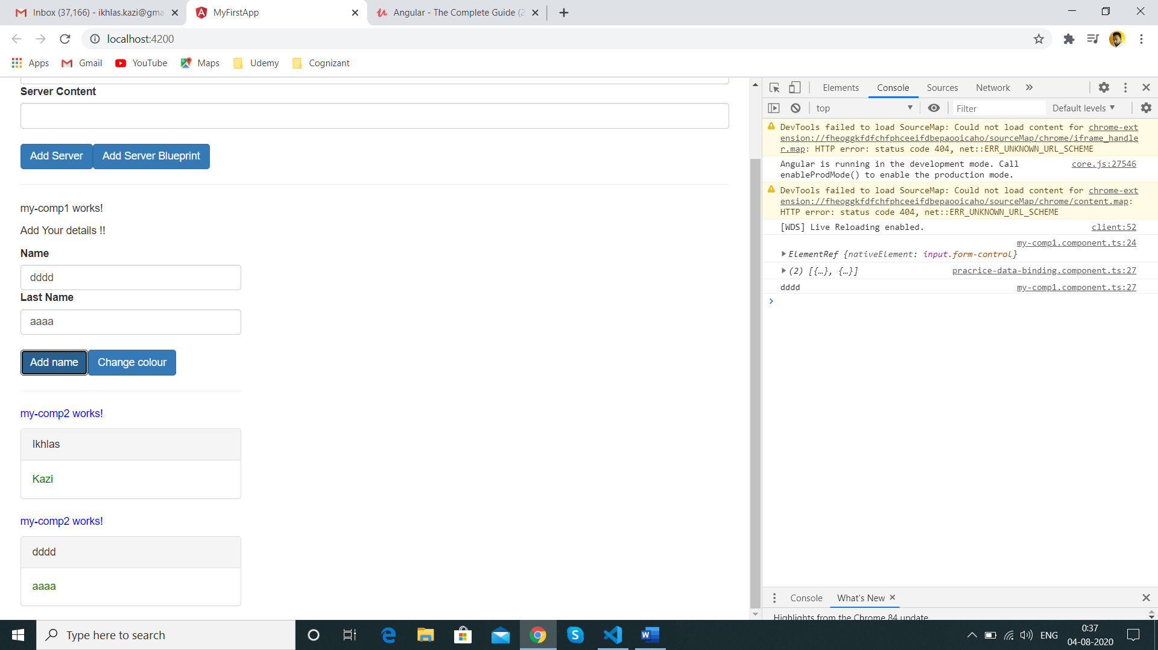

**Projecting Content into Component with ng-content (Another way of data passing )**

In my-comp2.html we have below highlited code ,Sometimes we want to add this kind of conditional code in some place of other component here we add it in parent component

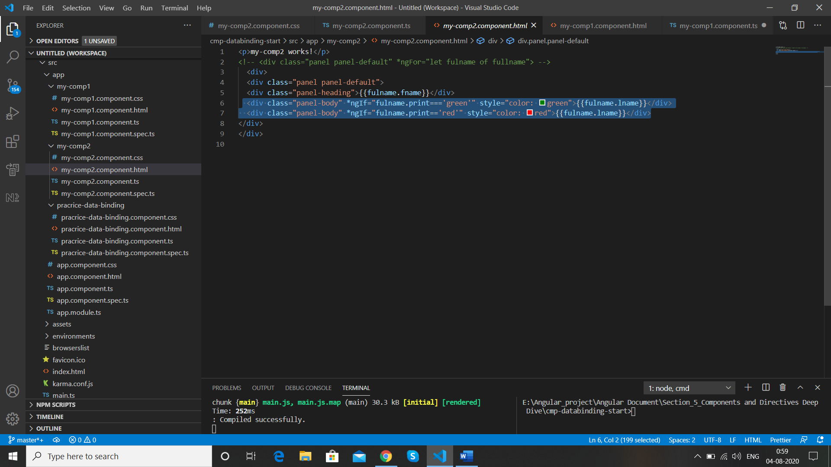

We cut paste the code in parent component ie Practice-data-binding

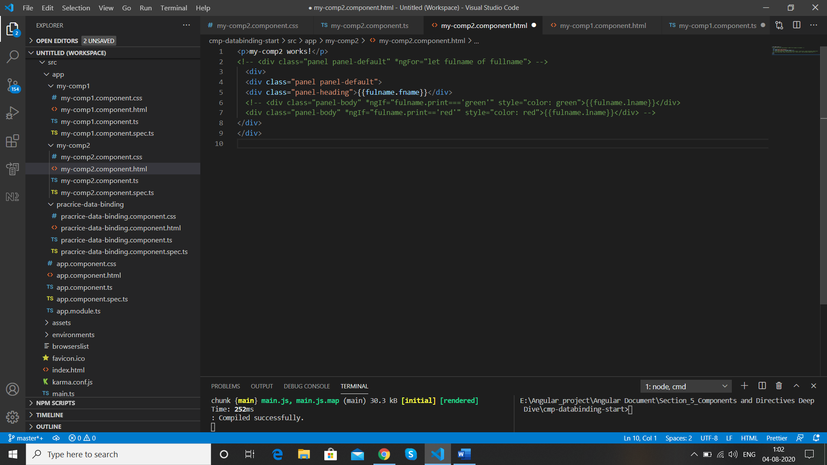

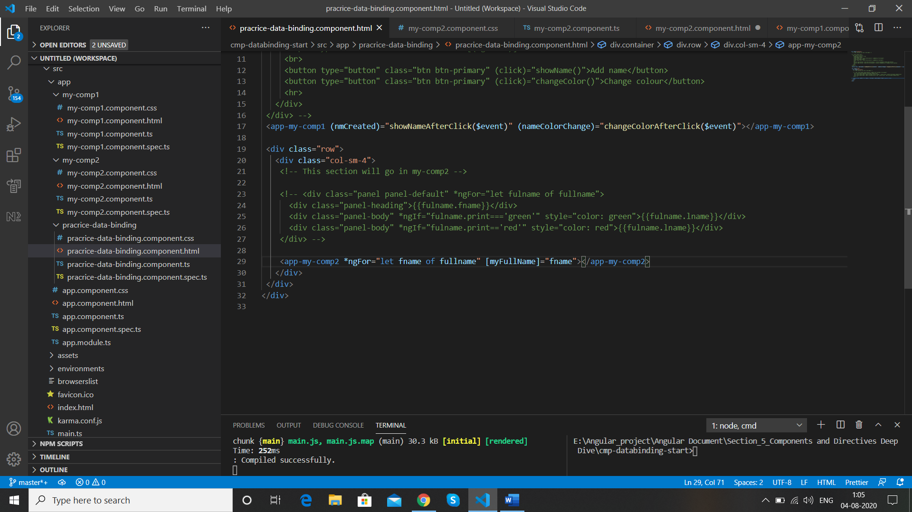

Paste

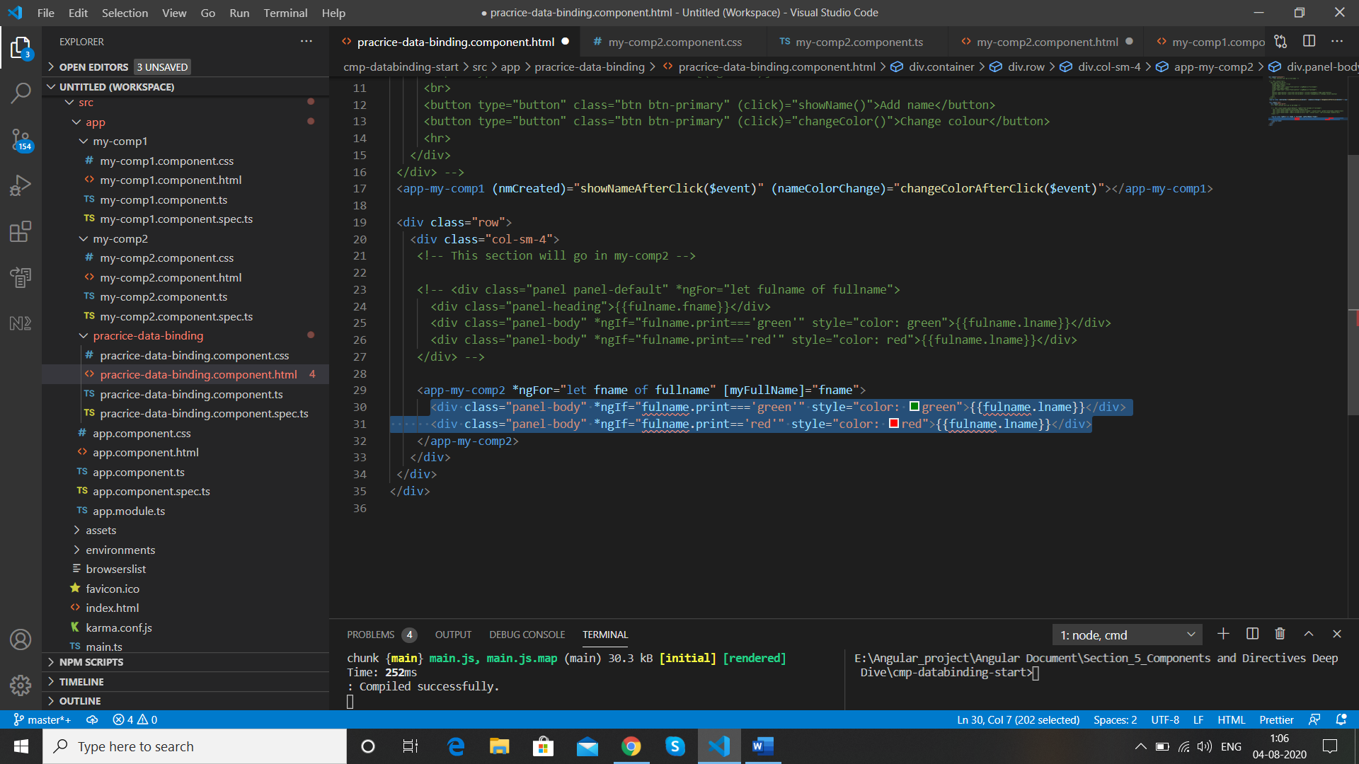

Now we replace fullname in ngIF with fname as we already have its value on my-comp2 ts file as below

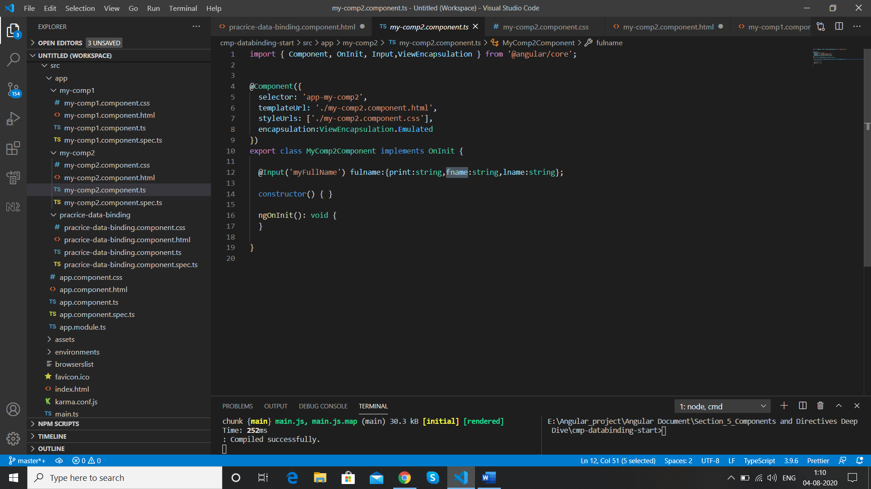

So we changed

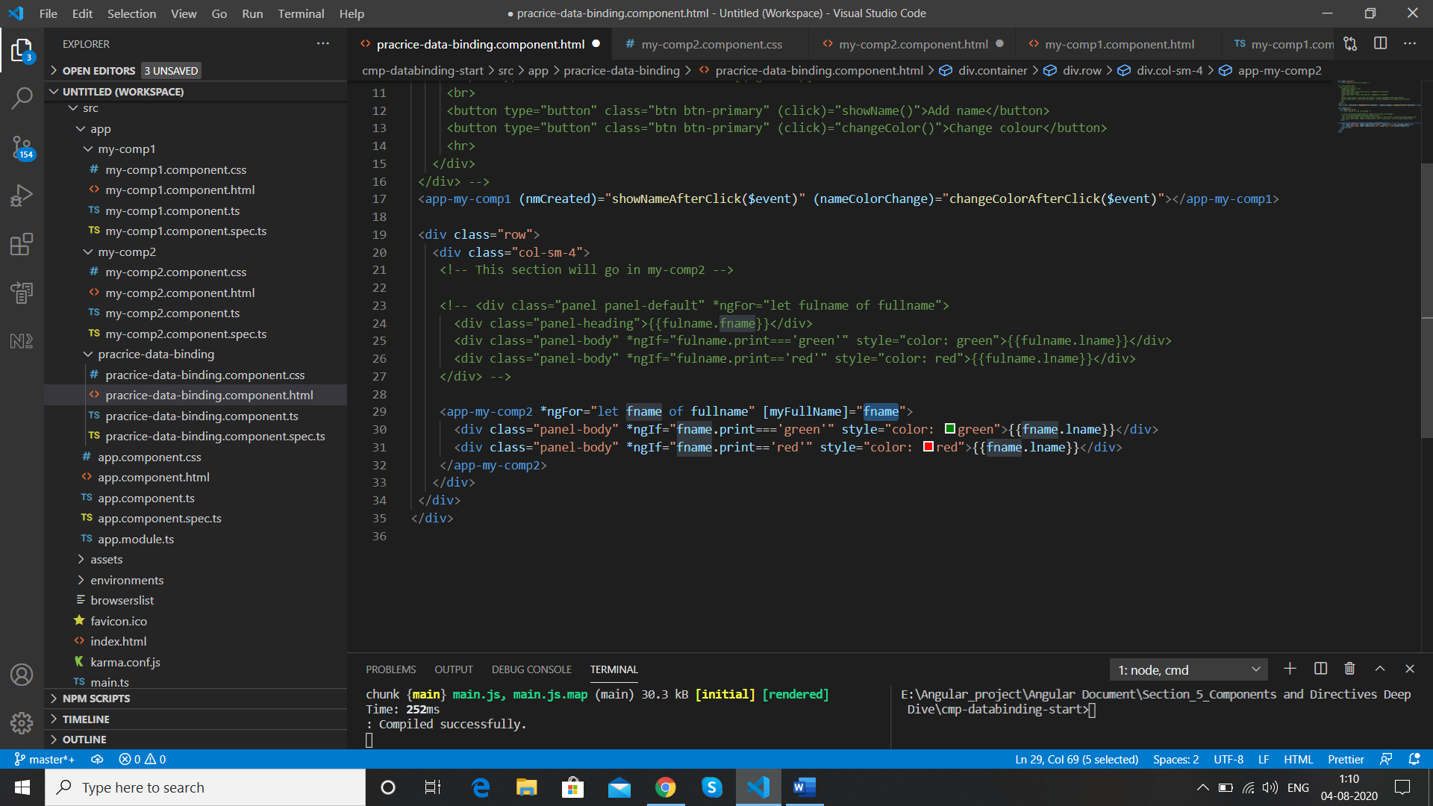

When we run we do not get the error but do not get the values as well

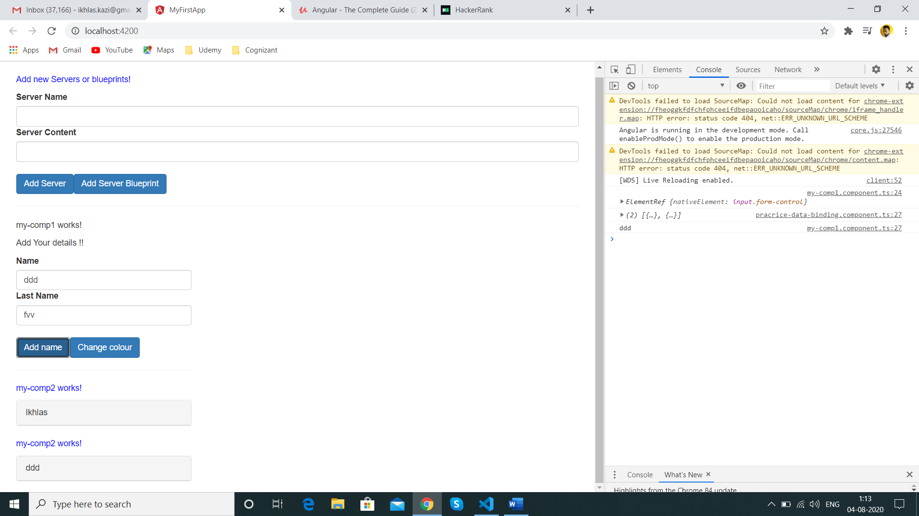

This is a default behaviour ,anything that we place between the opening and closing of our component tag is lost ie

<app-my-comp2>Lost</app-my-comp2>

We have our new code added in between the opening and closing tags so its lost

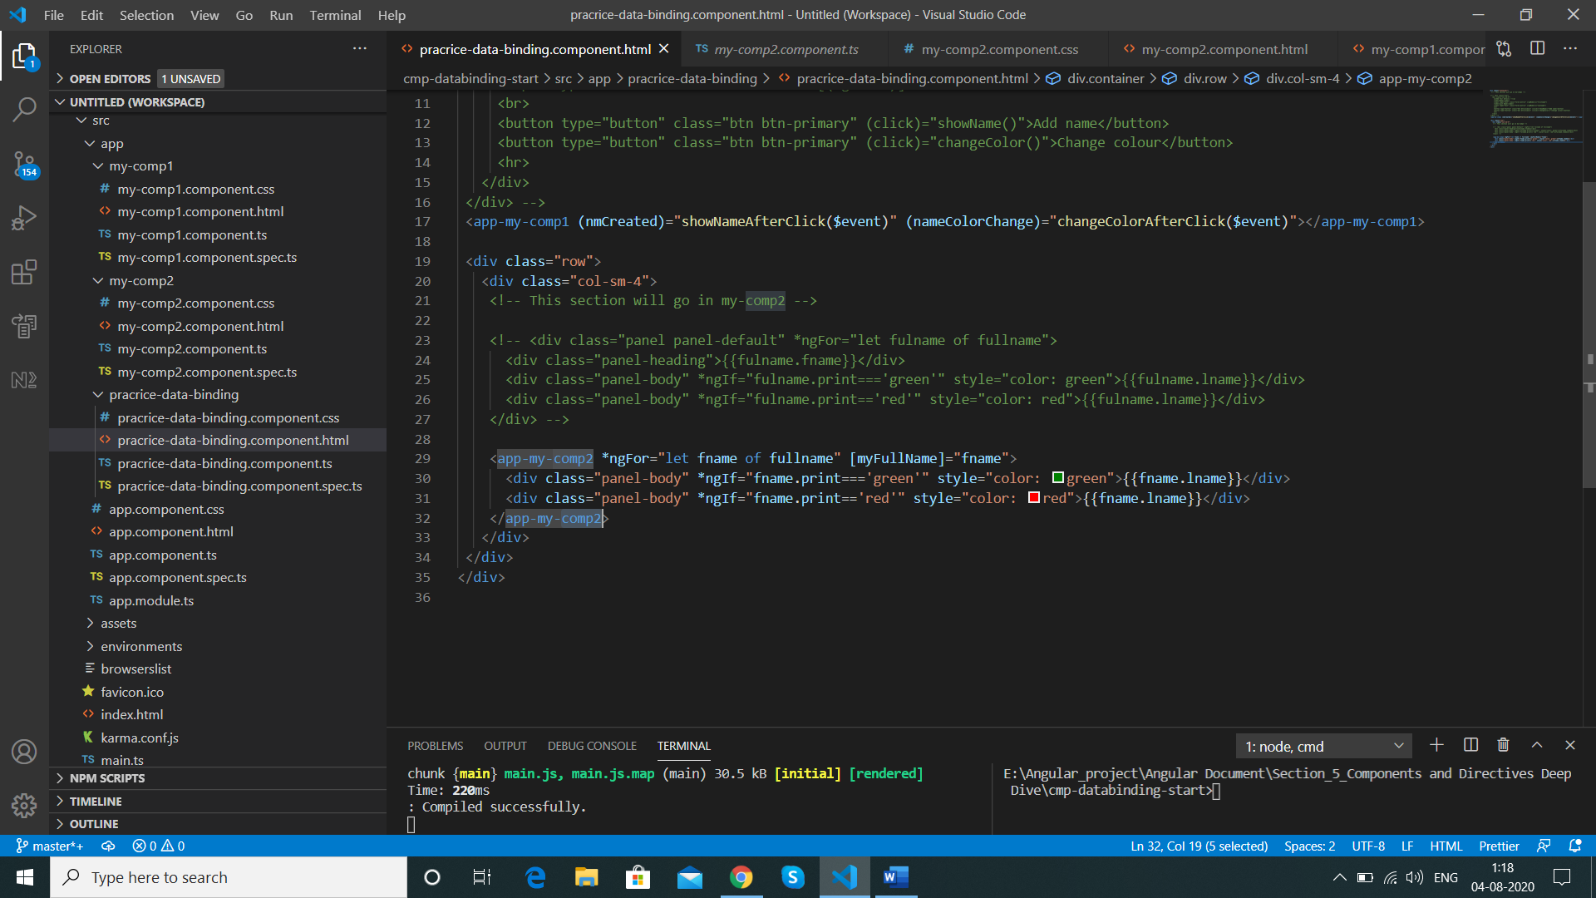

We have a very special directive but it looks like a template or component ie ng-content

<ng-content></ng-content>

We can add this directive in the place where we want to render the content ie in my-comp2.component.html

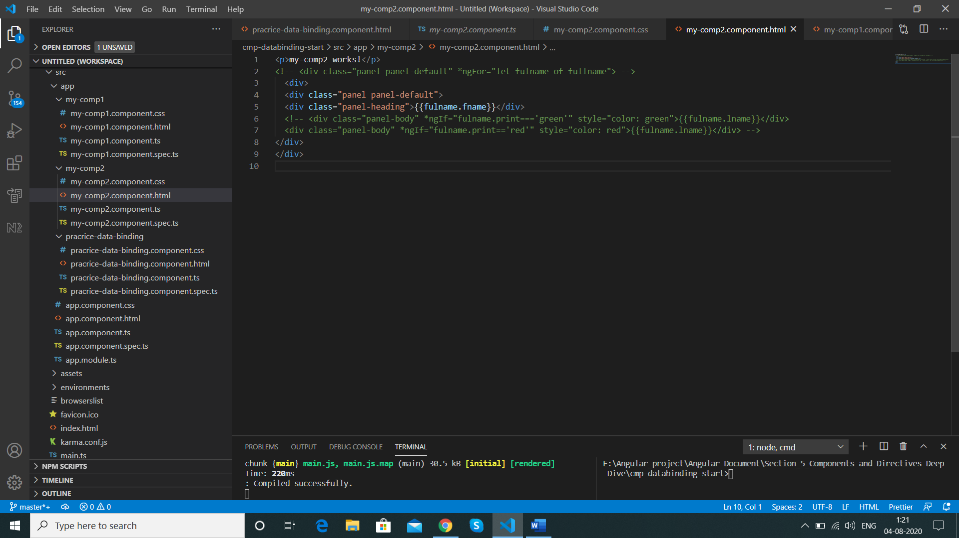

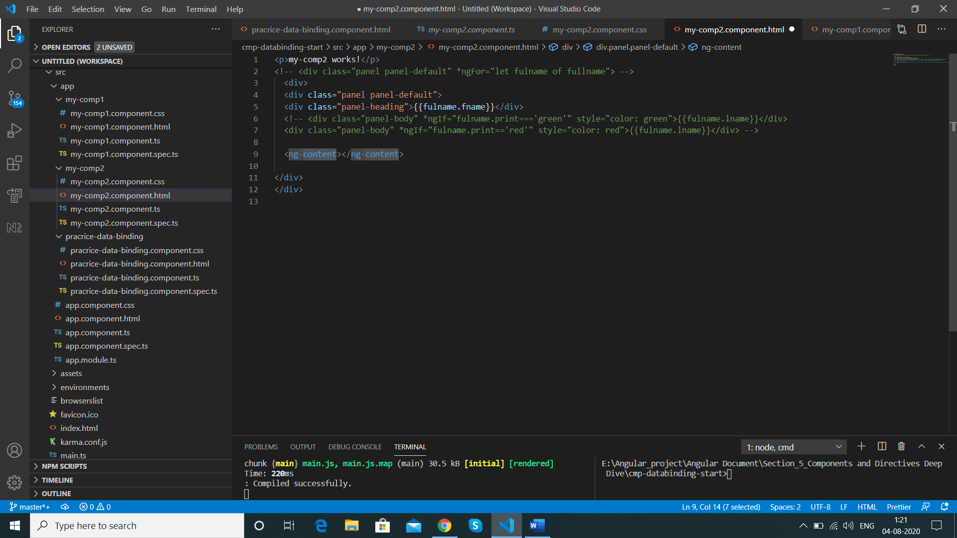

The <ng-content></ng-content> acts as a hook to mark the place where angular can add the content which it finds between below tags

  <app-my-comp2> </app-my-comp2>

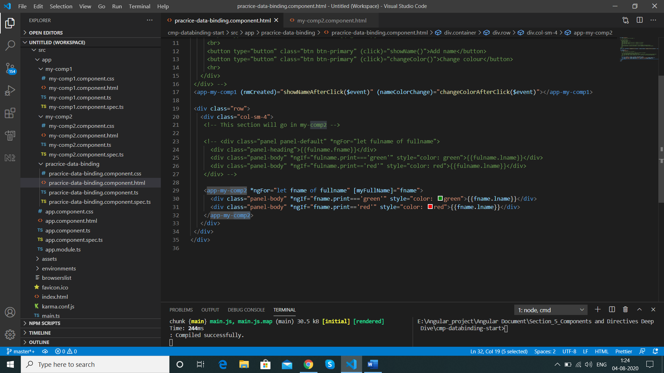

The below code

 <div class="panel-body" *ngIf="fname.print==='green'" style="color: green">{{fname.lname}}</div>

      <div class="panel-body" *ngIf="fname.print=='red'" style="color: red">{{fname.lname}}</div>

Will be projected in below tag

  <ng-content></ng-content>

Result

